George the Sun Safe Superstar

Talk Cards

What did George’s mummy tell him to wear when he was playing in the sun?

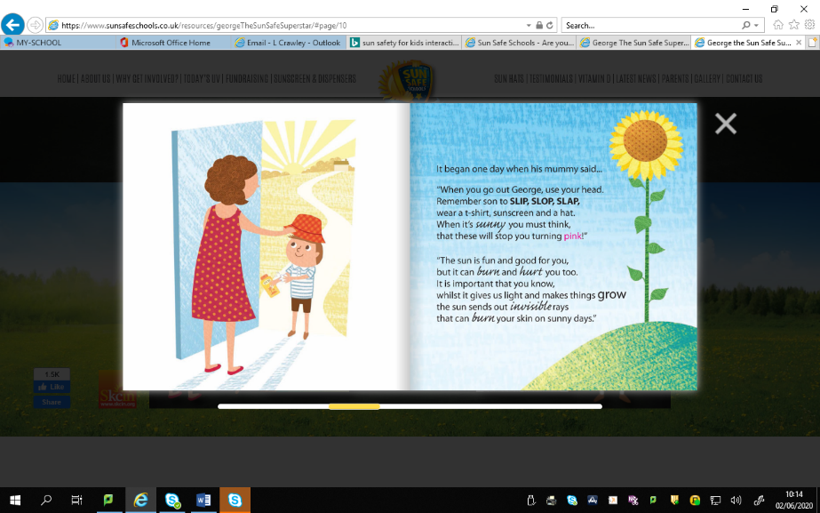

What would happen to George’s skin if he did not wear a hat, t-shirt and sunscreen?

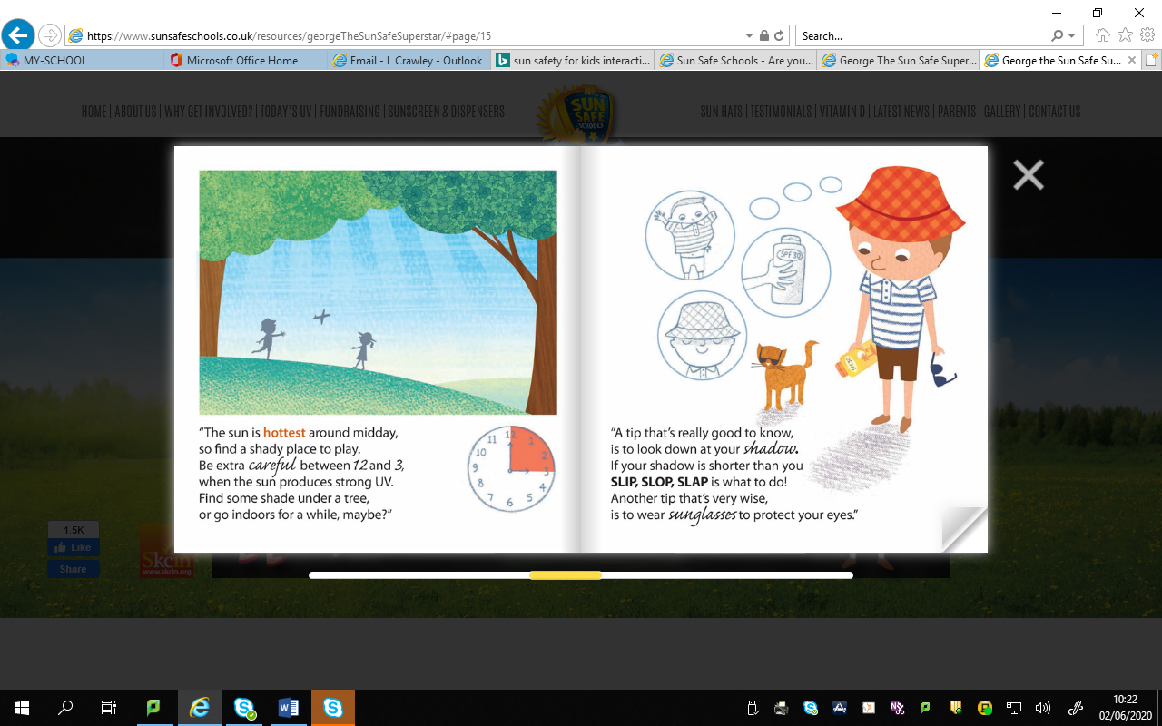

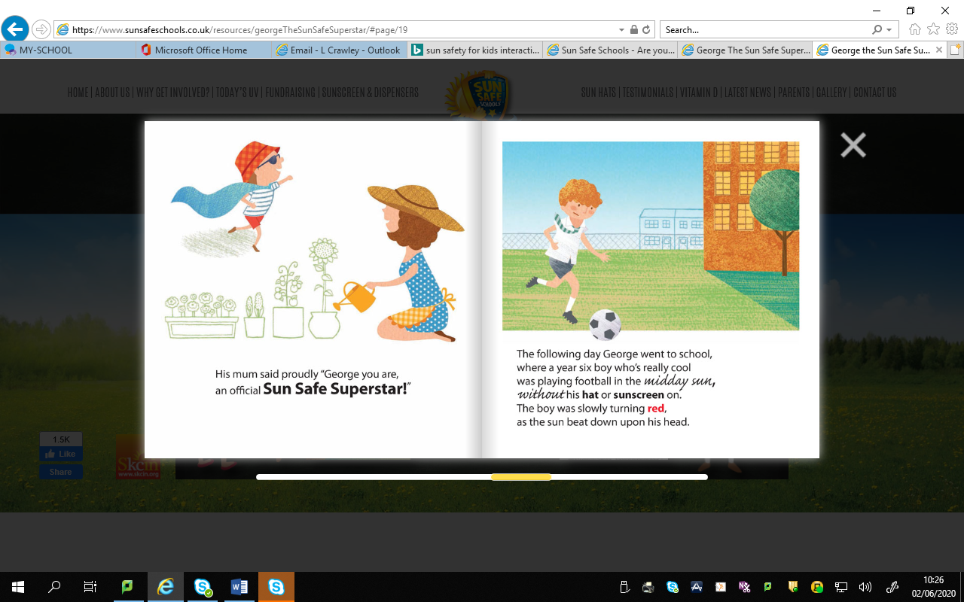

Why did the boy playing football get sunburned?

Who else did George tell the sun safe rule to?

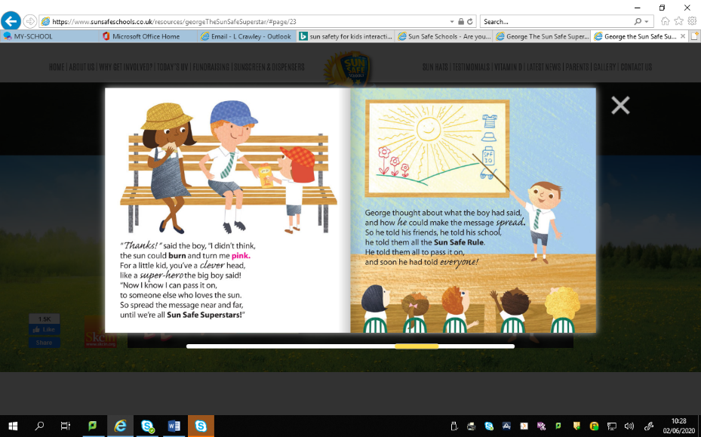

How can you be a Sun Safe Superstar like George?

