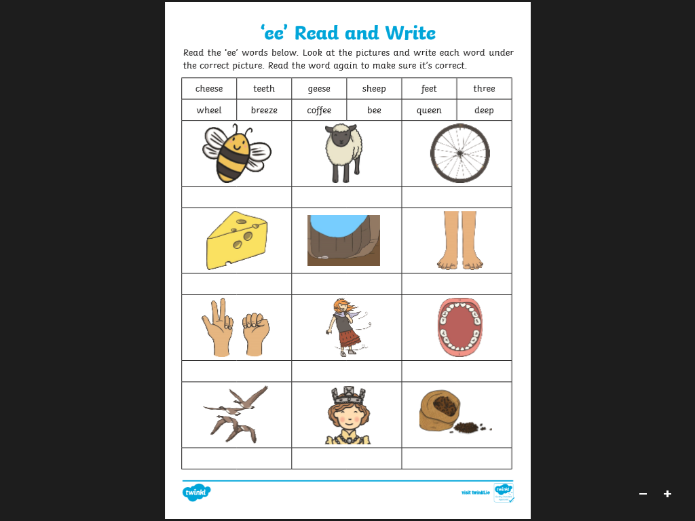

Coffee

queen

geese

teeth

breeze

three

feet

deep

cheese

wheel

sheep

bee