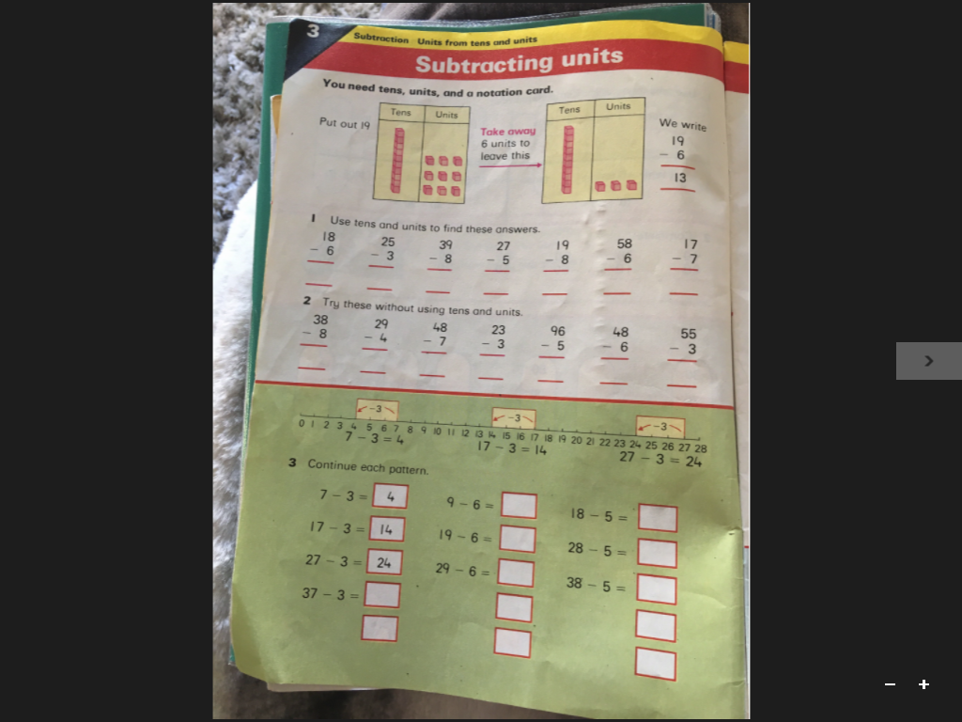

**Answers**

1. 12 22 31 22 11 52 10
2. 30 25 41 20 91 42 52

3 13

13 23

23 33

39-6=33 48-5=43

49-6=43 58-5=53

1. 34

47-3=44