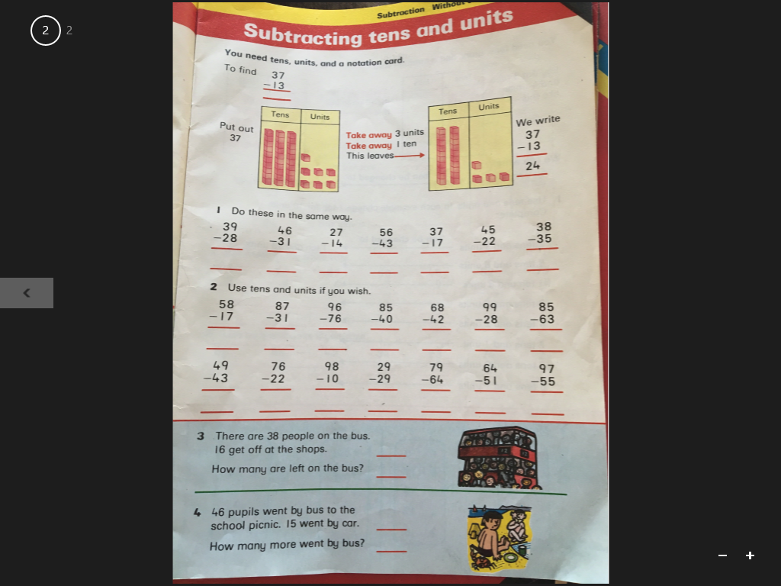

**Answers**

1. **11 15 13 20 23 3**
2. 41 56 20 45 26 71 22

6 54 88 0 15 13 42

1. 38 46

-16 -15

22 31