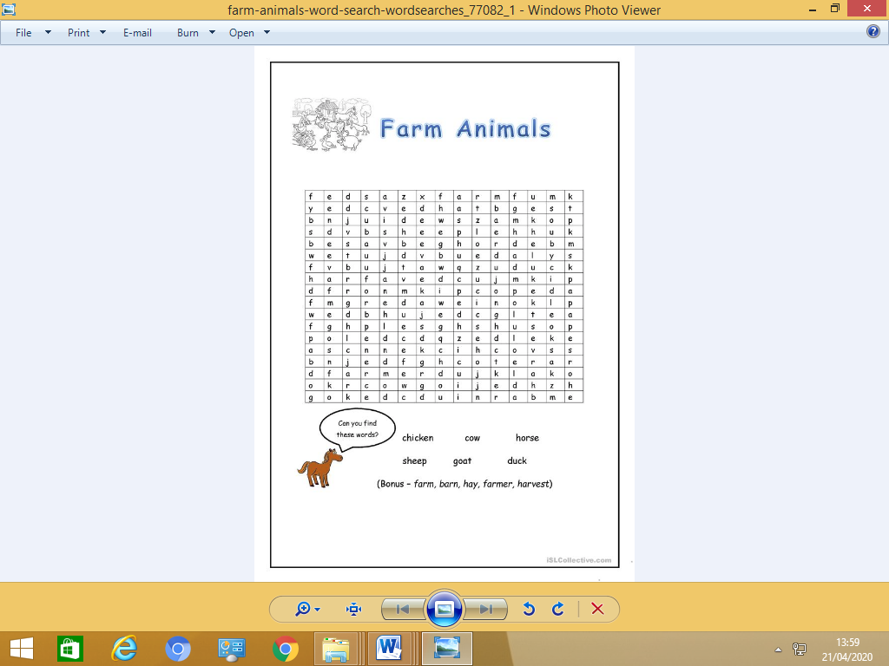

Farm, barn, hat, farmer,

harvest

hat