Monday 15th June

Hello and welcome back. We hope you are all staying safe and well.

This week in World Around Us we will be continuing on with our topic of pirates. Please find below some new small world sensory ideas for our Pirate Topic, I have linked some small world finger puppets and role play masks which can used to help build your own sensory small world. Also attached are some pirates art and crafts activities, children can make their own pirate hats and some lovely playdough sensory activities. Please also find attached a playdough recipe for you to make your own playdough at home. Have Fun ☺

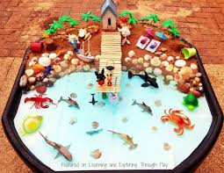 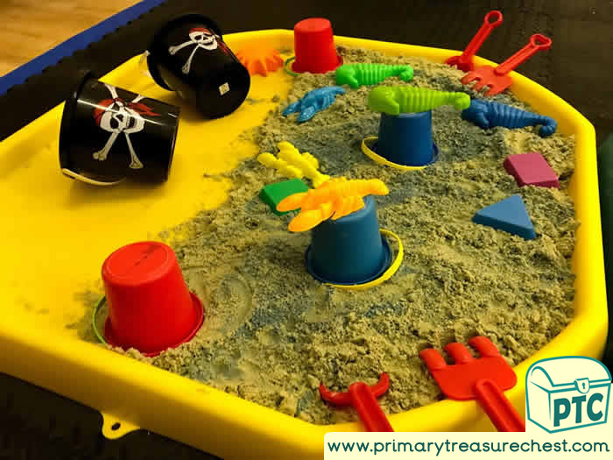

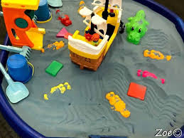 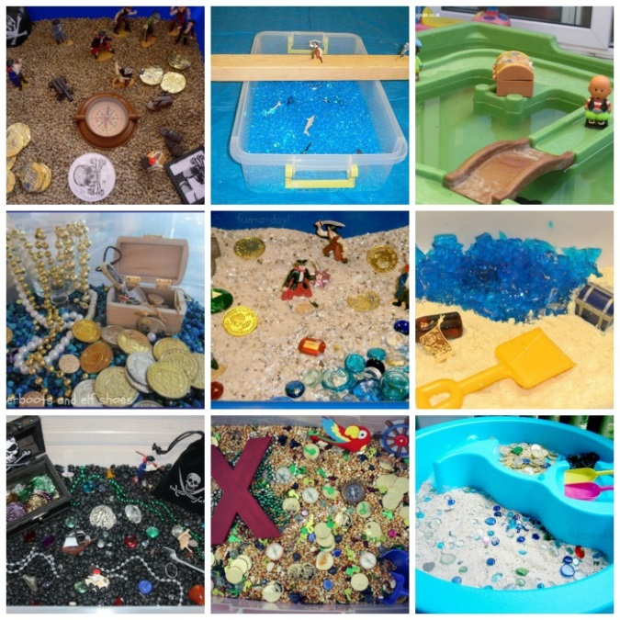

Youtube also has some great Pirate songs

* <https://www.youtube.com/watch?v=jx79dLuqPwQ>
* <https://www.youtube.com/watch?v=XDKlKiMIYv4>
* <https://www.youtube.com/watch?v=_qAngsMJD3I>

Literacy

* **High frequency words**: Please continue to revise all spellings to date. As we have been doing previously with the high frequency words homework, look and say each word. Orally put each word into a sentence. Practise writing each word and look out for the words in books. This week we will be reading the story ‘My things’. Please encourage your children to follow the story and repeat the sentences once read.
* **Phonics:** Continue to revise the sounds covered to date using the alphabet and Starfall website. **Introduce the new sound qu:**
* Geraldine the Giraffe ‘qu’ sound

<https://www.youtube.com/watch?v=mYGGk0MH_xQ>

* Alpha blocks ‘qu’ sound link

<https://www.youtube.com/watch?v=AzAabhC55xo>

* Watch out for this sound in story books and look for objects within the home that begin with this new sound.
* Practice the correct formation of *lowercase* qu sound
* **Reading:** Continue to access eBooks on the Oxford Owl website:

<https://home.oxfordowl.co.uk/books/free-ebooks/>

Here is a list of recommended book levels for your child to read, with corresponding titles to search for. If your child finds the level too hard or too easy, move up or down within the Oxford Level/Book Band Colour.

|  |  |  |
| --- | --- | --- |
| Oxford Level | Book Band Colour | Suggested Title |
| 1 | Lilac | The Haircut |
| 1+ | Pink | Big Feet |
| 2 | Red | Spots |
| 3 | Yellow | The Birthday Cake |

*It is so important that you continue to do daily reading with your children, in order to maintain the progress made to date! At least 10 minutes every day please.*

**We suggest the following timetable for Literacy**

**Week 8 (Monday 15th June- Friday 20th June)**

(Work on high frequency words and reading to be carried out every day)

Monday –My ‘qu’ booklet

Tuesday-‘Qu’ phonics page

Wednesday- ‘Qu’ Playdough mats

Thursday- ‘Qu’ tracing and words

Friday- Read and repeat the story ‘My Things’

**Numeracy**

This week we will be covering the topic of measuring. This is a great opportunity to encourage language development and understanding around the words long and short. I have also attached a recipe for playdough which would provide a great opportunity for some practical learning using the playdough boards attached. Please find below some Youtube songs around the topic of long and short.

* <https://www.youtube.com/watch?v=ryIxBrO1bJY>
* <https://www.youtube.com/watch?v=aLsmFbW8ikU>

**We suggest the following timetable for Numeracy:**

**Week 8 (Monday 15th –Friday 20th June)**

*Monday- Long and short playdough mats*

*Tuesday- Caterpillar sorting*

*Wednesday- Dinosaur measuring*

*Thursday- Long and short ordering*

*Friday- Big and small sorting*