[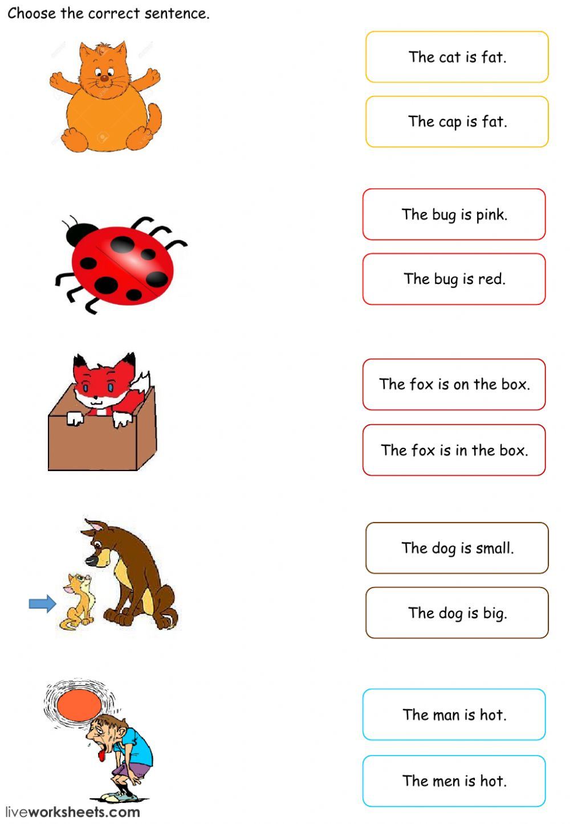](https://www.google.co.uk/url?sa=i&url=https%3A%2F%2Fwww.liveworksheets.com%2Fworksheets%2Fen%2FEnglish_as_a_Second_Language_(ESL)%2FReading%2FSimple_Sentences_Match_gp12515zh&psig=AOvVaw1VKj4EipPyJMZxZBMb1RfY&ust=1587729381250000&source=images&cd=vfe&ved=0CAIQjRxqFwoTCNCE0IG__ugCFQAAAAAdAAAAABAD)

[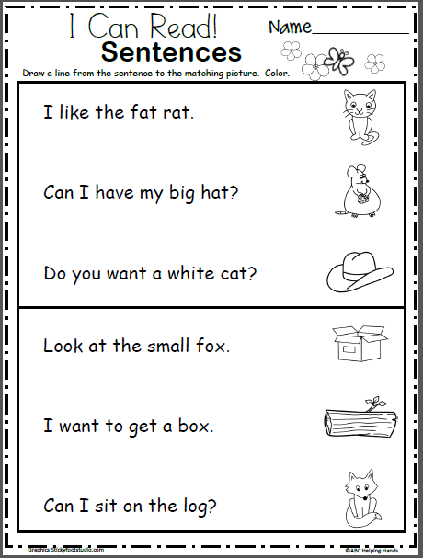](https://www.google.co.uk/url?sa=i&url=https%3A%2F%2Fwww.madebyteachers.com%2Fproducts%2Fread-match-sentences-beginning-readers%2F&psig=AOvVaw1VKj4EipPyJMZxZBMb1RfY&ust=1587729381250000&source=images&cd=vfe&ved=0CAIQjRxqFwoTCNCE0IG__ugCFQAAAAAdAAAAABAK)