[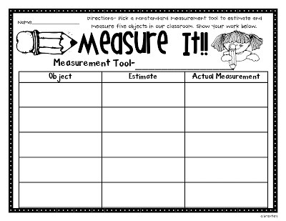](https://www.google.co.uk/url?sa=i&url=https%3A%2F%2Fwww.supplyme.com%2Fproducts%2Fnonstandard-measurement-activities-a7314&psig=AOvVaw0YV1q6zuVnngmr0Bv4X68w&ust=1587982073575000&source=images&cd=vfe&ved=0CAIQjRxqFwoTCNiRzv7shekCFQAAAAAdAAAAABAE)