[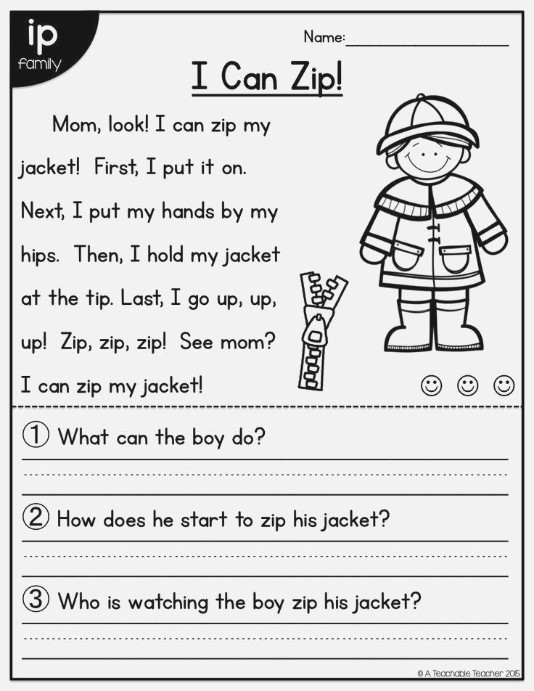](https://www.google.co.uk/url?sa=i&url=https%3A%2F%2Fwww.pinterest.com%2Fpin%2F426856870931562424%2F&psig=AOvVaw0Qpn4HJ0ADf72kR4ojhEEy&ust=1587730032173000&source=images&cd=vfe&ved=0CAIQjRxqFwoTCNDr2bLB_ugCFQAAAAAdAAAAABAg)

[](https://www.google.co.uk/url?sa=i&url=https%3A%2F%2Fwww.pinterest.com%2Fpin%2F841610249089592809%2F&psig=AOvVaw0Qpn4HJ0ADf72kR4ojhEEy&ust=1587730032173000&source=images&cd=vfe&ved=0CAIQjRxqFwoTCNDr2bLB_ugCFQAAAAAdAAAAABAl)