[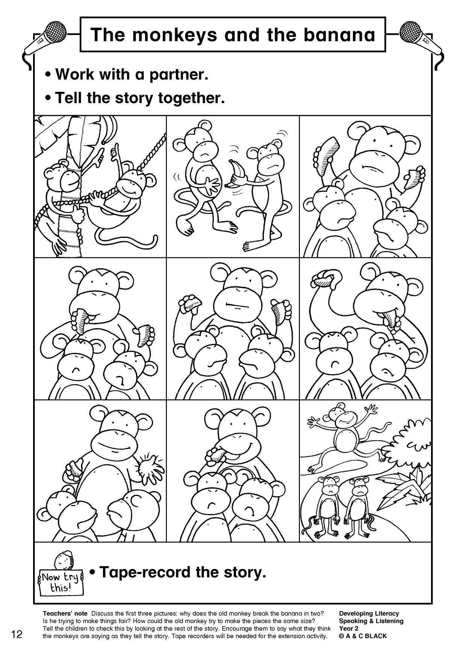](https://www.google.co.uk/url?sa=i&url=https%3A%2F%2Fwww.teachitprimary.co.uk%2Fspoken-language%2Fdrama-and-role-play%2Ftags%2F934&psig=AOvVaw0eJ0ZxyncUJX57RC0PK2zu&ust=1587810415152000&source=images&cd=vfe&ved=0CAIQjRxqFwoTCLDD4O7sgOkCFQAAAAAdAAAAABAU)