[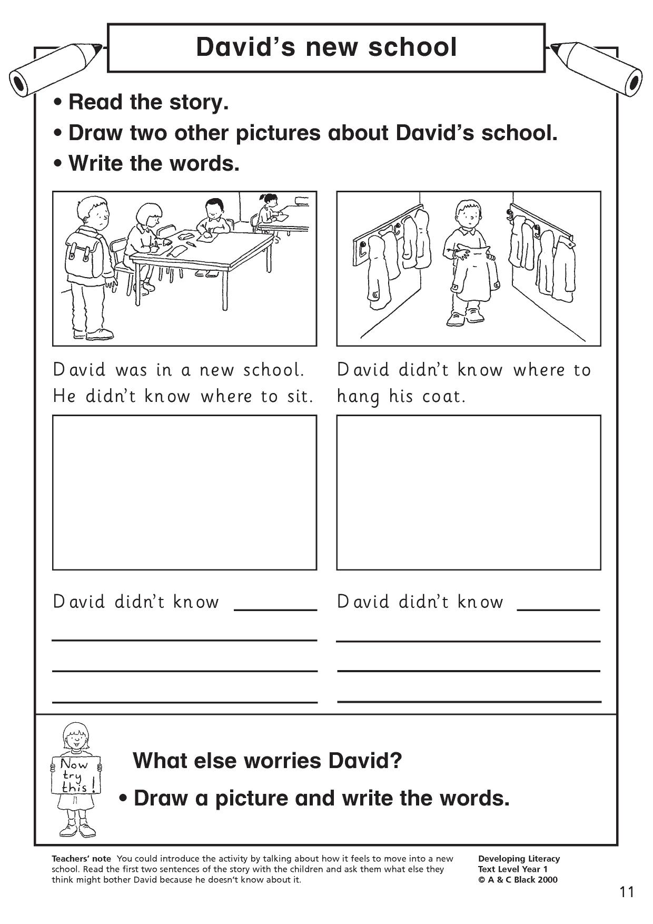](https://www.google.co.uk/url?sa=i&url=https%3A%2F%2Fwww.teachitprimary.co.uk%2Fwriting-composition%2Fstructuring-plots-and-planning%2Ftags%2F3092&psig=AOvVaw2EubdCWiT7tBB-CnSawaUc&ust=1587738953497000&source=images&cd=vfe&ved=0CAIQjRxqFwoTCMC1s9bi_ugCFQAAAAAdAAAAABAD)