[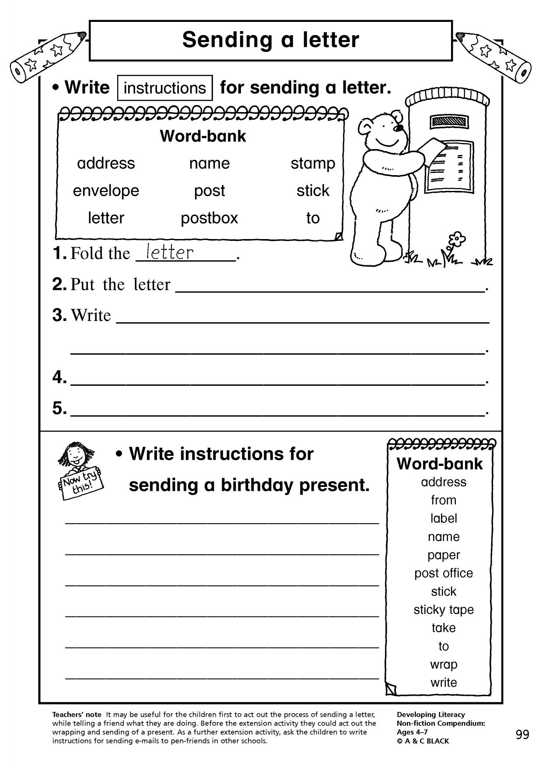](https://www.google.co.uk/url?sa=i&url=https%3A%2F%2Fwww.teachitprimary.co.uk%2Fwriting-composition%2Fletter-writing%2Ftags%2F1271&psig=AOvVaw2EubdCWiT7tBB-CnSawaUc&ust=1587738953497000&source=images&cd=vfe&ved=0CAIQjRxqFwoTCMC1s9bi_ugCFQAAAAAdAAAAABAK)

Answers

Instructions for sending a letter

1. Fold the letter.
2. Put the letter into the envelope.
3. Write the name and address on the envelope.
4. Stick the stamp on the envelope.
5. Post you letter into the post box.

Instructions for sending a birthday present.

1. Wrap the present using some wrapping paper.
2. Use sticky tape to keep the paper in place.
3. Stick a label on the front of your present.
4. Write the person’s name and address on it and also who the present is from.
5. Take your parcel to the post office to be sent away.