Monday 22nd June

Welcome back everyone to your final week of online learning. A huge Well Done to everyone for taking the time to complete activities via remote learning, Nessy, Sumdog and AR reader it is fantastic to see ☺

Reminder: reports are scheduled to be collected on Thursday 25th and Friday 26th June. Please avail of the document on the app or class page to see your own specific collection time and social distancing guidelines.

**World Around Us**

As we are nearing our Summer Holidays I thought it would be a great opportunity to focus this week on our Summer Topic. I have attached a lovely Summer and beach power point which goes through what you can see in the summer and when at the beach. Children can colour, paint or collage summer pictures attached separately or draw their own. Also below is an ice cream sensory tray this activity will allow children to experience making ice cream cones, you can use ice cream, sprinkles. This provides a great opportunity for children to experience different tastes and textures.

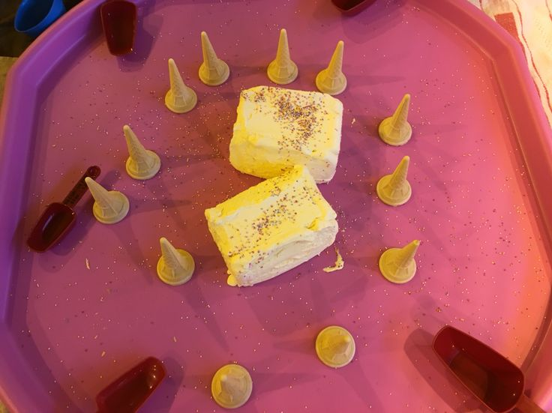

Another great exploration activity is creating your very own sensory ice world. This can be done by freezing some beach resources or underwater resources in ice and encourage children to explore.

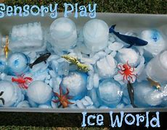

**Literacy**

* **High frequency words**: Please continue to revise all spellings to date. As we have been doing previously with the high frequency words homework, look and say each word. Orally put each word into a sentence. Practise writing each word and look out for the words in books. The high frequency covered are ‘I, a, the, and, my’. Please find attached these words on a separate document which children can decorate or trace over.
* **Phonics**: Continue to revise the sounds covered to date using the alphabet and Starfall website. **Introduce the new sound x:**
* Encourage your child to think of words which begin/end with this sound and ask them to draw things beginning with this sound.
* Access the ‘x’ page on Starfall website.

<https://www.starfall.com/h/abcs/letter-x/?t=297409717>

* Jack Hartman ‘x’ sound songs

<https://www.youtube.com/watch?v=gCr7VPh7ym4>

* Alpha blocks ‘x’ links

<https://www.youtube.com/watch?v=AMZ0zu_0zvU>

* Watch out for these sounds in story books and look for objects within the home that begin or end with these new sounds.
* Practice the correct formation of *Capital and lowercase x*.

Reading: Continue to access eBooks

* Summer line pencil control work sheets which can be completed using hand over hand technique or children can participate in mark making using shaving foam, sand, water. See examples below.

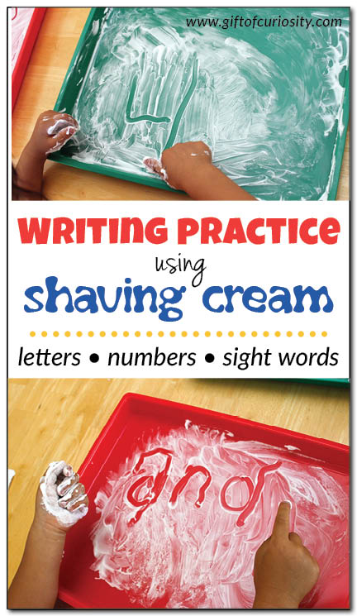 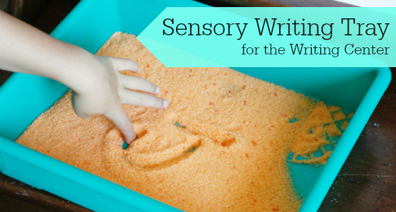

**Reading**

Recap on the stories uploaded so far I have also uploaded new additional stories to finish of the term.

Here is a list of recommended book levels for your child to read, with corresponding titles to search for. If your child finds the level too hard or too easy, move up or down within the Oxford Level/Book Band Colour.

|  |  |  |
| --- | --- | --- |
| Oxford Level | Book Band Colour | Suggested Title |
| 1 | Lilac | The Library |
| 1+ | Pink | Dad’s Feet |
| 2 | Red | Family Poems |
| 3 | Yellow | By the Streams |

*It is so important that you continue to do daily reading with your children, in order to maintain the progress made to date! At least 10 minutes every day please.*

We suggest following the timetable below:

Monday 22nd June – X sound listen to Jack Hartman and complete X worksheet

Tuesday 23rd June – Summer line pencil control workbook/ sensory mark making. High frequency word recap

Wednesday 24th June- Farewell Hand activity and summer picture painting.

**Numeracy**

This week in order to incorporate our beach/ summer theme I thought it would be nice for children to recap on the topic of money. In order to facilitate this I have attached some resources which can be used to make a beach shop and till area. This will allow children to experience handling money, recognising numbers on coins and exchanging and taking turns with money for ice cream or lollies.

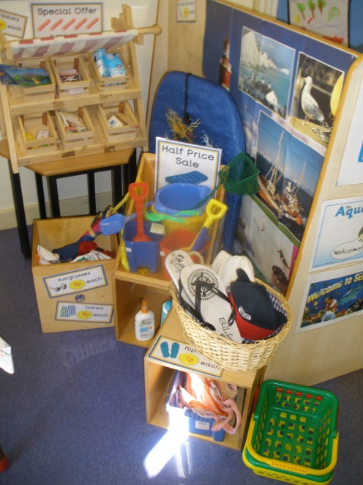 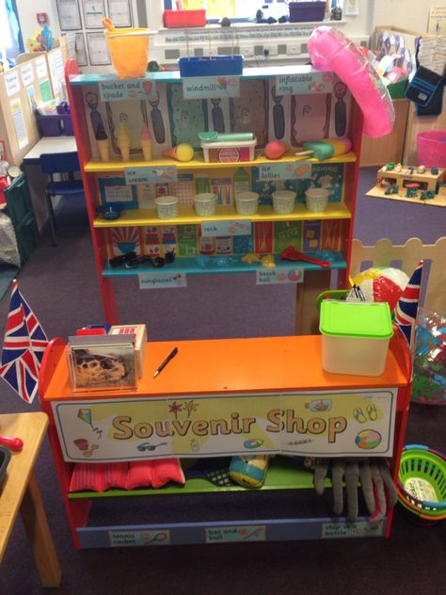

* <https://www.youtube.com/watch?v=vs8F_g3MGtM> Here is a money song to help introduce the topic of money.

As we are nearing Summer holidays I have attached a number power point which will remain online during the holiday period to help consolidate number knowledge to 10. Below I have attached some online games which can be accessed during the holidays also.

* <https://www.topmarks.co.uk/learning-to-count/teddy-numbers>
* <https://www.topmarks.co.uk/learning-to-count/underwater-counting>
* <https://www.topmarks.co.uk/learning-to-count/ladybird-spots>
* <https://www.topmarks.co.uk/ordering-and-sequencing/caterpillar-ordering>

We suggest you follow this timetable when completing Numeracy activities:

Monday 22nd June – Beach shop role play activity

Tuesday 23rd June –Numbers to 5 order and matching

Wednesday 24th June- Numbers to 10 order and matching

**Arts and Crafts**

Finally as an Arts and Crafts activity we thought as it is our last week and we will be saying goodbye to our P7s as they move on to secondary school, children could design our own goodbye hand in order to help children transition into the Summer period.

Instructions:

1. Place child’s hand on a piece of paper or card and encourage child to draw around their own hand. Use hand over hand assistance if necessary
2. Encourage children to decorate their own hand using paint, colouring pencils, markers. Chalk.
3. Stick Summers Here Poem in the middle of hand and read through with child.

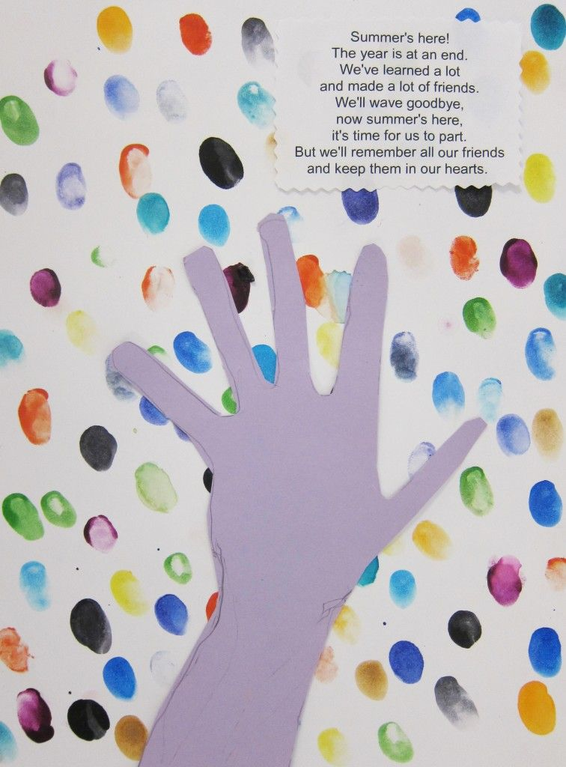 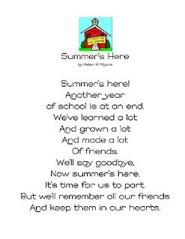

Have a wonderful Summer everyone and we will see you again very soon.

