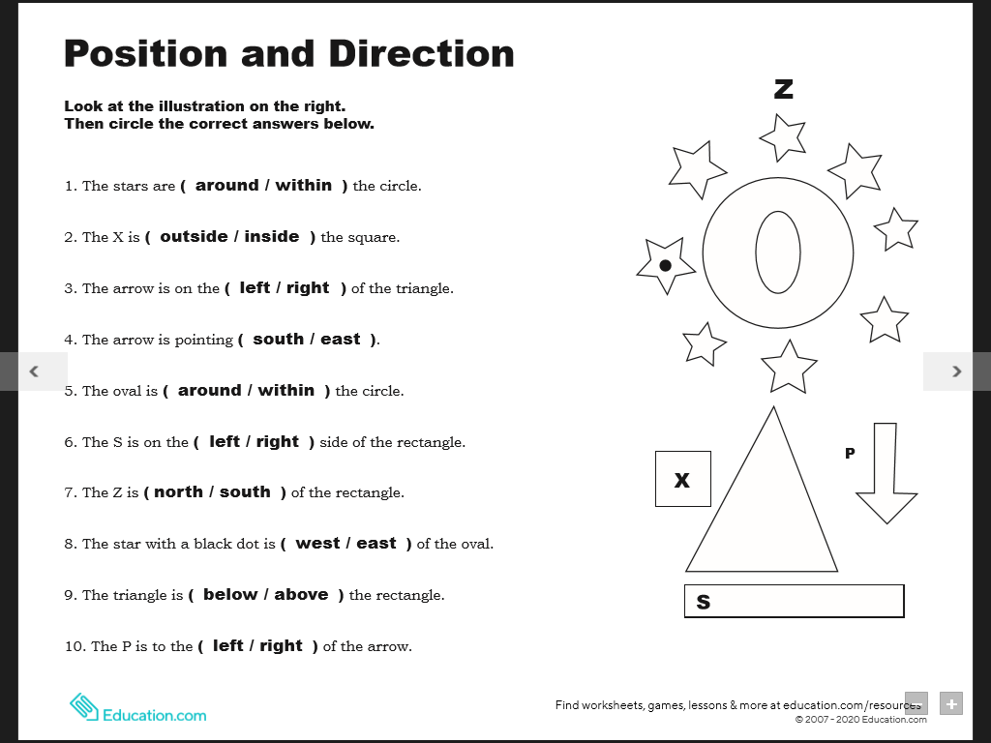 N **Literacy group 1**

W E

S