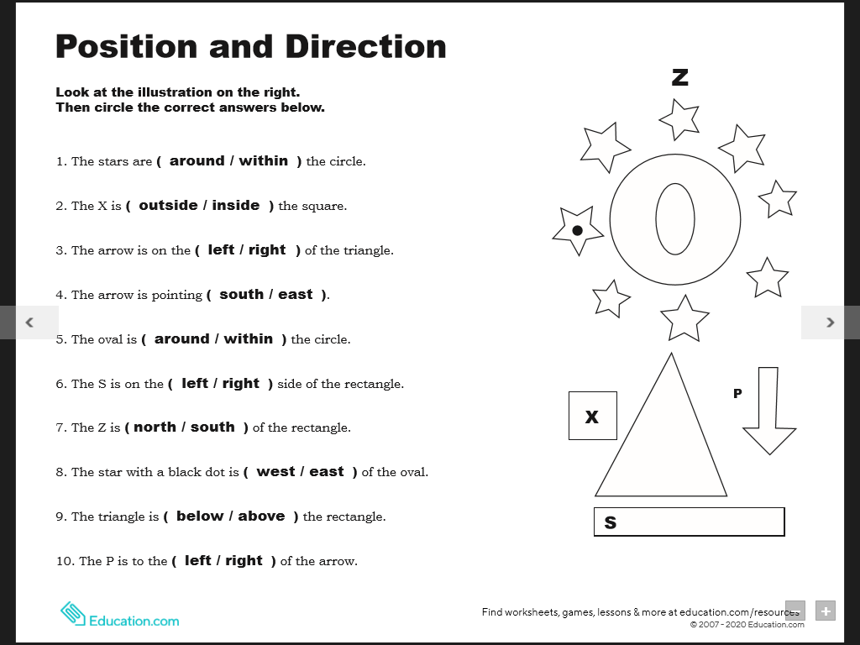 N **Literacy group 1**

W E

S

left

above

west

north

left

within

south

right

inside

around