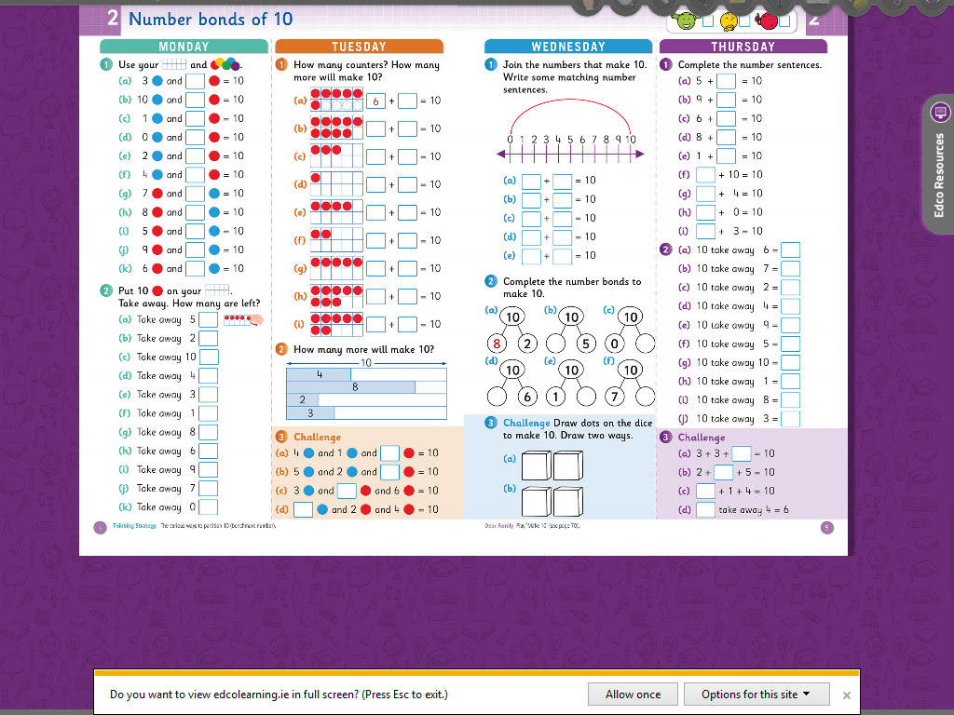

Monday

1 2

A 7 a 5

B 0 b 8

C 9 c 0

D 10 d 6

E 8 e 3

F 6 f 9

G 3 g 2

H 2 h 4

I 5 I 1

J 1 j 3

K 4 k 10