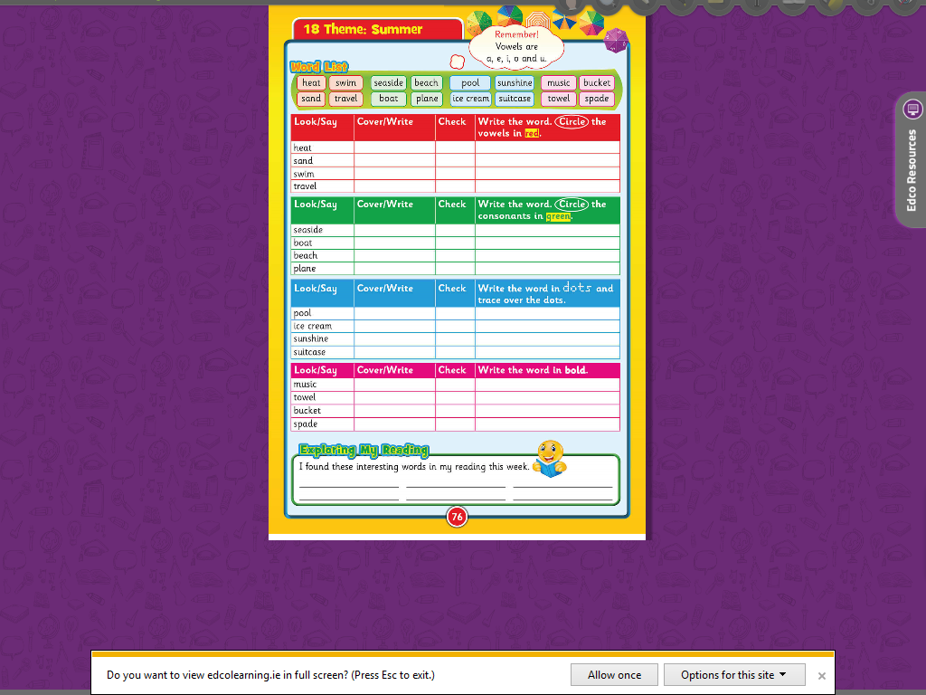**Literacy group** **1**

P l n

b c h

b t

s s d

a e

i

a

ea