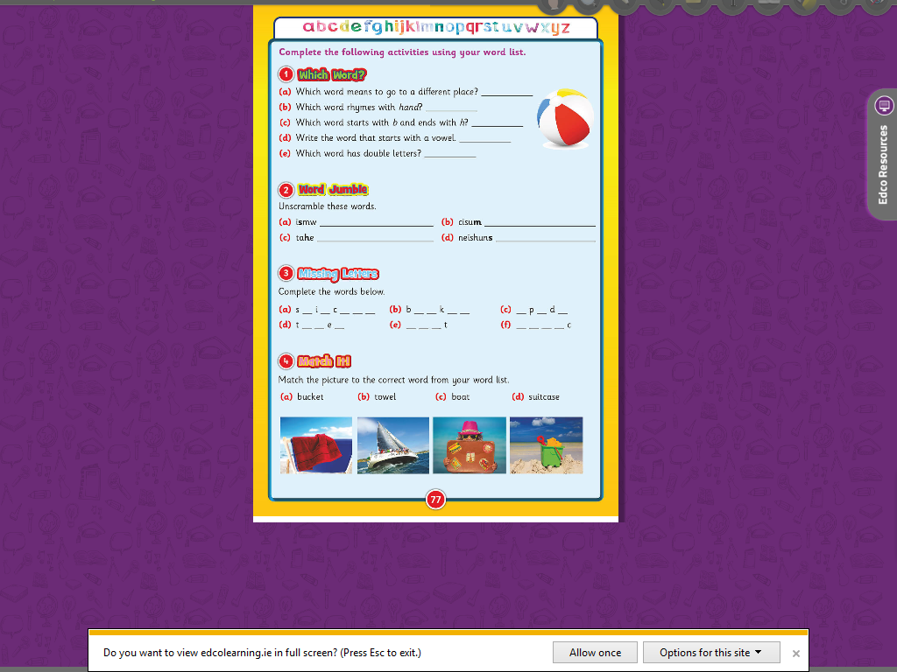**Literacy group 1 sheet 2**