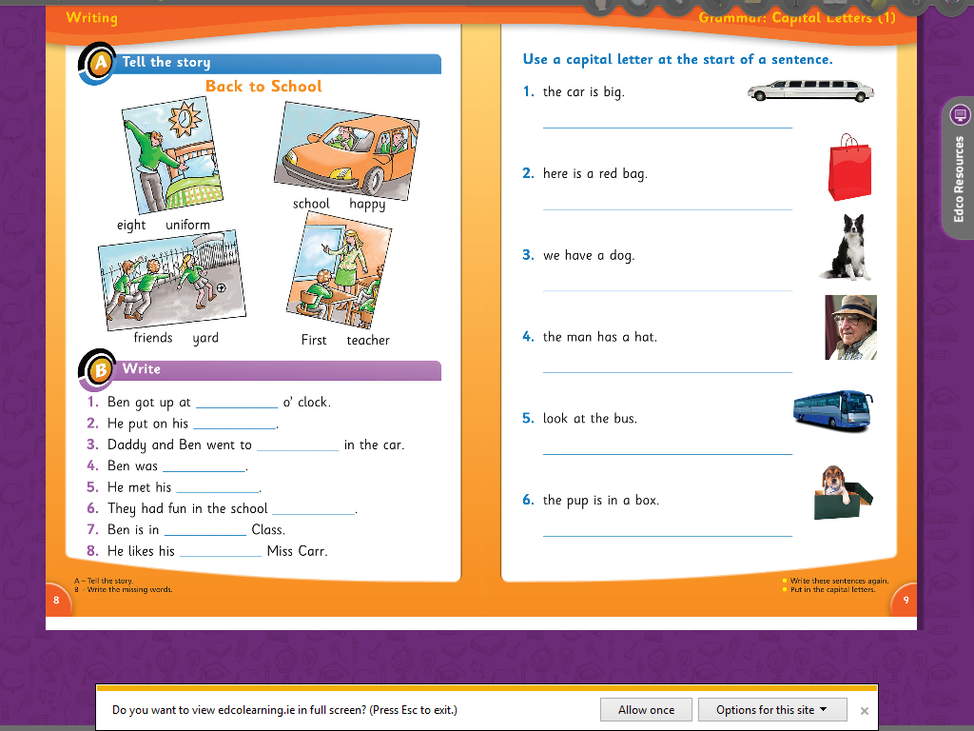

The pu pis in a box.

Look at the bus.

The man has a hat.

We have a dog.

Here is a red bag.

The car is big.

teacher

First

yard

friends

happy

school

uniform

eight