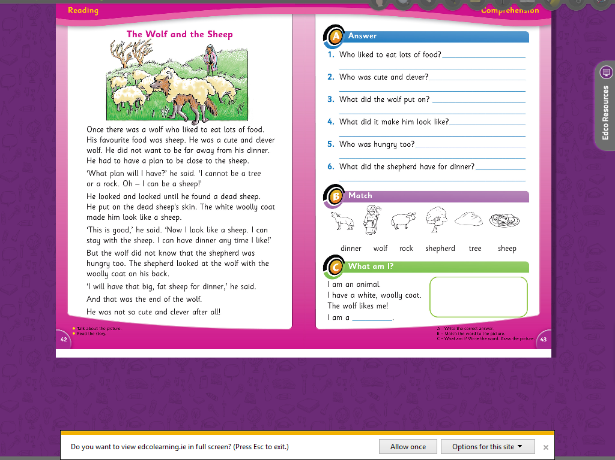

sheep

The shepherd had the wolf for dinner.

The shepherd was hungry too.

It made him look like a sheep.

The wolf put on a dead sheep’s skin.

The wolf was cute and clever.

The wolf liked to eat lots of food.