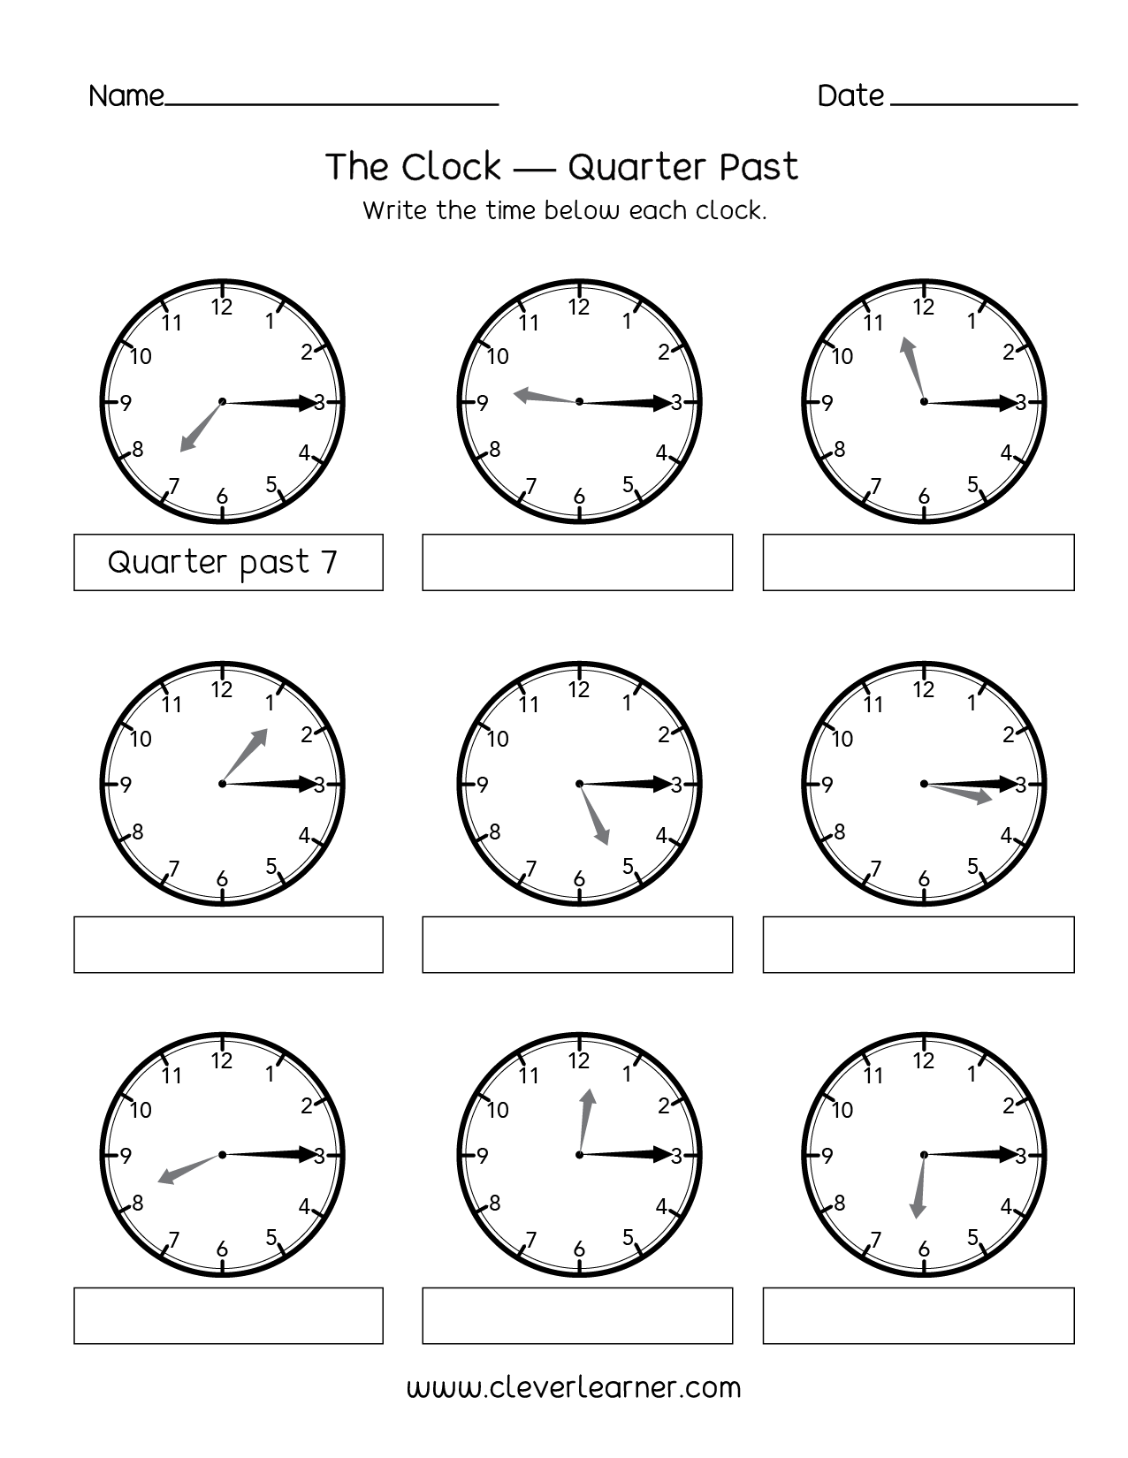

Quarter past 11

Quarter past 9

Quarter past 6

Quarter past 12

Quarter past 8

Quarter past 3

Quarter past 5

Quarter past 1

Quarter past 11

Quarter past 9