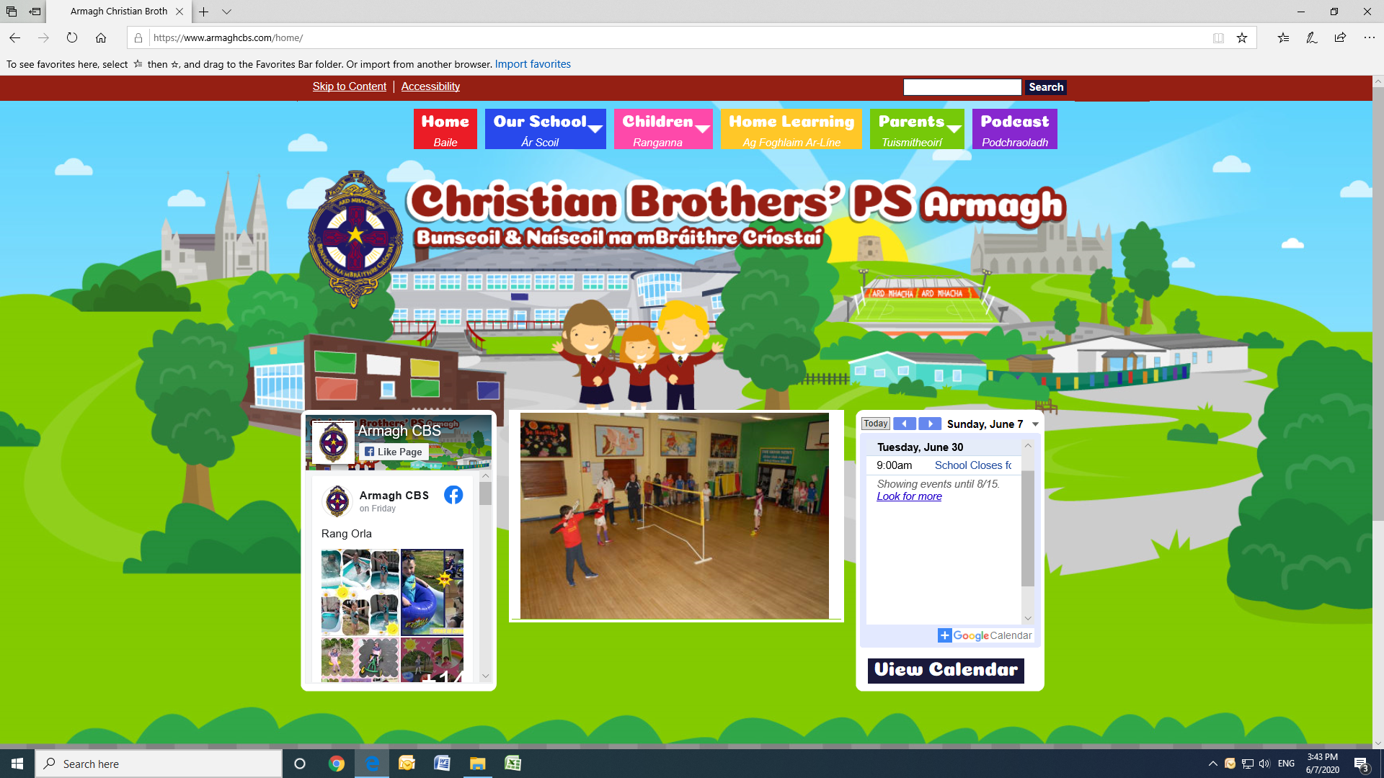End of year booklet for P.3

Name :

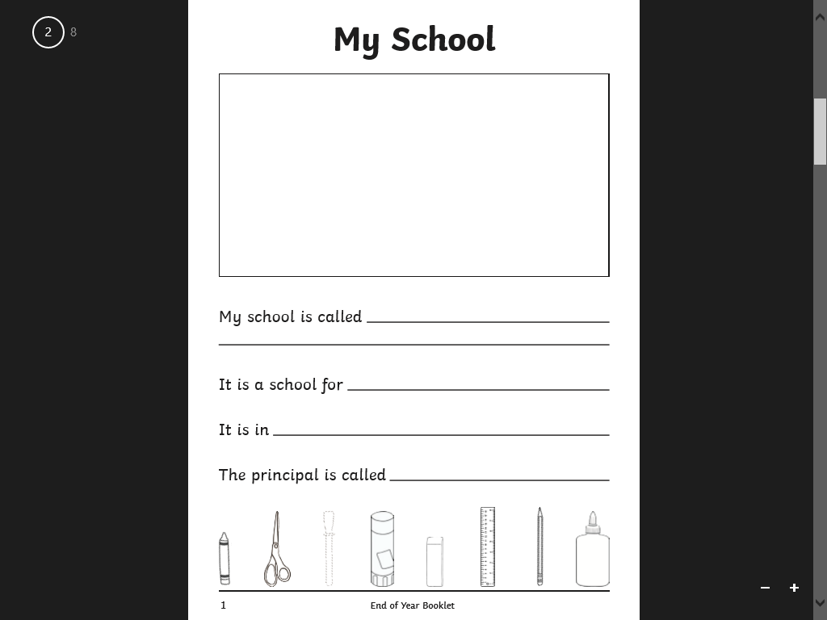

My school is called

The principal is called

It is in

It is a school for

**My School**

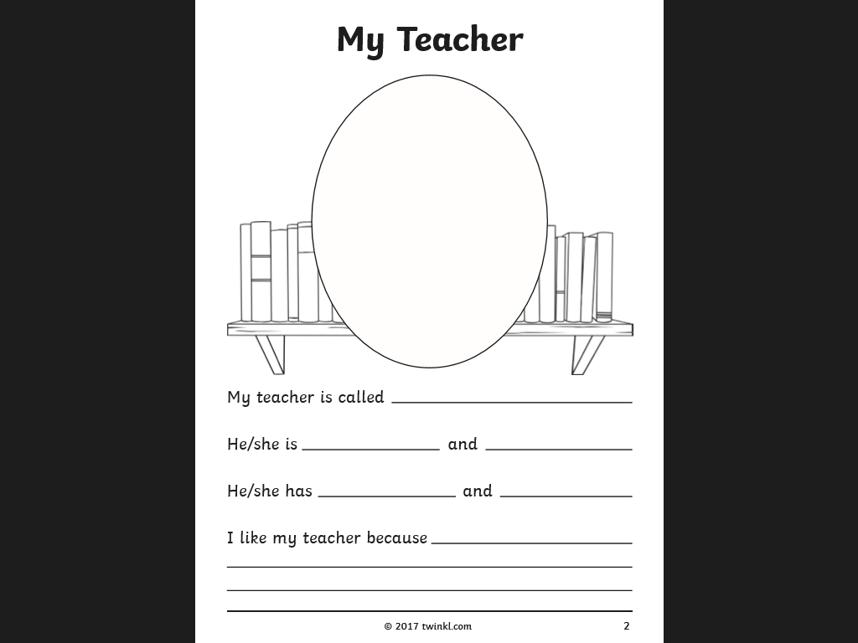

I like my teacher because

and

She has

andd

She is

My teacher is called

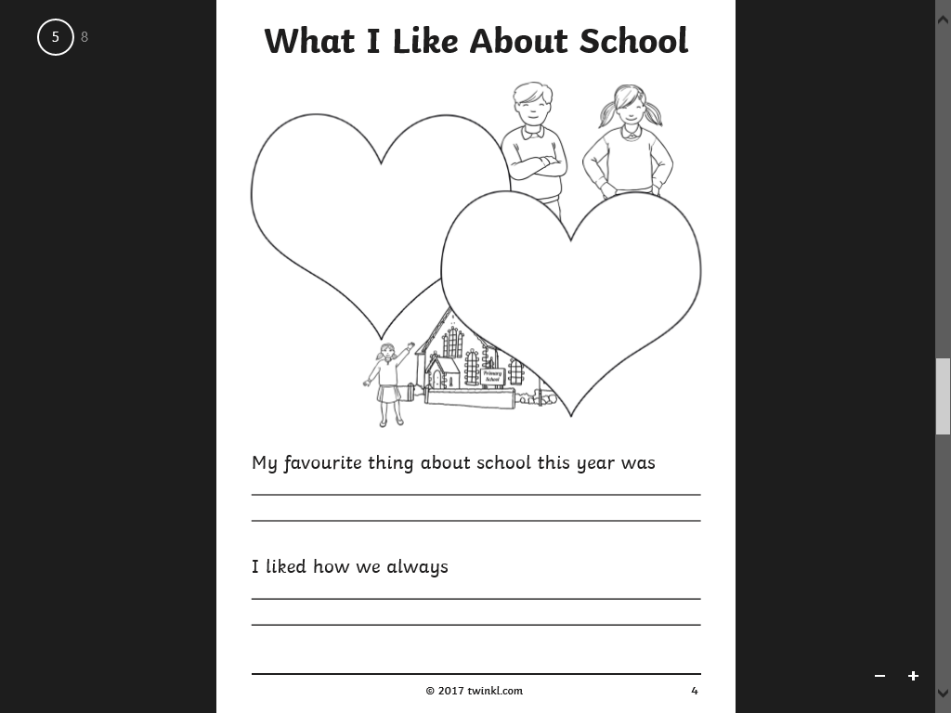

I liked how we always

My favourite thing about school this year was

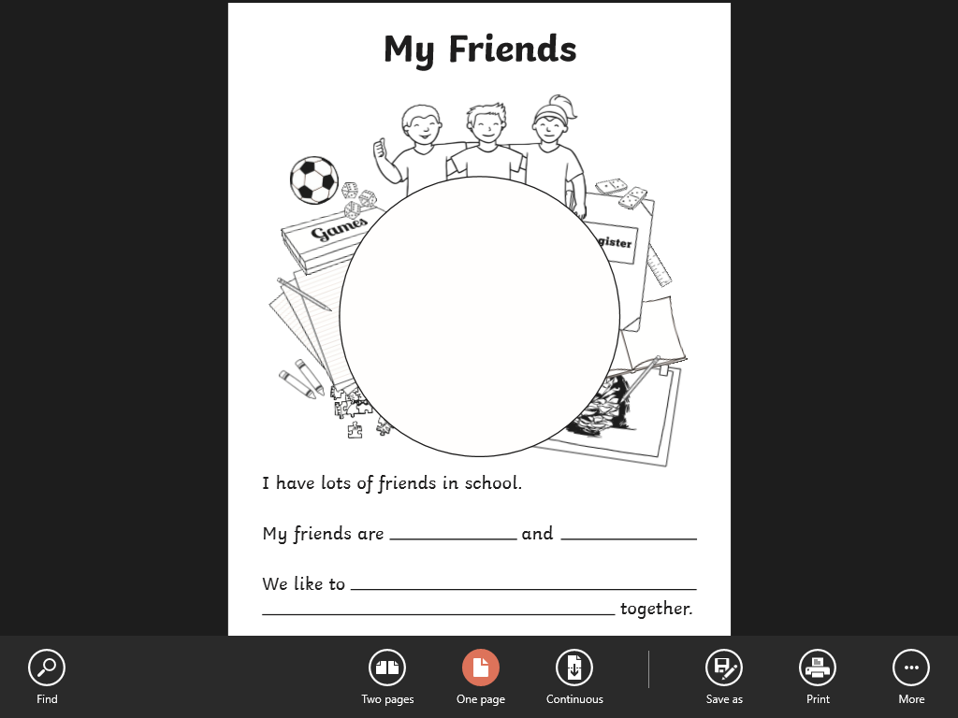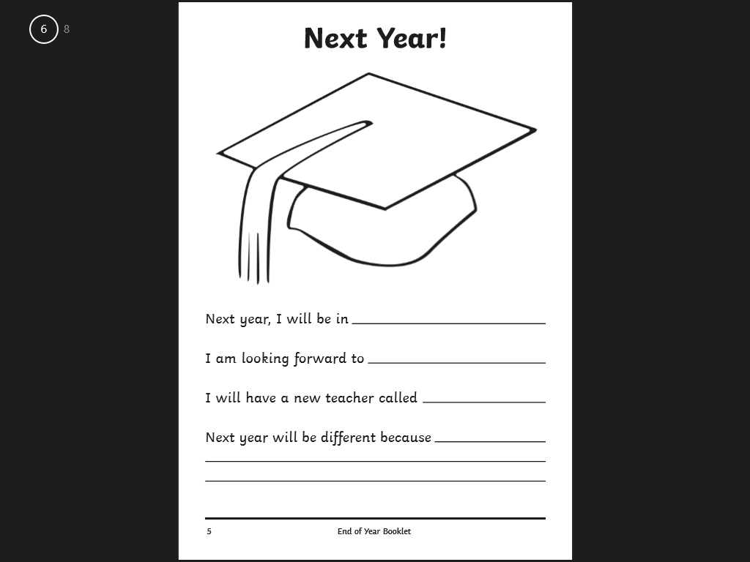

together

We like to

and

My friends are

I have lots of friends in school.

I will have a new teacher called

I am looking forward to

Next year, I will be in

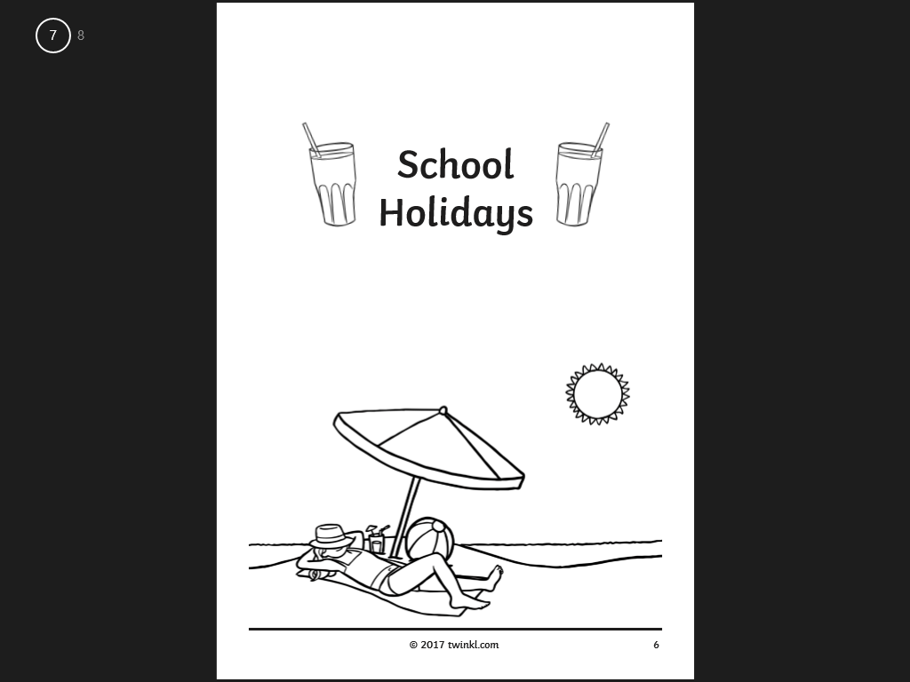

School

Holidays