**Primary One Phonics**

Primary One children follow the Linguistic Phonics method of teaching phonics.

We focus on learning the sounds for the 26 letters of the alphabet in the following order:

r a n m u d h o s t i c y e f l b g p j x k v w z q

The pronunciation of the sounds are as follows:

a – as in apple j – as in jug s – as in sun

b – as in bat k – as in kettle t – as in teddy

c – as in cat l – as in leg u – as in cut

d – as in duck m – as in mat v – as in van

e – as in egg n – as in nose w – as in wet

f – as in fish o – as in cot x – as in fox

g – as in gate p – as in pan y – as in yet

h – as in hat q – as in ‘queen’ z – as in zoo

i – as in pig r – as in red

Once the first six sounds are learnt, children begin to practise blending/segmenting to spell and read CVC words eg ‘ran’, ‘mud’, ‘man’, ‘run’ etc.

More and more CVC words can be explored as pupils move through learning each initial sound.

We encourage children to focus on the sound the letters make, rather than the letter names themselves. Some children may get confused between sounds and letter names, and in this instance it is much more beneficial for them to know the sounds.

Each time we learn a new sound we watch ‘Geraldine the Giraffe’ by ‘Mr Thorne Does Phonics’ on YouTube to demonstrate the correct pronunciation of each sound and explore different words beginning with them. Mr Thorne has a range of useful videos that can be viewed on his channel

<https://www.youtube.com/channel/UC7sW4j8p7k9D_qRRMUsGqyw>

(NB: digraphs (where two letters make one sound, such as ‘sh’ and ‘ch’) are taught from Primary Two, so please do not be concerned about these in Primary One).

Pupils also learn the Jolly Phonics action for each sound learned. The actions for all 26 initial sounds can be found here:

<https://www.youtube.com/watch?v=fScUJd9wSd0>

You can use the sound cards that were sent home during the year to practise **blending** sounds to **read** words. A video with examples on how to blend sounds can be found here:

<https://www.youtube.com/watch?v=3ovJIxTQpsU>

Pupils should also become familiar with **segmenting** sounds to **spell** words. This is when a child learns to identify the individual sounds in words and write them to spell them. A video demonstrating this skill can be found here:

<https://www.youtube.com/watch?v=IIWLmY0K71Q>

Children respond well to learning sounds through practical activities, such as using sound cards to build words. It is also useful to have a small individual whiteboard and whiteboard marker, particularly for practising segmenting words. For example, draw 3 ‘sound lines’ (illustrated below) on the whiteboard. Ask your child to identify the 3 sounds in a CVC word and try to write the word on their whiteboards. Incorrect attempts can easily be erased and children often find whiteboard work fun and engaging.

Sound lines drawn on a whiteboard

**Letter Formations**

Correct letter formations in line with our handwriting policy can be seen below.

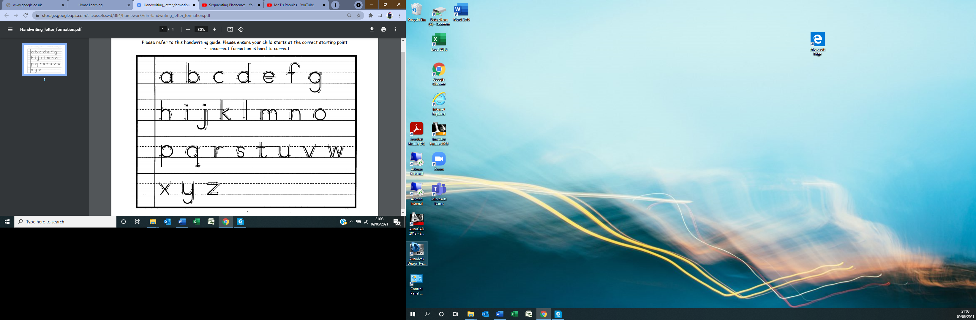

**High Frequency Words**

It is important for your child to become confident in recognising high frequency words. These are the words that appear most often in reading and it would interrupt your child’s reading fluency if they stopped to try and ‘sound out’ each high frequency word. In Primary One, we begin learning the pink word list and then move on to the red word list.

It is important for your child to know the words in ‘isolation’. This mean recognising each word on its own and not as part of a list. To practise this, please make sure you cut the laminated versions of the words up so they can be used and learned individually.

The more confident your child is at recognising words, the more confident they will become at recognising these words in their reading books.

A super link to a list of fun high frequency word games can be found below:

<https://www.youtube.com/playlist?list=PLw8ht3u1H9EX0T6HlXOETIuMumzI4dObi>

A video with illustrations to make some of our words more visually appealing can be found here:

<https://www.youtube.com/watch?v=Zd7tuu6lxQI>