Sentence Writing

Sentence writing is an important part of any child’s literacy journey.
I have collected some videos charts and activities which help to develop simple sentence writing skills. They also highlight important aspects of sentence level work such as, using capital letters and punctuation, learning simple sentence starters, using Hf words in our writing, rereading sentences to check for errors etc
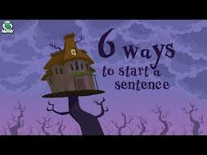
https://www.google.com/url?sa=t&rct=j&q=&esrc=s&source=web&cd=20&cad=rja&uact=8&ved=2ahUKEwjqrZCogMroAhXcTxUIHZiUDfQQwqsBMBN6BAgKEAQ&url=https%3A%2F%2Fwww.youtube.com%2Fwatch%3Fv%3DhQ1OwYu4GsY&usg=AOvVaw27lrs8a-BVnQWgISzuL6yK

Simple sentence starters which use high frequency words
