**HFW Rocket – Set 1**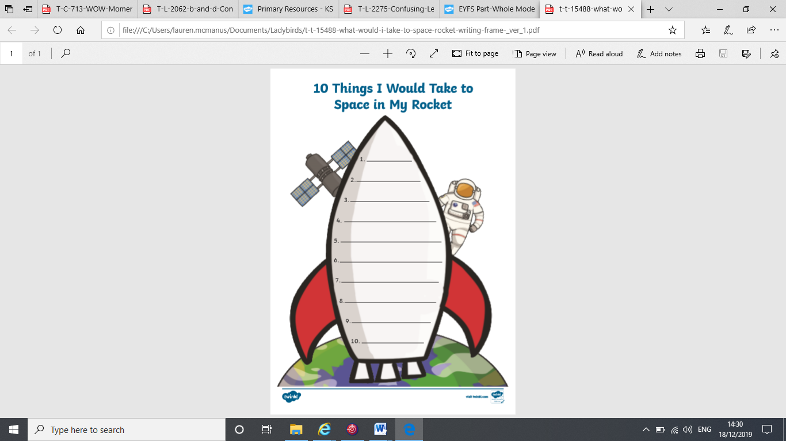Can you practise reading and writing these sight words every day?

**Mum**

**Dad**

**we**

**at**

**it**

**is**

**can**

**am**

**see**

**I**