**HFW Rocket – Set 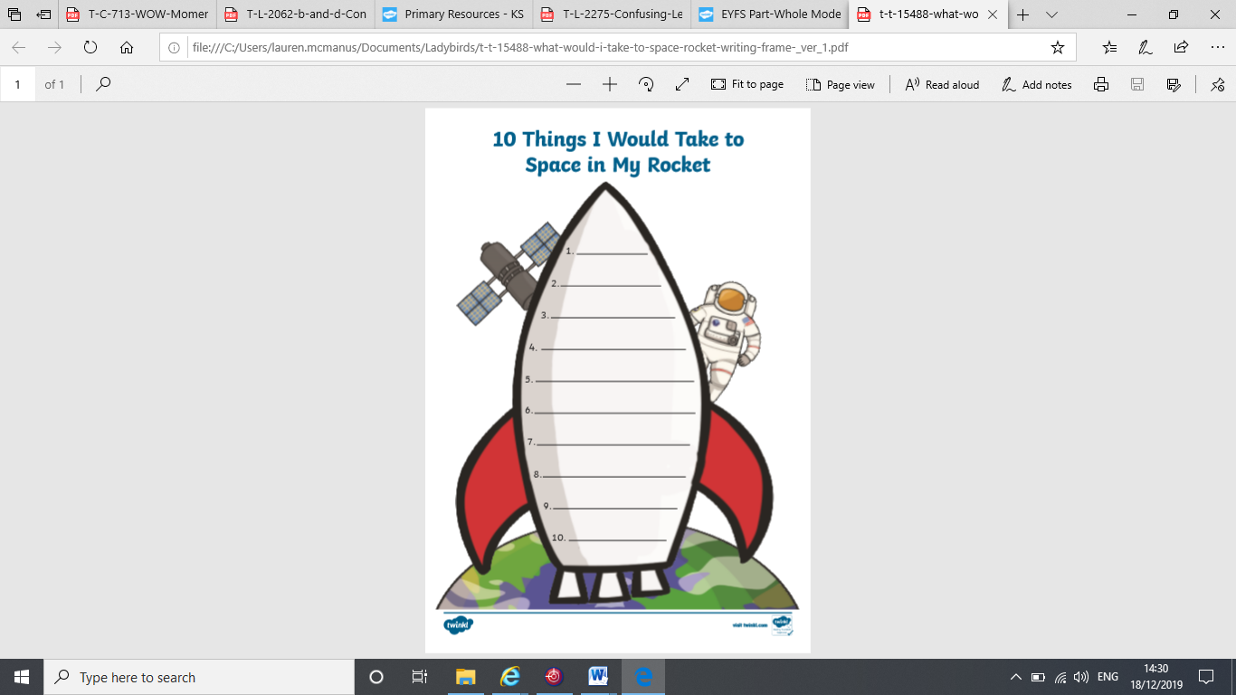2** Can you practise reading and writing these sight words every day?

**help**

**as**

**and**

**you**

**yes**

**no**

**not**

**look**

**in**

**here**