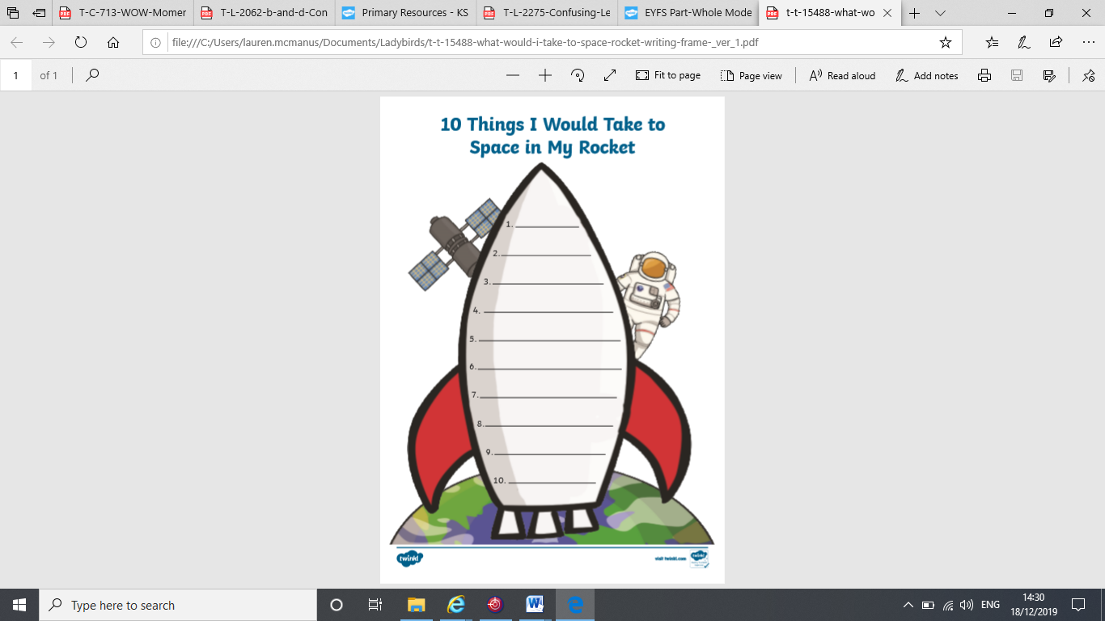**HFW Rocket – Set 3** Can you practise reading and writing these sight words every day?

**where**

**playy**

**go**

**come**

**big**

**to**

**want**

**the**

**are**

**my**