“Little Bo Peep” Lyrics
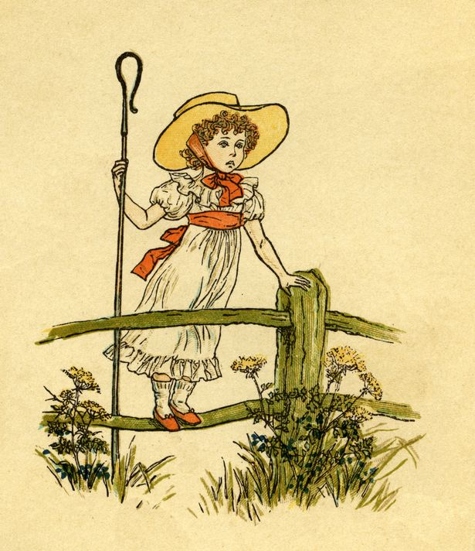
Little Bo peep has lost her sheep
And doesn’t know where to find them.
Leave them alone and they’ll come home,
Bringing their tails behind them.
Little Bo peep fell fast asleep
And dreamt she heard them bleating,
But when she awoke, she found it a joke,
For they were all still fleeting.
Then up she took her little crook
Determined for to find them.
She found them indeed, but it made her heart bleed,
For they left their tails behind them.
It happened one day, as Bo peep did stray
Into a meadow hard by,
There she espied their tails side by side
All hung on a tree to dry.
She heaved a sigh, and wiped her eye,
And over the hillocks went rambling,
And tried what she could,
As a shepherdess should.

https://www.youtube.com/watch?v=oQ1X7qc9sSs

Find any L/l’s in the rhyme.
Can you find any rhyming words such as could and should?
Tap, clap and stamp to the beat of the rhyme.
Recite the rhyme

