C:\Users\StewartA1\AppData\Local\Microsoft\Windows\Temporary Internet Files\Content.IE5\2DAYTAI7\EA Version 3 Logo for printing.tiff

**Colour Coded Timetable**

**Examples and Templates**

We have included some examples of how you can organise your timetable using colours.

Templates have been included which you can amend to suit your child’s specific school set up.

Remember it works best when you match the colour of your subject you choose for your timetable to the books you use for your subjects. You could use matching colour folders or add a colour strip to your books.

Example: A4 Timetable 11 period

**Monday**

**Tuesday**

**Wednesday**

**Thursday**

**Friday**

**Music**

**Double Award**

**Careers**

**Mathematics**

**English**

**Music**

**Double Award**

**Irish**

**Mathematics**

**English**

**Form Period**

**Mathematics**

**PE**

**French**

**Mathematics**

**English**

**English**

**Spanish**

**Spanish**

**Form Period**

**History**

**History**

**Lunch**

**Irish**

**French**

**Design/Tech**

**Design/Tech**

**English**

**Geography**

**Geography**

**Lunch**

**Spanish**

**French**

**Mathematics**

**English**

**PE**

**Double Award**

**Double Award**

**Lunch**

**Irish**

**History**

**RE**

**RE**

**Geography**

**Art/Design**

**Art/Design**

**Lunch**

**French**

**Irish**

**Double Award**

**Double Award**

**Mathematics**

**Spanish**

**RE**

**Lunch**

A4 Timetable 11 period Template

|  |  |  |  |  |  |
| --- | --- | --- | --- | --- | --- |
|  | **Monday** | **Tuesday** | **Wednesday** | **Thursday** | **Friday** |
|  |  |  |  |  |  |
|  |  |  |  |  |  |
|  |  |  |  |  |  |
|  |  |  |  |  |  |
|  |  |  |  |  |  |
|  |  |  |  |  |  |
|  |  |  |  |  |  |
|  |  |  |  |  |  |
|  |  |  |  |  |  |
|  |  |  |  |  |  |
|  |  |  |  |  |  |
|  |  |  |  |  |  |

Example: A4 Timetable 12 periods

**Technology**

**Maths**

**PD**

**Irish**

**Technology**

**Maths**

**Geography**

**RE**

**Irish**

**Home Economics**

**Geography**

**Art**

**Geography**

**Home Economics**

**Science**

**Art**

**LUNCH**

**LUNCH**

**LUNCH**

**LUNCH**

**Maths**

**Science**

**History**

**Science**

**Science**

**English**

**RE**

**Science**

**Science**

**English**

**English**

**Geography**

**English**

**Careers**

**Maths**

**English**

**English**

**RE**

**Maths**

**English**

**RE**

**History**

**Italian**

**Music**

**French**

**French**

**Irish**

**Music**

**Maths**

**Maths**

**History**

**History**

**LUNCH**

**French**

**Science**

**Science**

**PE**

**PE**

**PE**

**Italian**

**Friday**

**Thursday**

**Wednesday**

**Tuesday**

**Monday**

A4 Timetable 12 periods Template

|  |  |  |  |  |  |
| --- | --- | --- | --- | --- | --- |
|  | **Monday** | **Tuesday** | **Wednesday** | **Thursday** | **Friday** |
|  |  |  |  |  |  |
|  |  |  |  |  |  |
|  |  |  |  |  |  |
|  |  |  |  |  |  |
|  |  |  |  |  |  |
|  |  |  |  |  |  |
|  |  |  |  |  |  |
|  |  |  |  |  |  |
|  |  |  |  |  |  |
|  |  |  |  |  |  |
|  |  |  |  |  |  |
|  |  |  |  |  |  |
|  |  |  |  |  |  |

A4 Timetable Template 8 Periods

Example: Colour Coded Timetable with supporting images.

|  |  |  |  |  |  |
| --- | --- | --- | --- | --- | --- |
|  | 1 Monday | 1 Tuesday | 1 Wednesday | 1 Thursday | 1 Friday |
| 1 | Library | English  http://regentsparkcollege.org.uk/wp-content/uploads/2017/01/english-subject-clipart-clipart-panda-free-clipart-images-jfvihk-clipart.gif | Technology | History  http://www.northcave-school.co.uk/sampled/2557887/930/0/notbigger | Maths  http://maths-teacher.co.uk/images/maths-teacher-uxbridge.png |
| 2 | HE | Maths  http://maths-teacher.co.uk/images/maths-teacher-uxbridge.png | Geography  https://3hzqtk1fl9rx1oeesj3uzf0y-wpengine.netdna-ssl.com/wp-content/uploads/2017/02/oup_22335.jpg | PE | Irish |
| Break | http://moziru.com/images/coffee-clipart-break-time-3.jpg | http://moziru.com/images/coffee-clipart-break-time-3.jpg | http://moziru.com/images/coffee-clipart-break-time-3.jpg | http://moziru.com/images/coffee-clipart-break-time-3.jpg | http://moziru.com/images/coffee-clipart-break-time-3.jpg |
| 3 | History  http://www.northcave-school.co.uk/sampled/2557887/930/0/notbigger | Geography  https://3hzqtk1fl9rx1oeesj3uzf0y-wpengine.netdna-ssl.com/wp-content/uploads/2017/02/oup_22335.jpg | RE  http://www.lscprom.co.uk/wp-content/uploads/2015/11/Ov3z0FoR7aGvYF751rQZ_Discussing-Freedom-of-Religion-or-Belief.png | Math  http://maths-teacher.co.uk/images/maths-teacher-uxbridge.png | PE |
| 4 | RE  http://www.lscprom.co.uk/wp-content/uploads/2015/11/Ov3z0FoR7aGvYF751rQZ_Discussing-Freedom-of-Religion-or-Belief.png | Science  http://www.st-ives.cornwall.sch.uk/wp-content/uploads/2016/11/Science.jpg | Spanish | Science  http://www.st-ives.cornwall.sch.uk/wp-content/uploads/2016/11/Science.jpg | English  http://regentsparkcollege.org.uk/wp-content/uploads/2017/01/english-subject-clipart-clipart-panda-free-clipart-images-jfvihk-clipart.gif |
| Lunch | http://images.clipartpanda.com/kids-lunch-time-clipart-yckee7yoi.gif | http://images.clipartpanda.com/kids-lunch-time-clipart-yckee7yoi.gif | http://images.clipartpanda.com/kids-lunch-time-clipart-yckee7yoi.gif | http://images.clipartpanda.com/kids-lunch-time-clipart-yckee7yoi.gif | http://images.clipartpanda.com/kids-lunch-time-clipart-yckee7yoi.gif |
| 5 | Drama | Spanish | English  http://regentsparkcollege.org.uk/wp-content/uploads/2017/01/english-subject-clipart-clipart-panda-free-clipart-images-jfvihk-clipart.gif | Art  http://smart-defence.co.uk/wp-content/uploads/2015/03/art.jpg | Science  http://www.st-ives.cornwall.sch.uk/wp-content/uploads/2016/11/Science.jpg |
| 6 | French | Irish | Science  http://www.st-ives.cornwall.sch.uk/wp-content/uploads/2016/11/Science.jpg | HE | Music |

Example: Pocket Timetables -8 Periods

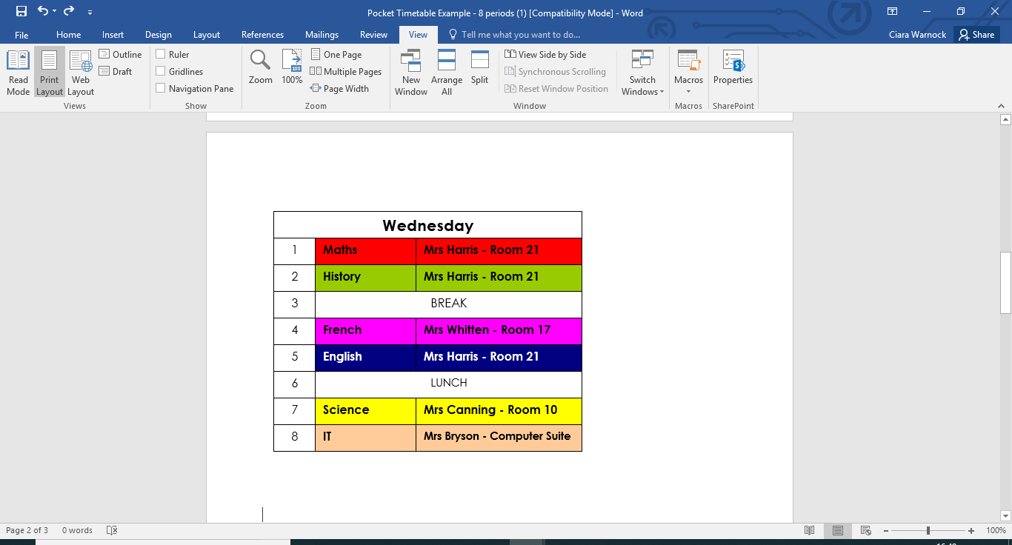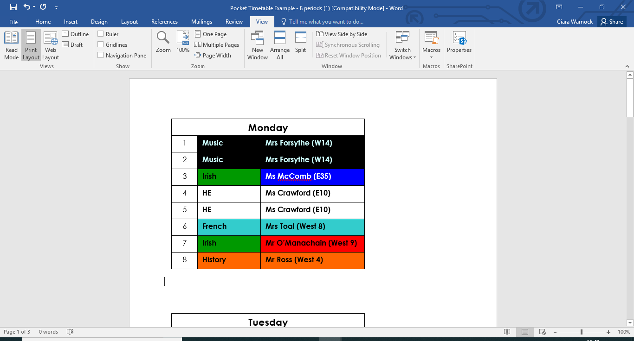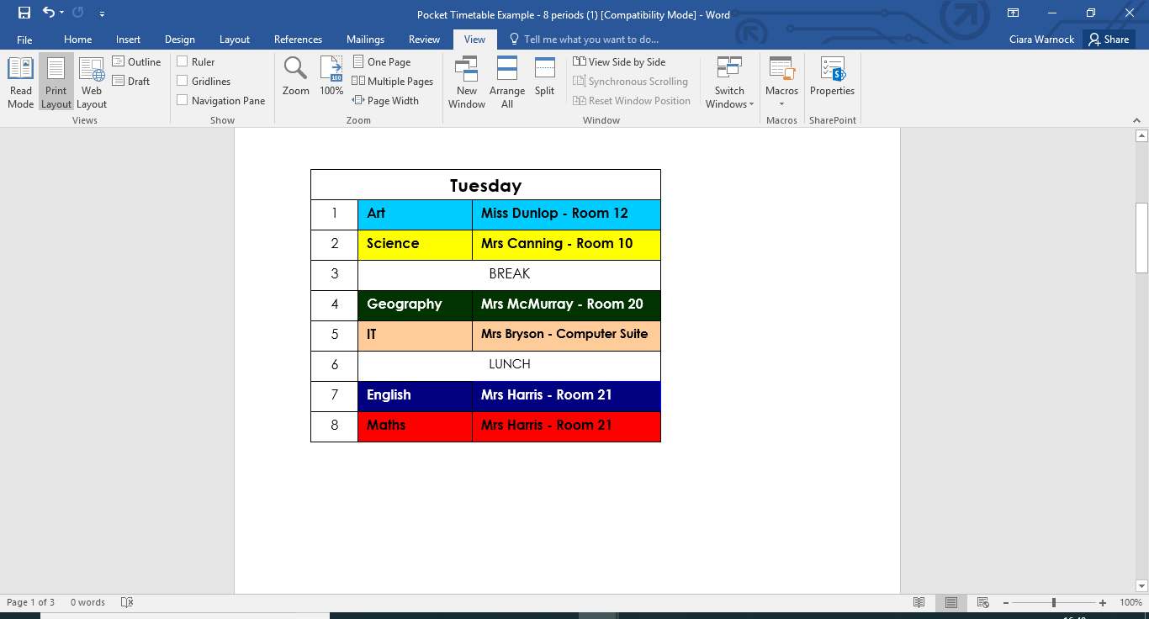

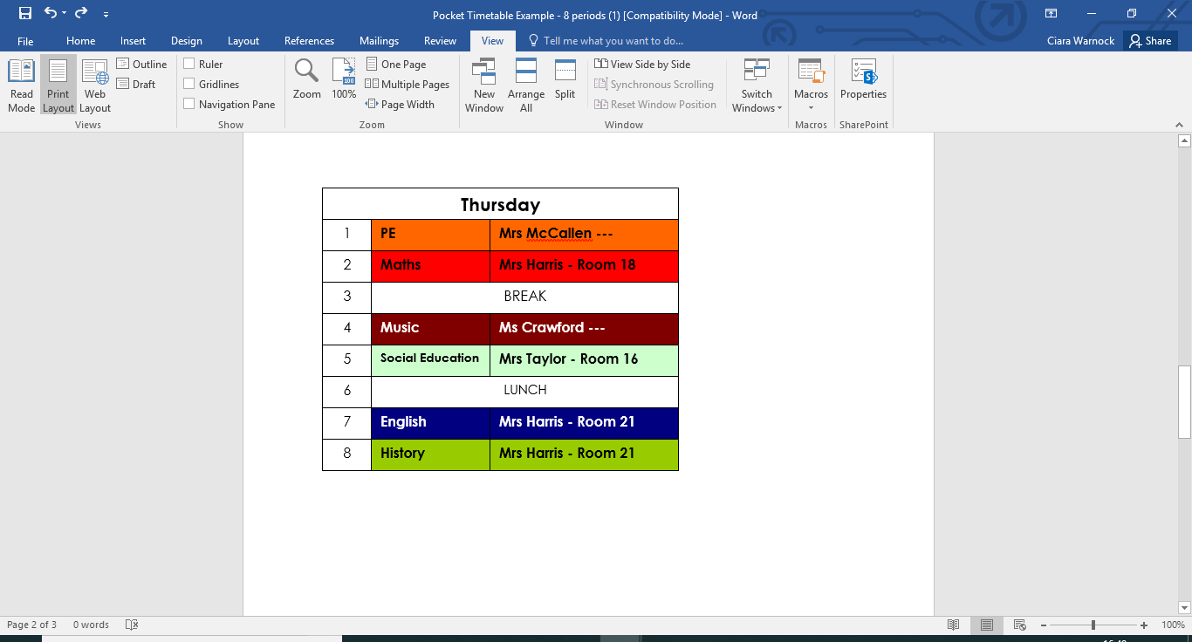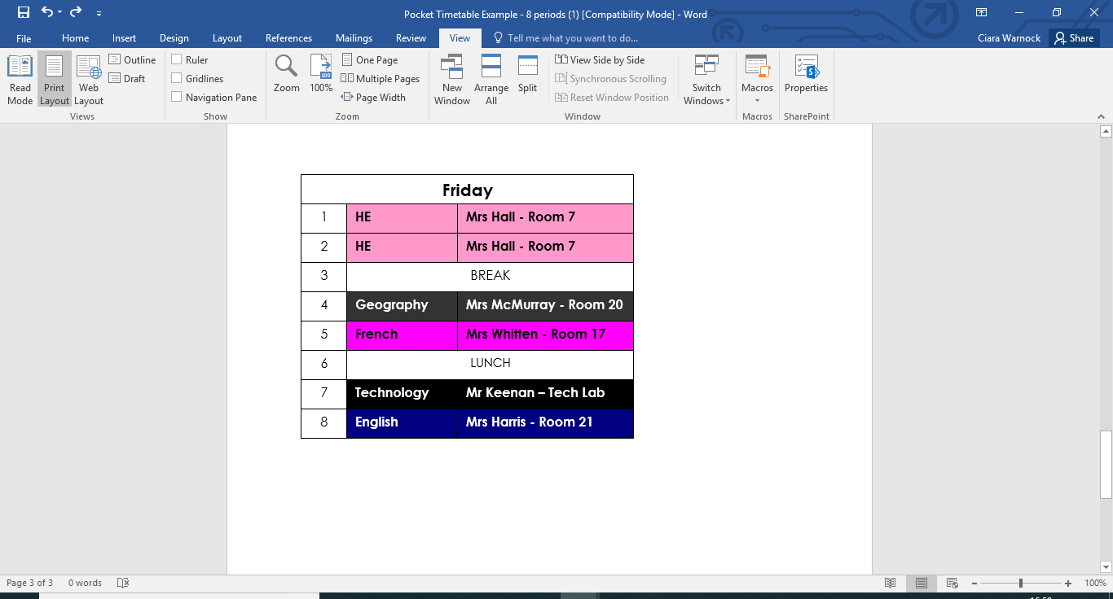

Pocket Size Timetable 8 periods template

|  |  |  |
| --- | --- | --- |
|  | **Wednesday** | |
| **1** |  |  |
| **2** |  |  |
| **3** |  |  |
| **4** |  |  |
| **5** |  |  |
| **6** |  |  |
| **7** |  |  |
| **8** |  |  |

|  |  |  |
| --- | --- | --- |
|  | **Monday** | |
| **1** |  |  |
| **2** |  |  |
| **3** |  |  |
| **4** |  |  |
| **5** |  |  |
| **6** |  |  |
| **7** |  |  |
| **8** |  |  |

|  |  |  |
| --- | --- | --- |
|  | **Tuesday** | |
| **1** |  |  |
| **2** |  |  |
| **3** |  |  |
| **4** |  |  |
| **5** |  |  |
| **6** |  |  |
| **7** |  |  |
| **8** |  |  |

|  |  |  |
| --- | --- | --- |
|  | **Thursday** | |
| **1** |  |  |
| **2** |  |  |
| **3** |  |  |
| **4** |  |  |
| **5** |  |  |
| **6** |  |  |
| **7** |  |  |
| **8** |  |  |

|  |  |  |
| --- | --- | --- |
|  | **Friday** | |
| **1** |  |  |
| **2** |  |  |
| **3** |  |  |
| **4** |  |  |
| **5** |  |  |
| **6** |  |  |
| **7** |  |  |
| **8** |  |  |

Pocket Size Timetable 12 Periods part 1

|  |  |  |
| --- | --- | --- |
|  | **Tuesday** | |
| **1** |  |  |
| **2** |  |  |
| **3** |  |  |
| **4** |  |  |
| **5** |  |  |
| **6** |  |  |
| **7** |  |  |
| **8** |  |  |
| **9** |  |  |
| **10** |  |  |
| **11** |  |  |
| **12** |  |  |

|  |  |  |
| --- | --- | --- |
|  | **Wednesday** | |
| **1** |  |  |
| **2** |  |  |
| **3** |  |  |
| **4** |  |  |
| **5** |  |  |
| **6** |  |  |
| **7** |  |  |
| **8** |  |  |
| **9** |  |  |
| **10** |  |  |
| **11** |  |  |
| **12** |  |  |

|  |  |  |
| --- | --- | --- |
|  | **Monday** | |
| **1** |  |  |
| **2** |  |  |
| **3** |  |  |
| **4** |  |  |
| **5** |  |  |
| **6** |  |  |
| **7** |  |  |
| **8** |  |  |
| **9** |  |  |
| **10** |  |  |
| **11** |  |  |
| **12** |  |  |

Pocket Size Timetable 12 Periods part 2

|  |  |  |
| --- | --- | --- |
|  | **Friday** | |
| **1** |  |  |
| **2** |  |  |
| **3** |  |  |
| **4** |  |  |
| **5** |  |  |
| **6** |  |  |
| **7** |  |  |
| **8** |  |  |
| **9** |  |  |
| **10** |  |  |
| **11** |  |  |
| **12** |  |  |

|  |  |  |
| --- | --- | --- |
|  | **Thursday** | |
| **1** |  |  |
| **2** |  |  |
| **3** |  |  |
| **4** |  |  |
| **5** |  |  |
| **6** |  |  |
| **7** |  |  |
| **8** |  |  |
| **9** |  |  |
| **10** |  |  |
| **11** |  |  |
| **12** |  |  |