Home School directions 23th march- 3rd April 2020

Léitheoireacht / Reading

This Photo by Unknown Author is licensed under CC BY-SA

Your child is using ‘Clár Luathléitheoireachta’. Extra reading books will be sent home and all support materials are on-line (see links under pupil space on website).
‘Féasta focal’ workbooks can also be used to consolidate high frequency words as well as the ‘Féasta focal’ snakes and ladders game.
Foghlaí Mara is a good site to play games with high frequency words
Continue to practice sight words and play games using these words such as
Roll and Cover, 4 in a row, Snakes and ladders, Snap, Pelmanism and Bingo.

Teach Your Monster to Read – good for English reading

Fónaic / Phonics
This Photo by Unknown Author is licensed under CC BY-ND


To revise initial sounds we have been using a programme called ‘Fónaic na Gaeilge’ that can be found on léighleat.com.

Follow the links for ‘ceachtanna’.
- Fónaic - Uladh, then press the relevant letter sound.
- You could also check out ‘Focail is coitianta’ and ‘cluas fhoghlama’.

We are also using Cód na Gaeilge- Rang 2 CCEA This is also on line.

Children have been given the appropriate workbooks.

Scríbhneóireacht/ Writing

This Photo by Unknown Author is licensed under CC BY-SA-NC

Your child is beginning to write sentences independently with help from wordbook. Encourage your child to do this using his/her smartpal.
I have also included a sequencing story workbook to improve sentence and story order.
Reading activities based on reading book are very useful as well as simple comprehensions- answering questions
Your child is beginning to write on lines; learn about tall, small and hanging letters. Further guidance will follow on this

Uimhearthacht / Numeracy
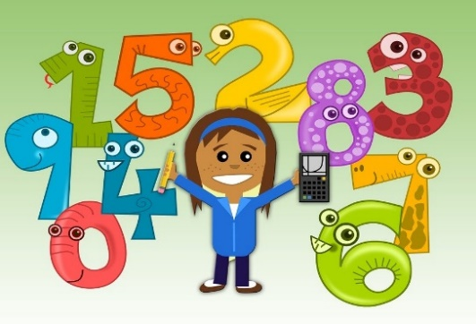

We are coming to the end of our Feb/March planner. We had been working on:
- Counting in 2s within 20
- Doubles to 10
- Odd and even numbers – looking for patterns;
- Putting different numbers of objects out to find which numbers cannot be put in pairs
- odd/even numbers that end in 0 2 4 6 8 (even nos.) or in 1 3 5 7 9 (odd nos.)

- Knowing number bonds to 10
- Understanding the empty box sum in relation to number bonds,
e.g. 5 + = 10.

- Word problems/ word stories using addition and subtraction with in 20
- Money activities – work out change from 5p or 10p. Find totals up to 20p.
- Telling the Time – o’ clock and half past the hour.
- Class Block graphs.
- Following directions – right and left.
- Positional language – above, below, between etc.

Use ‘Mathletics’ wisely to consolidate work already taught. Your child has password to log in.

Check out ‘Sumdog’ also. You need to register for this but it is free

‘Topmarks’ is very good for practicing and consolidating.
5 – 7 Years – choose category: Counting, Shapes, Measures etc.

Scileanna Mínluaile / Fine Motor Skills

We encourage the further development of fine motor skills by employing such things as:
- threading,
- cutting and tearing paper,
- picking up things with pegs or tongs
- pressing and manipulating playdough.
We ask you to incorporate these activities into home life.

Other useful websites for Rang 2

You will find these under links and many more in Spás daltaí on school website

https://www.teachyourmonstertoread.com/

https://m.soundcloud.com/search?q=walker%20eireann

phonicsplay.co.uk username: march20 password: home
worldbook.kitaboo.com
Tellyscealta
Also Vooks, relief teaching ideas, coolmaths, tellyscéalta to be added shortly

These websites are offering free subscription for the month
Twinkl password:IRLTWINKLHELPS
Twinkl – parents can sign up to Twinkl for free during the Coronavirus outbreak. They have created packs for each keystage which are free to download after you register. They have lots of fun educational resources and also have Irish Medium resources for lots of topics!
Dabbledoo music - similiar

Check out the following on youtube
Bongo Bongo TV Nursery Rhymes – Have a range of rhymes/songs translated into Irish.
DIY Mammy (Irish educational videos)
TG Lurgan (Chart songs translated in Irish and sung).

This list will be added to over the coming weeks

I would recommend use of smartpals ( plastic wallets for worksheets that can be used over and over again) These can be purchased on Amazon.

