|  |
| --- |
| **Home School Guidance 6**  **Rang 3**  A thuismitheoirí,  I hope everyone is getting on well with the packs. Remember you can message me at any time for help or guidance and I’ll get back to you as soon as I can.  I will continue to upload links to online reading, games and maths games on Class Dojo and I will also post some stories in Irish for Rang 3 to listen to.  Remember there are links on the school website to listen to class songs, poems and also some audio to go along with their work packs.  Please feel free to share pictures of and work or any other fun activities you have been up to at home. If you would like us to share these on the school Facebook page or the school website, please feel free to tag us online.  Pictures for the website can be emailed to [animhaolomhair107@c2kni.net](mailto:animhaolomhair107@c2kni.net)  Or sent via Class Dojo.  Go raibh maith agaibh,  Múinteoir Aisling    [This Photo](https://5thgradefiles.wordpress.com/2014/12/01/class-dojo-isnt-the-problem-we-are/) by Unknown Author is licensed under [CC BY](https://creativecommons.org/licenses/by/3.0/) |

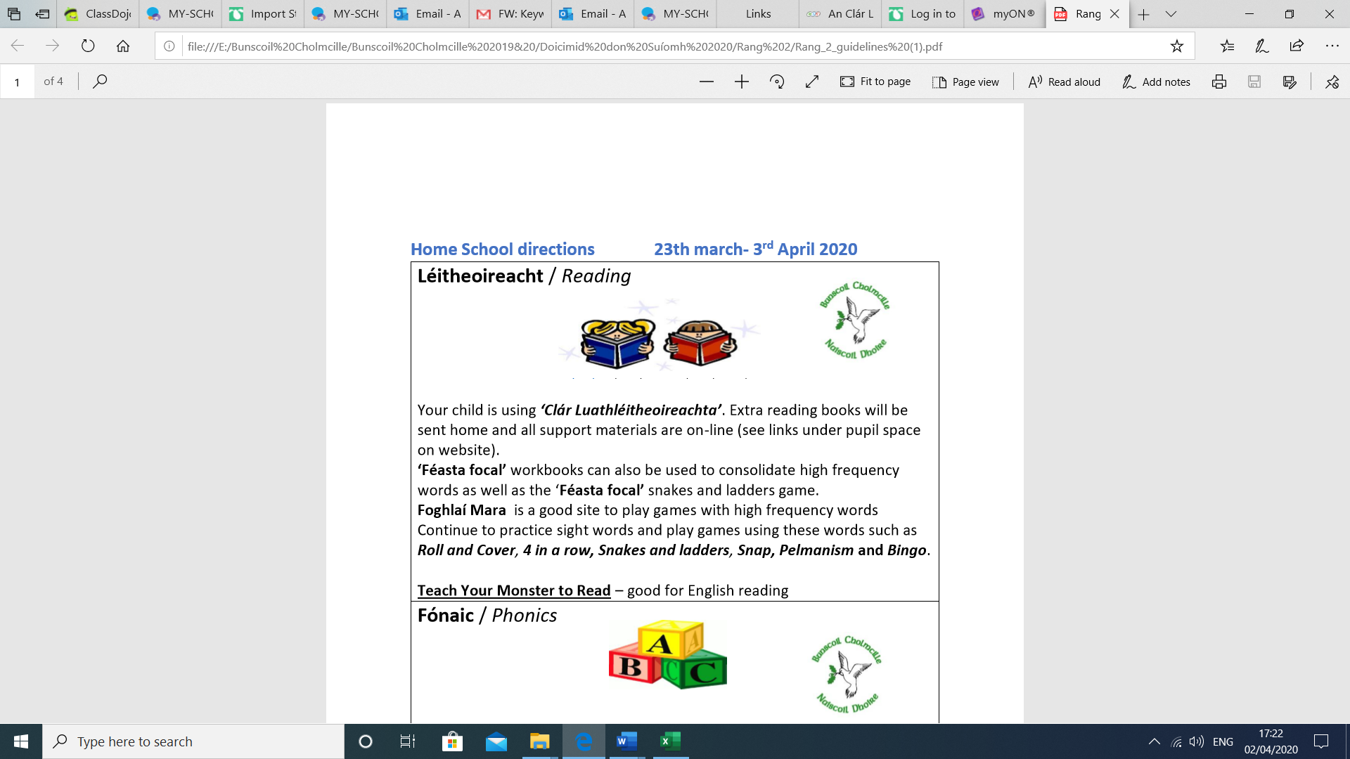

**Mata/ Maths**

Links to Online Learning for Maths  
  
Here are some links to online maths activities to help consolidate R3's learning.  
  
**Revise number patterns**

<https://ie.ixl.com/math/class-1/hundred-chart>  
<https://ie.ixl.com/math/class-1/skip-counting-patterns-with-tables>

<https://ie.ixl.com/math/class-1/put-numbers-in-order>  
  
**Practise subtraction skills**

<https://ie.ixl.com/math/class-1/make-a-number-using-subtraction-numbers-up-to-10>

<https://ie.ixl.com/math/class-1/subtraction-sentences-using-number-lines-numbers-up-to-18>

**Telling the Time**

The titles below are hyperlinks – Press CTRL and click on them to open!

1. **V.1**

[Match analogue clocks and times](https://ie.ixl.com/math/class-1/match-analogue-clocks-and-times)

1. **V.2**

[Match digital clocks and times](https://ie.ixl.com/math/class-1/match-digital-clocks-and-times)

1. **V.3**

[Match analogue and digital clocks](https://ie.ixl.com/math/class-1/match-analogue-and-digital-clocks)

1. **V.4**

[Read clocks and write times](https://ie.ixl.com/math/class-1/read-clocks-and-write-times)

1. **V.5**

[A.M. or P.M.](https://ie.ixl.com/math/class-1/am-or-pm)

1. **V.6**

[Times of everyday events](https://ie.ixl.com/math/class-1/times-of-everyday-events)

1. **V.7**

[Compare clocks](https://ie.ixl.com/math/class-1/compare-clocks)

1. **V.8**

[Time and clocks: word problems](https://ie.ixl.com/math/class-1/time-and-clocks-word-problems)

1. **V.9**

[Elapsed time I](https://ie.ixl.com/math/class-1/elapsed-time)

1. **V.10**

[Elapsed time II](https://ie.ixl.com/math/class-1/elapsed-time-ii)

1. **V.11**

[Seasons of the year](https://ie.ixl.com/math/class-1/seasons-of-the-year)

1. **V.12**

[Days of the week](https://ie.ixl.com/math/class-1/days-of-the-week)

1. **V.13**

[Months of the year](https://ie.ixl.com/math/class-1/months-of-the-year)

1. **V.14**

[Read a calendar](https://ie.ixl.com/math/class-1/read-a-calendar)

**Counting and grouping in 10s**

<https://ie.ixl.com/math/class-1/estimate-to-the-nearest-ten>

**Addition Practice**

<https://ie.ixl.com/math/class-1/add-two-two-digit-numbers-without-regrouping>

**Comparing Numbers**

Press CTRL and click to open links below.

1. **J.1**

[Comparing - review](https://ie.ixl.com/math/class-1/comparing-review)

1. **J.2**

[Comparing numbers up to 10](https://ie.ixl.com/math/class-1/comparing-numbers-up-to-10)

1. **J.3**

[Comparing numbers up to 100](https://ie.ixl.com/math/class-1/comparing-numbers-up-to-100)

**Litearthacht/Literacy**

**Talking and Listening:**

* Practice your songs and poems every day. (See website for links)
* Watch and listen to videos sent on Dojo and use the links on the school website
* Listen to a story in Irish every day. Ask your child to tell you what happened in the story, who were the characters etc… <https://soundcloud.com/search?q=walker%20eireann> (Sound only)

<https://www.bbc.co.uk/programmes/b00tr700> (Video stories)

* Read stories in English or Irish and talk about what happened. Ask the children to retell the story to you in Irish!
* Free stories available at <https://readon.myon.co.uk/> (Look under ‘Genre’ for fiction)

**Writing:**

* Continue to use Dialann Obair Bhaile as a diary. They could write one or two sentences each day about one thing they did and how they feel.

e.g. Inniu bhí mé ag dathú isteach. Mhothaigh mé sásta.

*“In-yoo vee may igg da-hu isschock. Waw-hee may sa-sta”*

*Today I was colouring in. I felt happy.*

* Complete work in packs – one page of Literacy and Maths a day. Some of the activities will have an accompanying voice note/video on the website/ClassDojo
* Write out the stories you listen too in your own words.

**Reading:**

**Seideán Sí** – <https://seideansi.ie/rang1.php> (ROI Rang 1 is our R3 equivalent)

Copy and paste this link to your browser and play Irish reading games

WEEK 12 :   
Treasure Hunt - Hold your finger down to guide the character into the balloons then choose the correct word.  
<https://seideansi.ie/rang1/gniomhaiocht-1/1/m/ceim3/>  
  
Cá Bhfuil mo Dhinnéar? / Where is My Dinner?  
Order the words to make the sentence you hear..  
<https://seideansi.ie/rang1/gniomhaiocht-2/L1/1/V3/Ceim%203/Cabhfuilmodhinnear/>

WEEK 13:

Treasure Hunt - Hold your finger down to guide the character into the balloons then choose the correct word.  
<https://seideansi.ie/rang1/gniomhaiocht-1/1/m/ceim3/>

Rainn agus Amhráin / Songs and Rhymes  
Put the words in order to make the sentence you hear.  
<https://seideansi.ie/rang1/gniomhaiocht-2/L1/1/V3/Ceim%203/RainnagusAmhrain/>

**Léigh Anois** – Go on this website and let the children explore and read their own reading books! [www.leighanois.com](http://www.leighanois.com) (Choose Ulster dialect)

[**https://www.leighanois.com/leabhair.php?banda=2**](https://www.leighanois.com/leabhair.php?banda=2)

[**https://www.leighanois.com/leabhair.php?banda=3**](https://www.leighanois.com/leabhair.php?banda=3)

[**https://www.leighanois.com/leabhair.php?banda=4**](https://www.leighanois.com/leabhair.php?banda=4)

**An Chlár Luathléitheoireachta** – <http://feedback.ccea.org.uk/curriculum/gaeloideachas/bhonnchéim/réimsí_foghlama/teanga_agus_litearthacht/an_clár>

Play games based on the reading books we use in school. Rang 3 should use Cluichí Bhanda 2 & Cluichí Bhanda 3

**Lexia –** TARGET – 1 Hour per week on Lexia to earn a certificate. Anyone who completes their full hour per week will be rewarded with Dojo Lexia Points.



**Ceol/Music**



[This Photo](http://www.pngall.com/summer-png) by Unknown Author is licensed under [CC BY-NC](https://creativecommons.org/licenses/by-nc/3.0/)

**Na Laethanta Saoire**

Caith uait do mhála scoile mar níl sé uait níos mó

Caith isteach sa chófra é fág é go dtí Meán Fómhair

Téigh amach ag súgradh is téigh amach ag spraoi

Téigh amach ag imirt péile nó ag luascadh ó na crainn

Is féidir dul ag iascaireacht nó is féidir dul ag snámh



[This Photo](http://thecuppajo.blogspot.com/2011/05/summertime.html) by Unknown Author is licensed under [CC BY-ND](https://creativecommons.org/licenses/by-nd/3.0/)

Mar tá na laethanta saoire anseo

Bain díot d’éadaí scoile mar níl sé uait níos mó

Caith isteach sa chófra iad fág iad go dtí Meán Fómhair

Téigh amach ag súgradh is téigh amach ag spraoi

Téigh amach ag imirt peile nó ag luascadh ó na crainn

Is féidir dul ag rothaíocht nó is féidir dul ag snámh

Mar tá na laethanta saoire anseo

Is féidir dul ag marcaíocht nó is féidir dul ag snámh

Mar tá na laethanta saoire anseo!



[This Photo](http://samogaathome.blogspot.com/2013/06/sports-worksheet.html) by Unknown Author is licensed under [CC BY-NC-ND](https://creativecommons.org/licenses/by-nc-nd/3.0/)

**Class Poem**

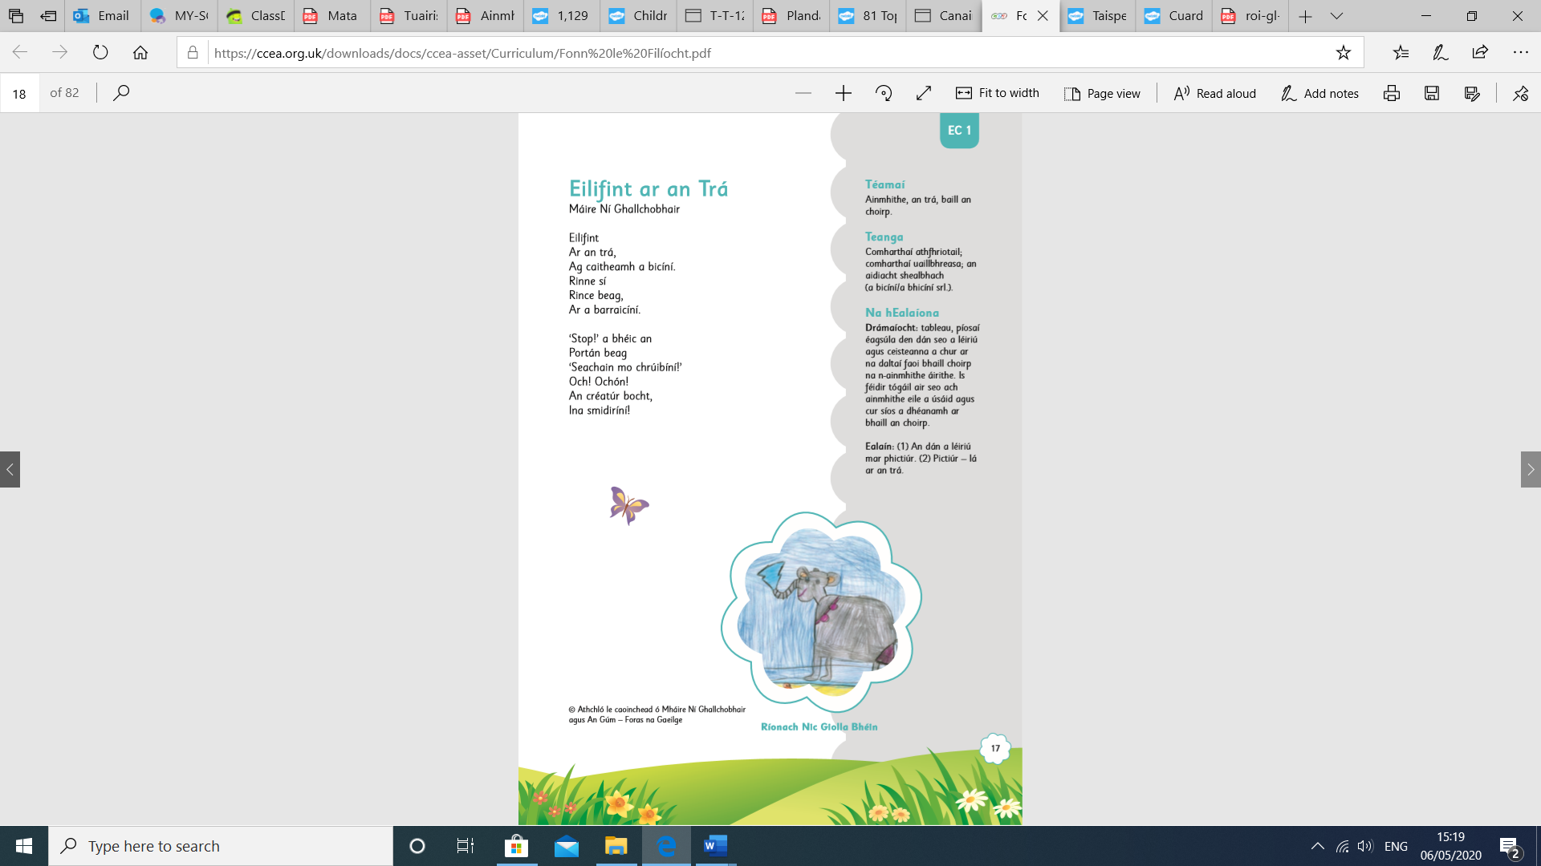

**Corpoideachas/P.E.**

It’s important to keep active every day at home. If you have a garden, let the children out to run around and play to burn off some energy. There are lots of online activities for PE on YouTube.

* Virtual Sports Day

<https://www.bunscoilcholmcille.com/news/l-spirt-shamhalta--virtual-sports-day-2020/?p=2&tags=,1081,>

* Keep an eye on Class Dojo for our Sports Day activities!!



[This Photo](http://iktannis.blogspot.com/2013/03/pyt-praktisk-yrkesteori.html) by Unknown Author is licensed under [CC BY-SA-NC](https://creativecommons.org/licenses/by-nc-sa/3.0/)

**Daily Activities**

😊 **Spellings:**

*Please message Múinteoir Aisling via ClassDojo if you need help with pronunciation or translation.*

Continue to use the homework booklet to practise spellings every day. You could also hold a ‘spelling test’ at home on Fridays!

😊 **Reading:**

**Irish – Monday, Wednesday and Friday**

**Seideán Sí** – <https://seideansi.ie/rang1.php>

Copy and paste this link to your browser and play Irish reading games

**An Chlár Luathléitheoireachta** – <http://feedback.ccea.org.uk/curriculum/gaeloideachas/bhonnchéim/réimsí_foghlama/teanga_agus_litearthacht/an_clár>

Play games based on the reading books we use in school. Rang 3 should use Cluichí Bhanda 2 & Cluichí Bhanda 3

**English – Tuesday&Thursday–** Lexia – Aim to spend at least 1 hour on Lexia each week. Certificates can be earned which I will email to parents. Every child who spends 60minutes on lexia will also be rewarded with a Class Dojo point.

😊 **Phonics:**

**Irish**

**-** Download the free Cód na Gaeilge app and play at least one game per day

- Continue to complete 1 page of Cód na Gaeilge book per day

**English**

**-**Complete 1 page of High Frequency Words booklet every day

-Try reading some books in English on MyON for free - <https://readon.myon.co.uk/>

😊 **Key Words**:

**Irish**

Visit Féasta Focal website and complete at least one activity per day to consolidate key words.

**\*\*Focus on words 101 – 120\*\***

**English**

Play games on this website to reinforce key words in English.

<https://www.education.com/games/sight-words/>