
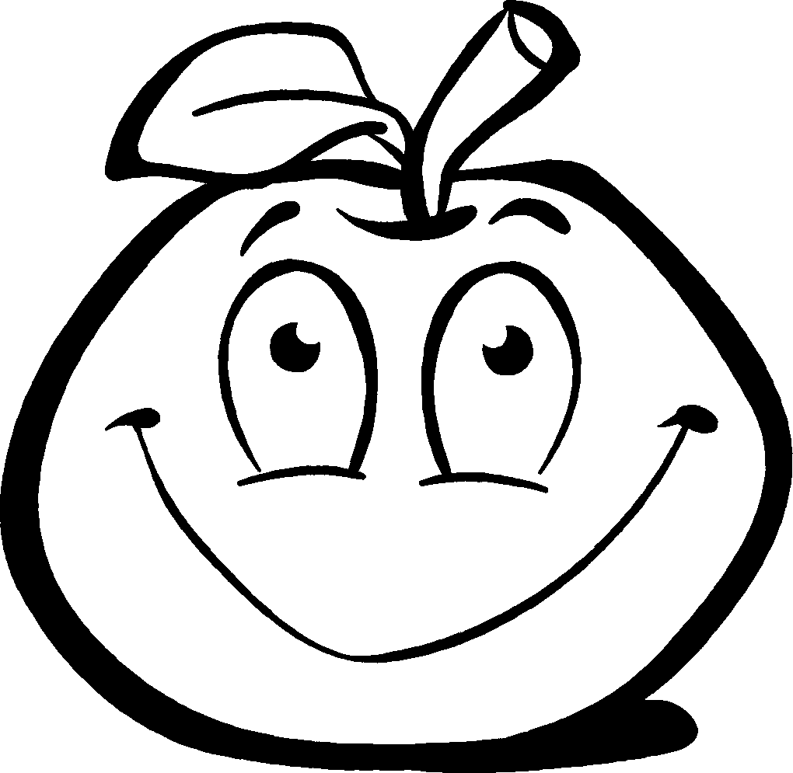
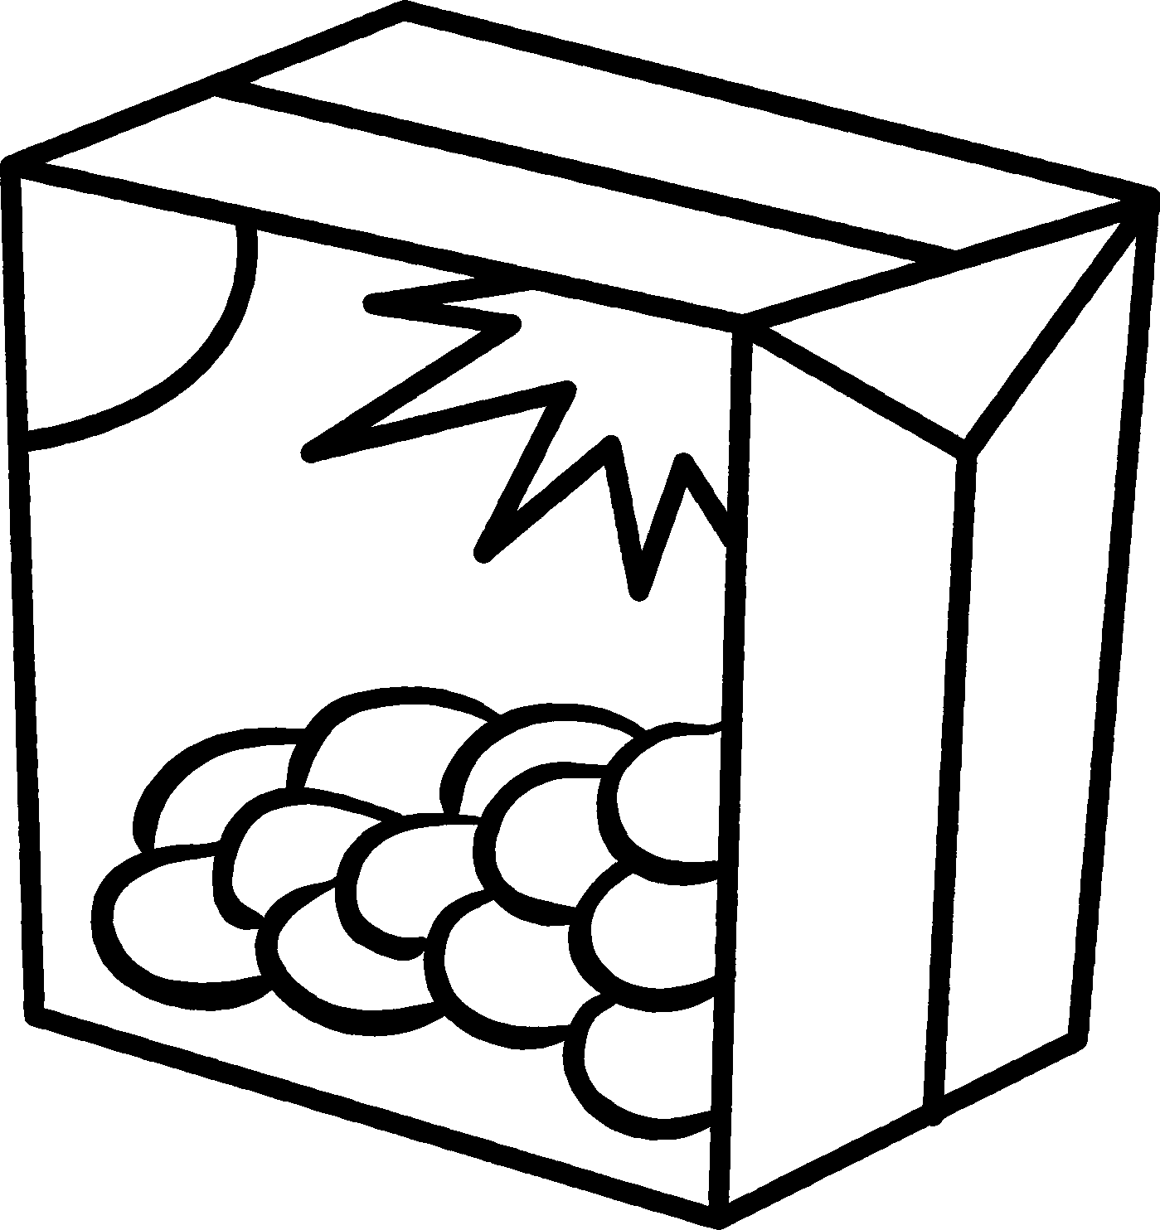
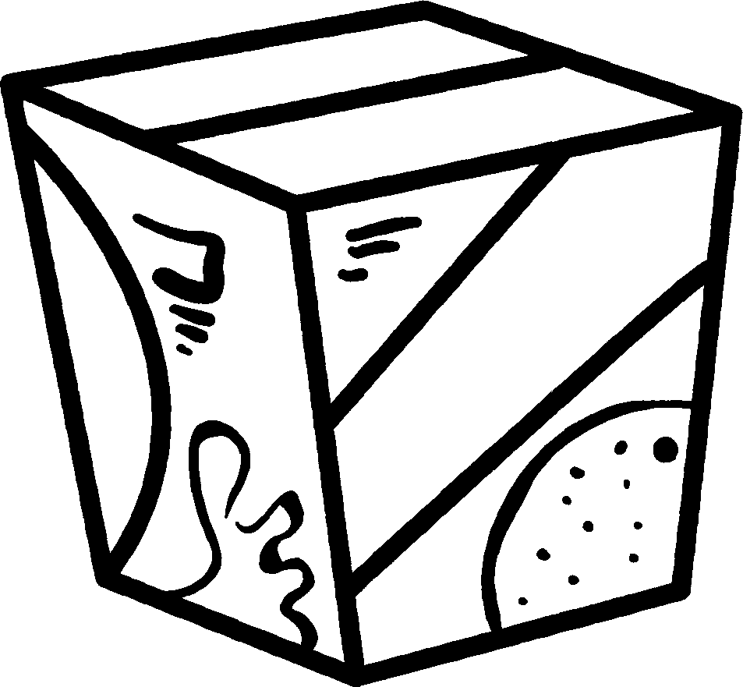
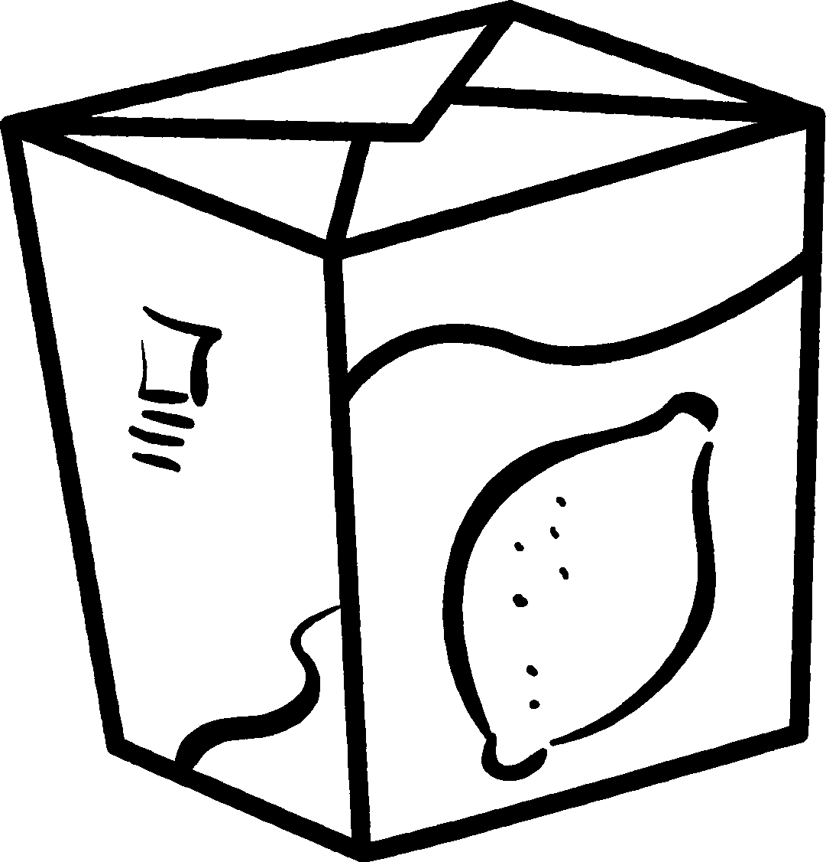
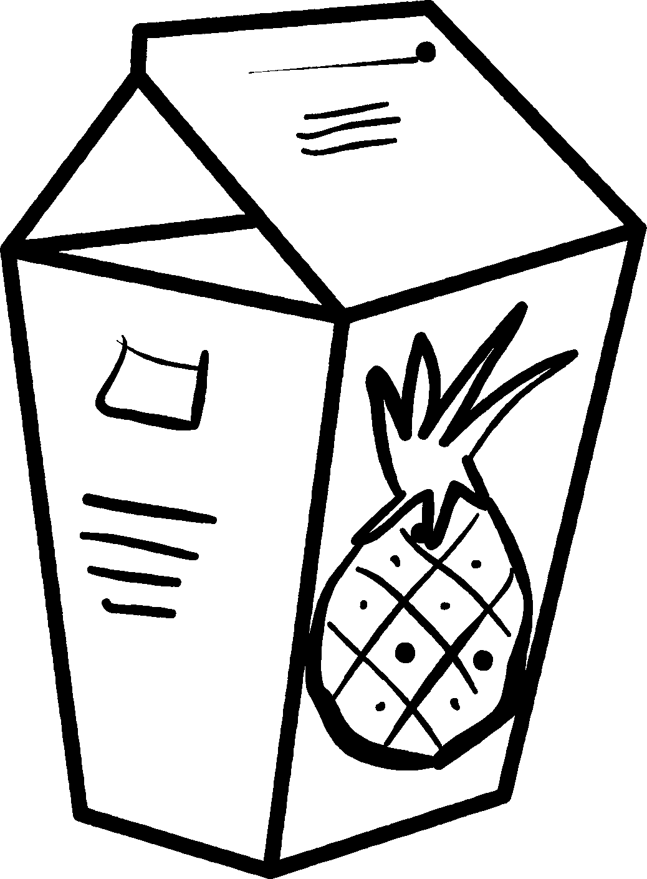
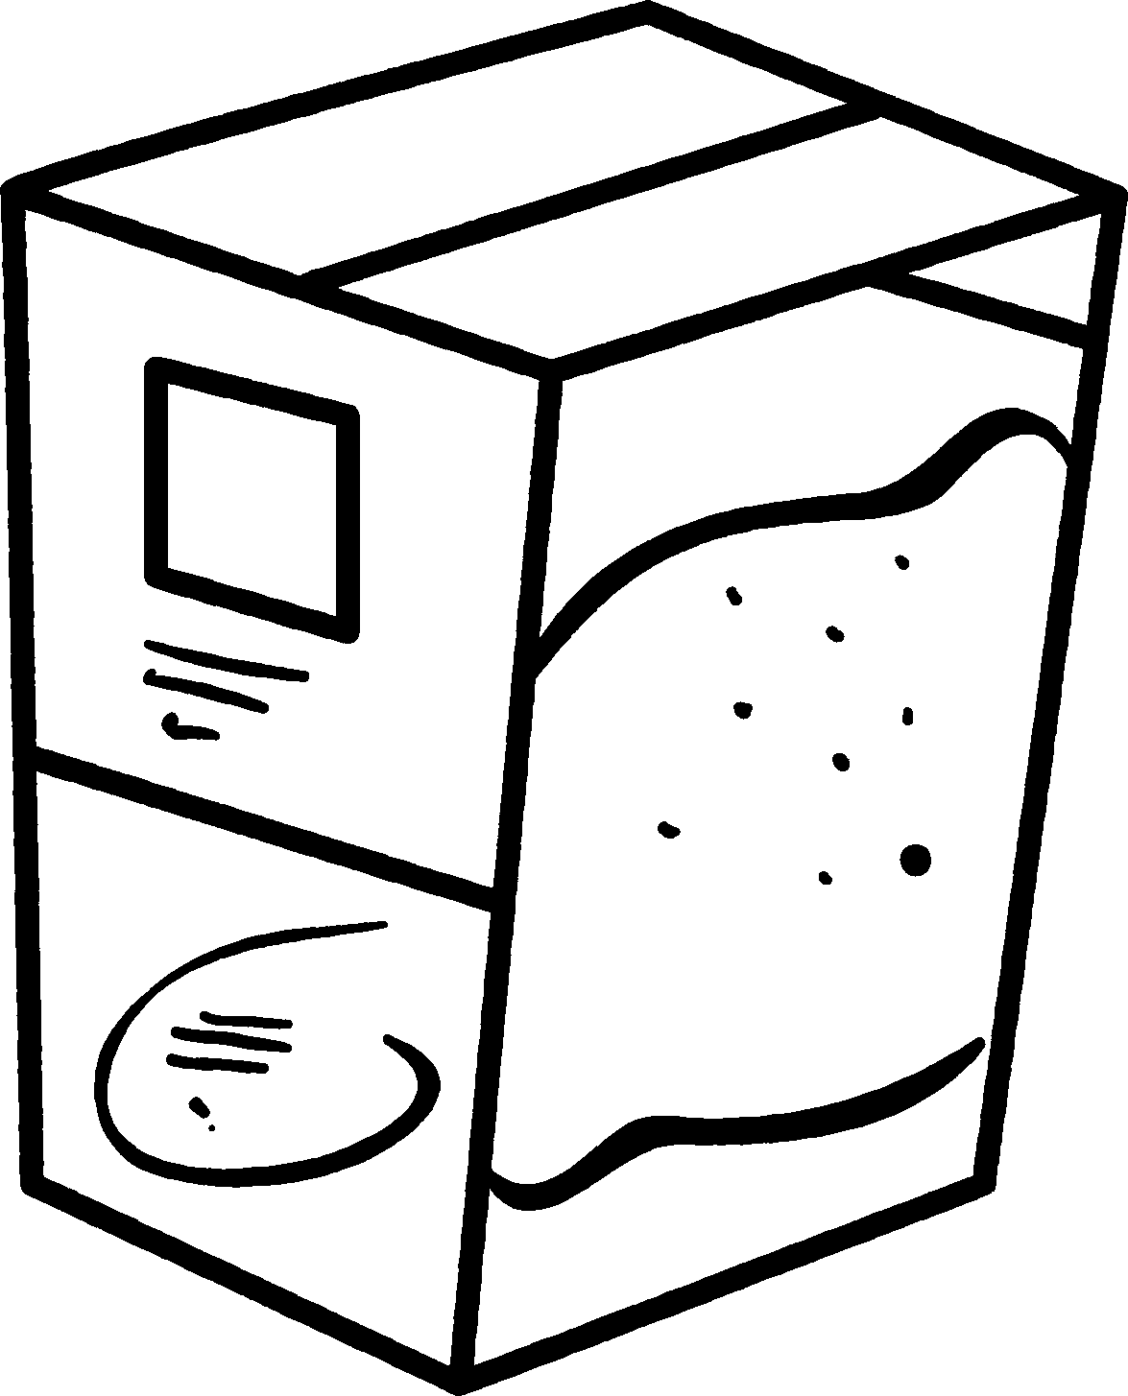
Jo has three cartons of each type of juice in her cupboard.
Fruit punch
•Design a poster to show the different fruit
punches she could have made, and the proportion
of each type of juice in each fruit punch.
•Use tables or diagrams to show the information.
orange lemon pineapple lime grape
NOW TRY THIS!

100 ml 150 ml 200 ml 250 ml 300 ml
per carton per carton per carton per carton per carton


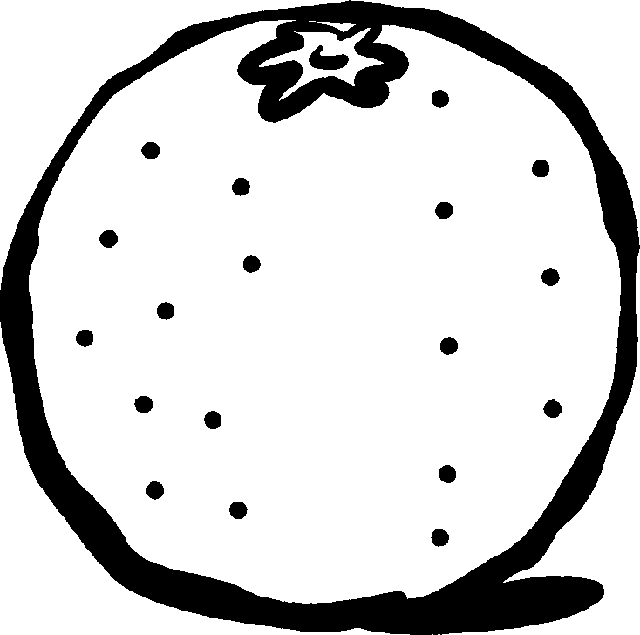


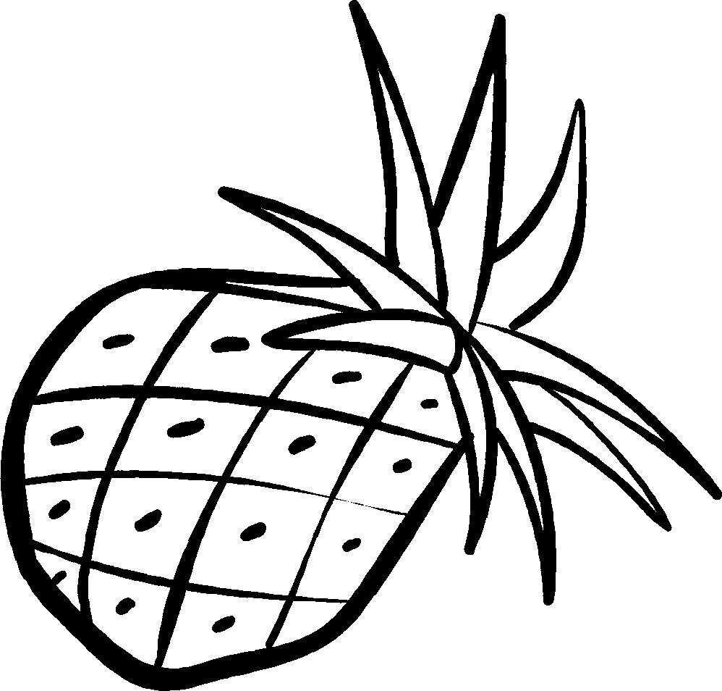

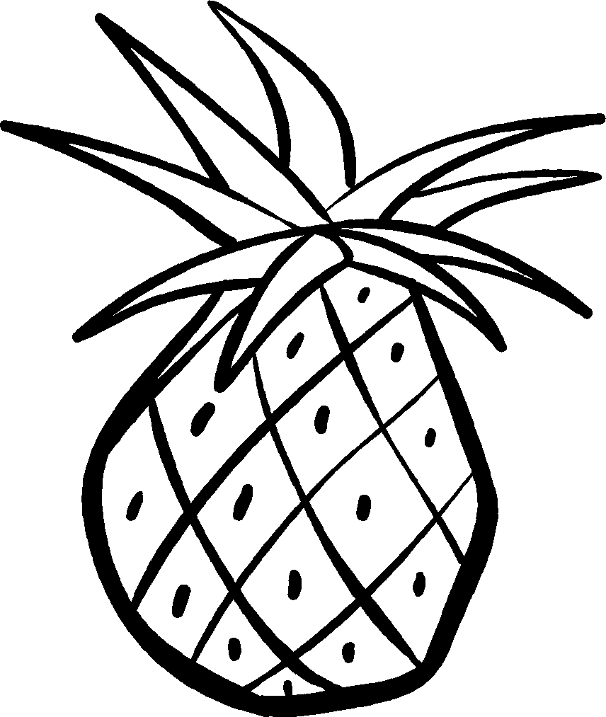
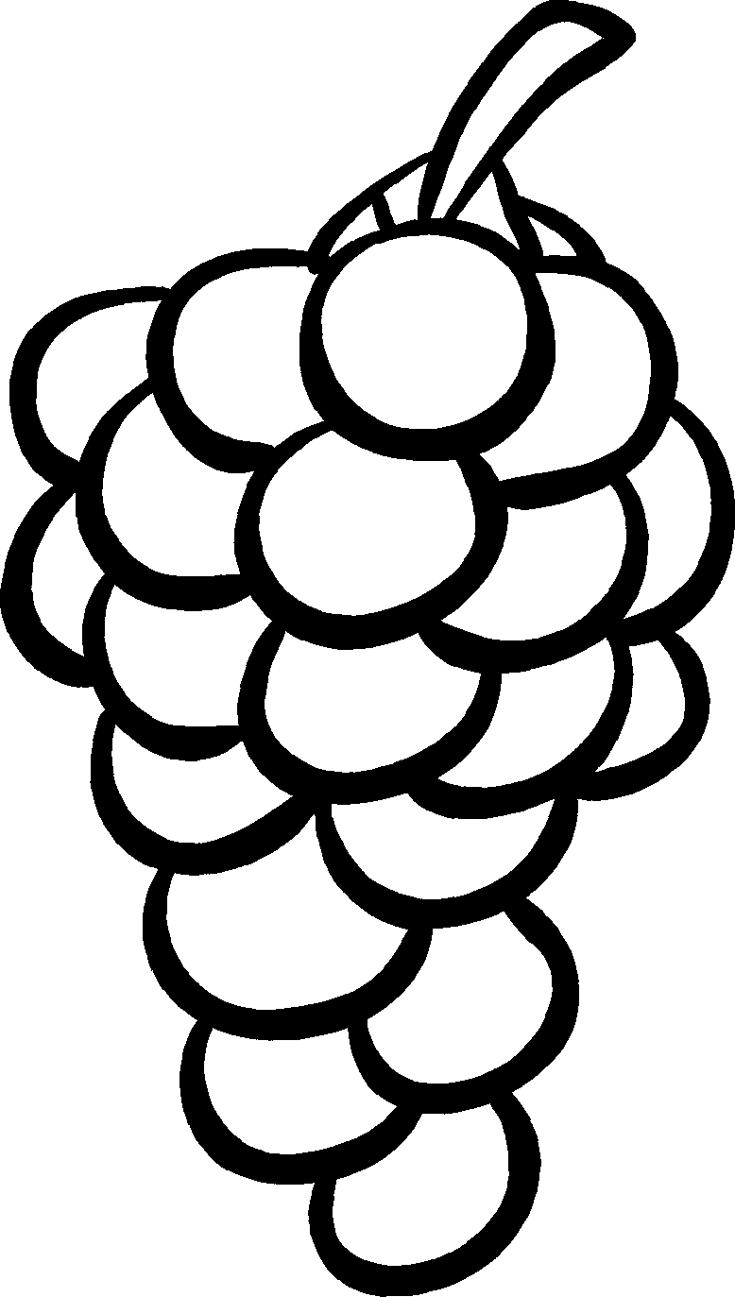

Jo uses whole cartons of juice to make a 500 ml fruit punch.
Show your answers here.
Find as many different
ways as you can.

• Which cartons could she have used?
She did not use parts of cartons.

• Talk to a partner about the proportion of each type
of juice in each fruit punch.

