
•Talk to a partner about how
you worked out each answer.
NOW TRY THIS!
POSTCARD
42 girls, 35 boys and 9 adults are
going to stay at a residential centre
in Wales.
Each child pays £72 to go on the trip.
A coach can carry 44 people.
A minibus can carry 12 people plus
a driver.
Each girls’ dormitory can sleep 8 girls.
Each boys’ dormitory can sleep 9 boys.
AFFIX
STAMP
HERE



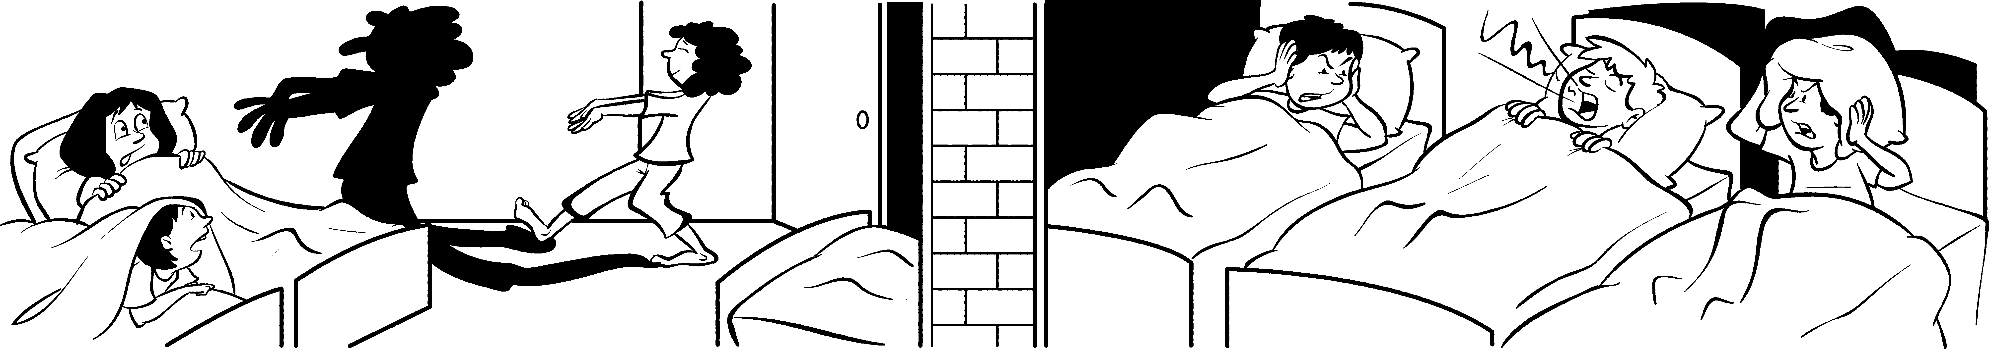
• Use the information above to answer these questions.

1 How many people altogether
are going on the trip? _____

3 If the school party travel to the
residential centre by coach,
how many coaches will be
needed? _____
5 How many girls’ dormitories
are needed? _____
2 What is the total amount that
the children pay? __________
4 Trips from the centre are made
by minibus. If some of the
adults drive them, how many
minibuses are needed? _____
6 How many boys’ dormitories
are needed? _____
School residential trip

