
• Find how many of each animal there are in the field.

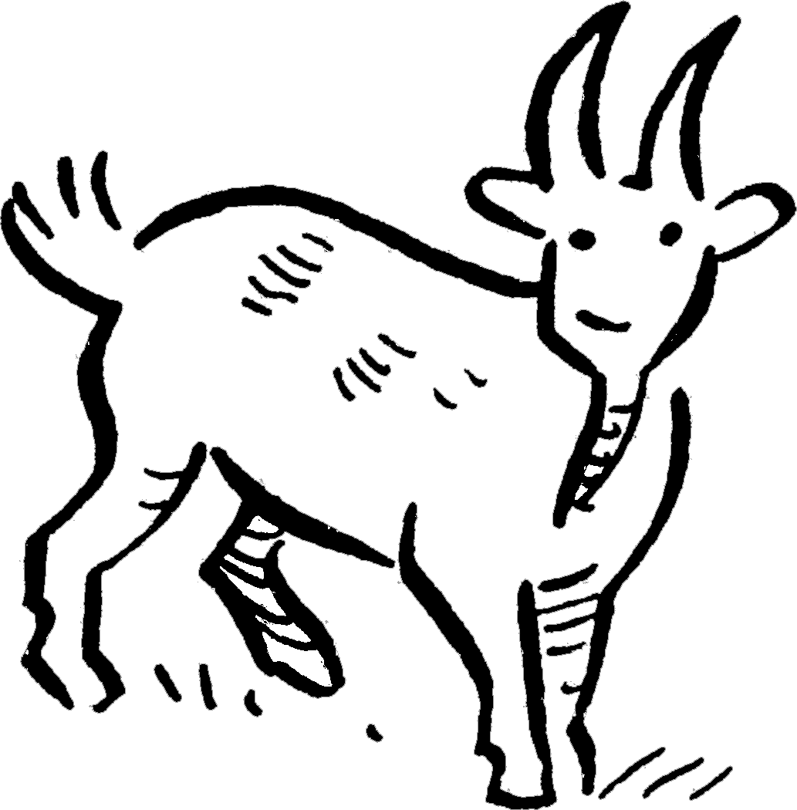
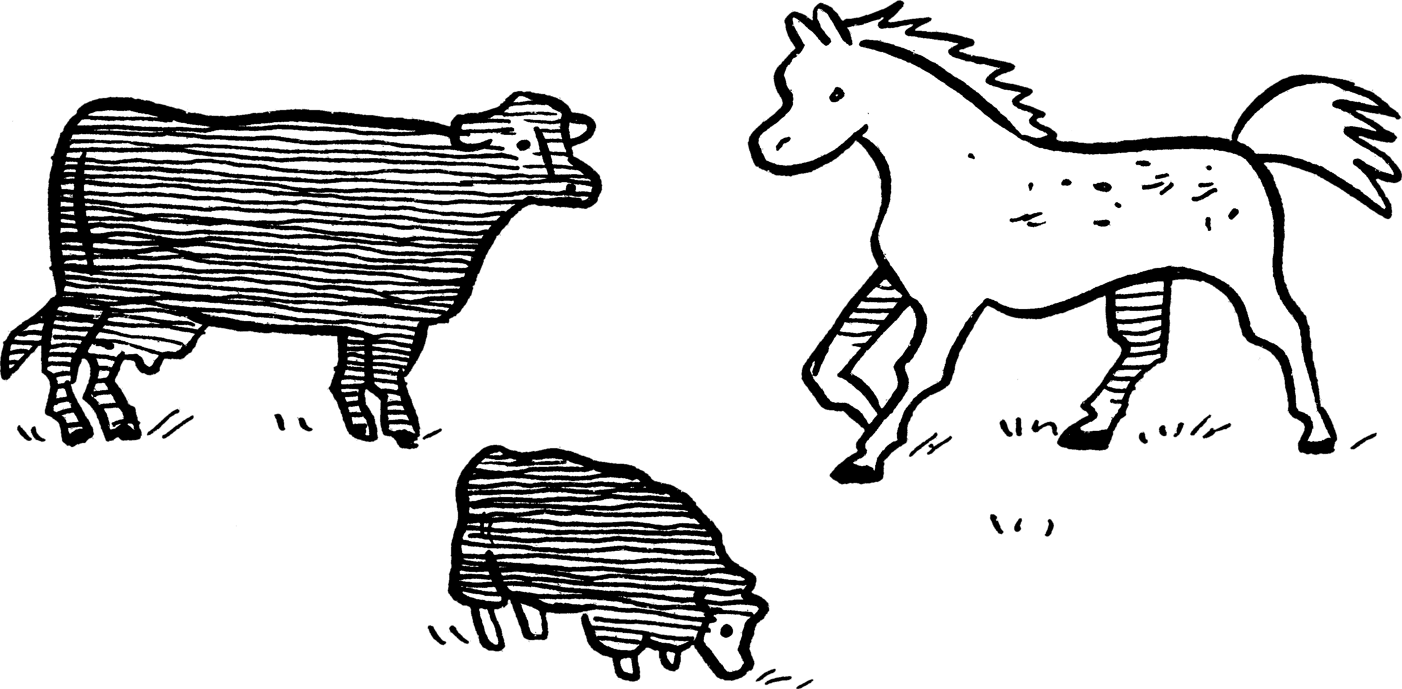
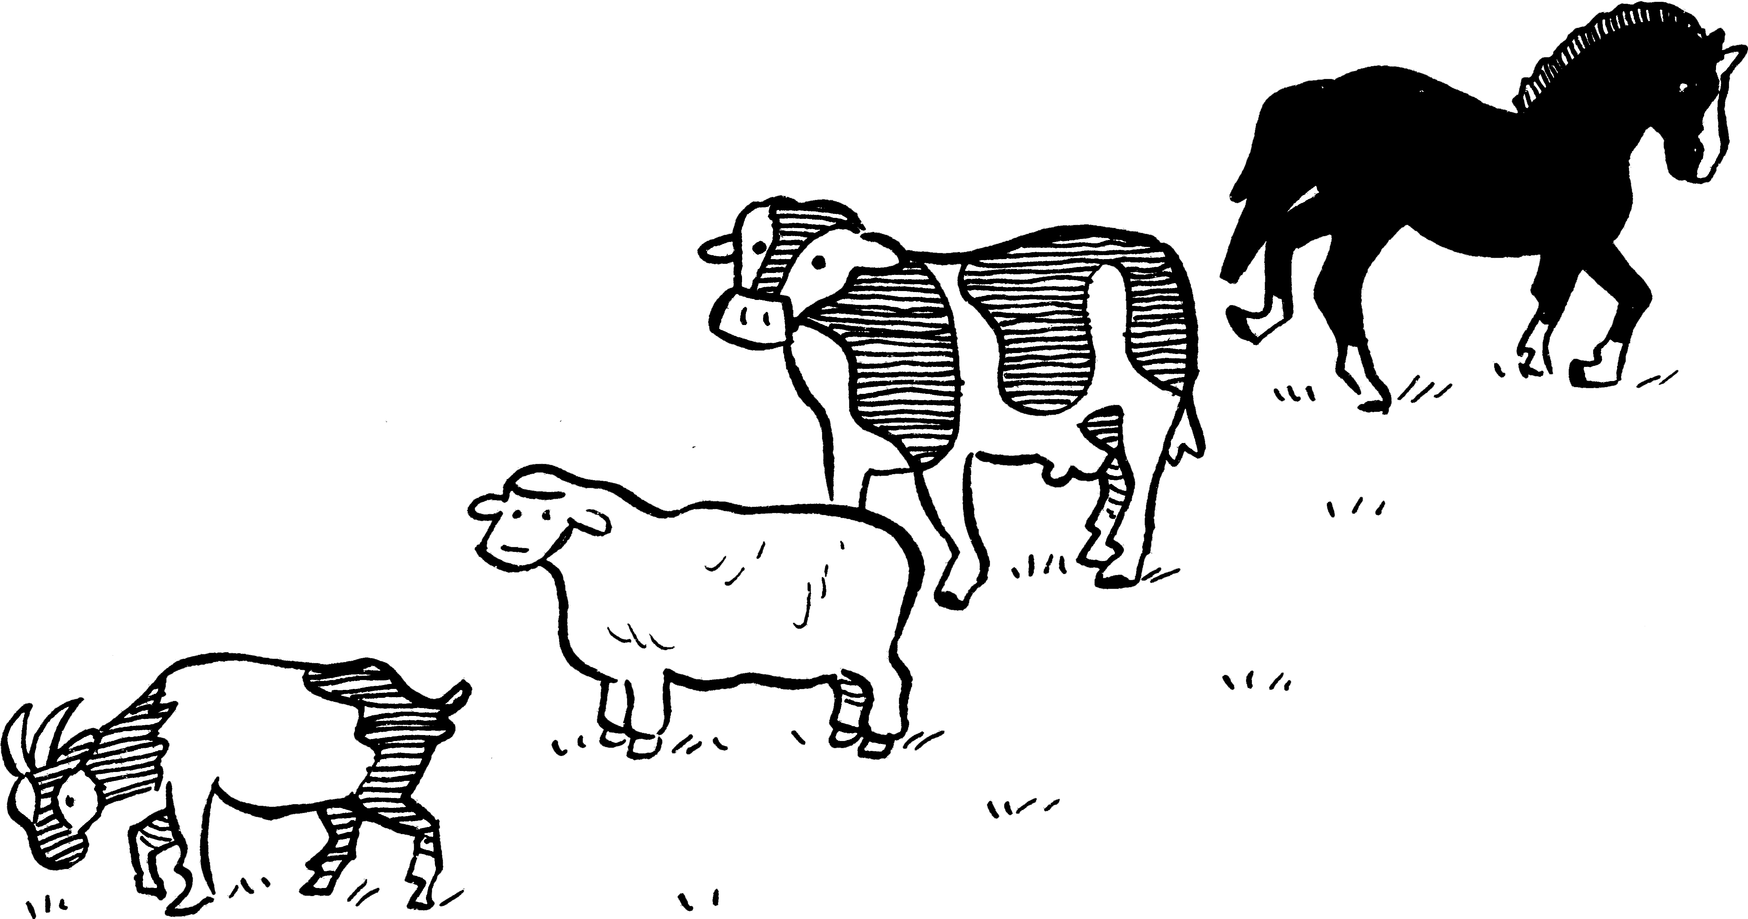
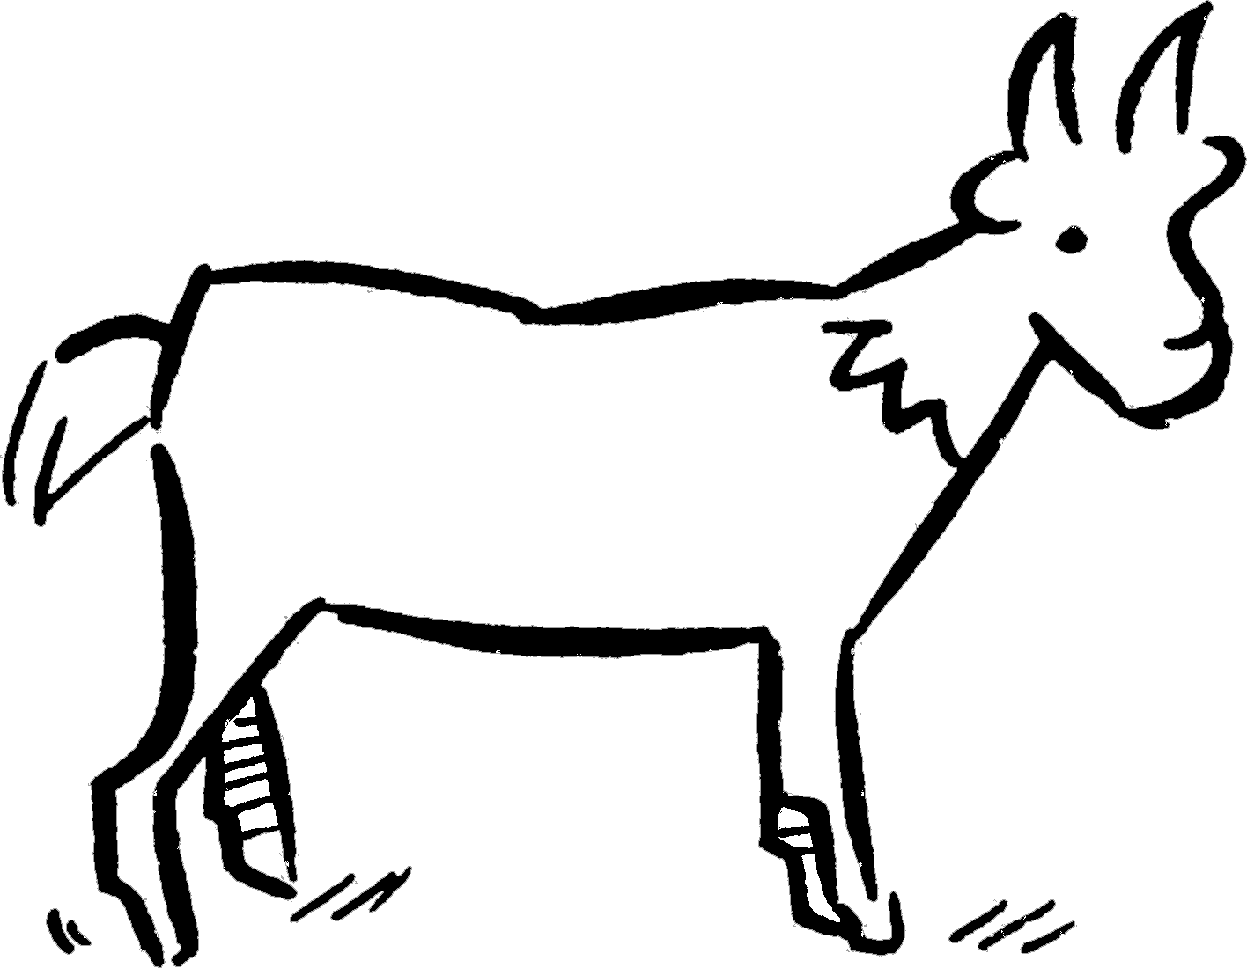
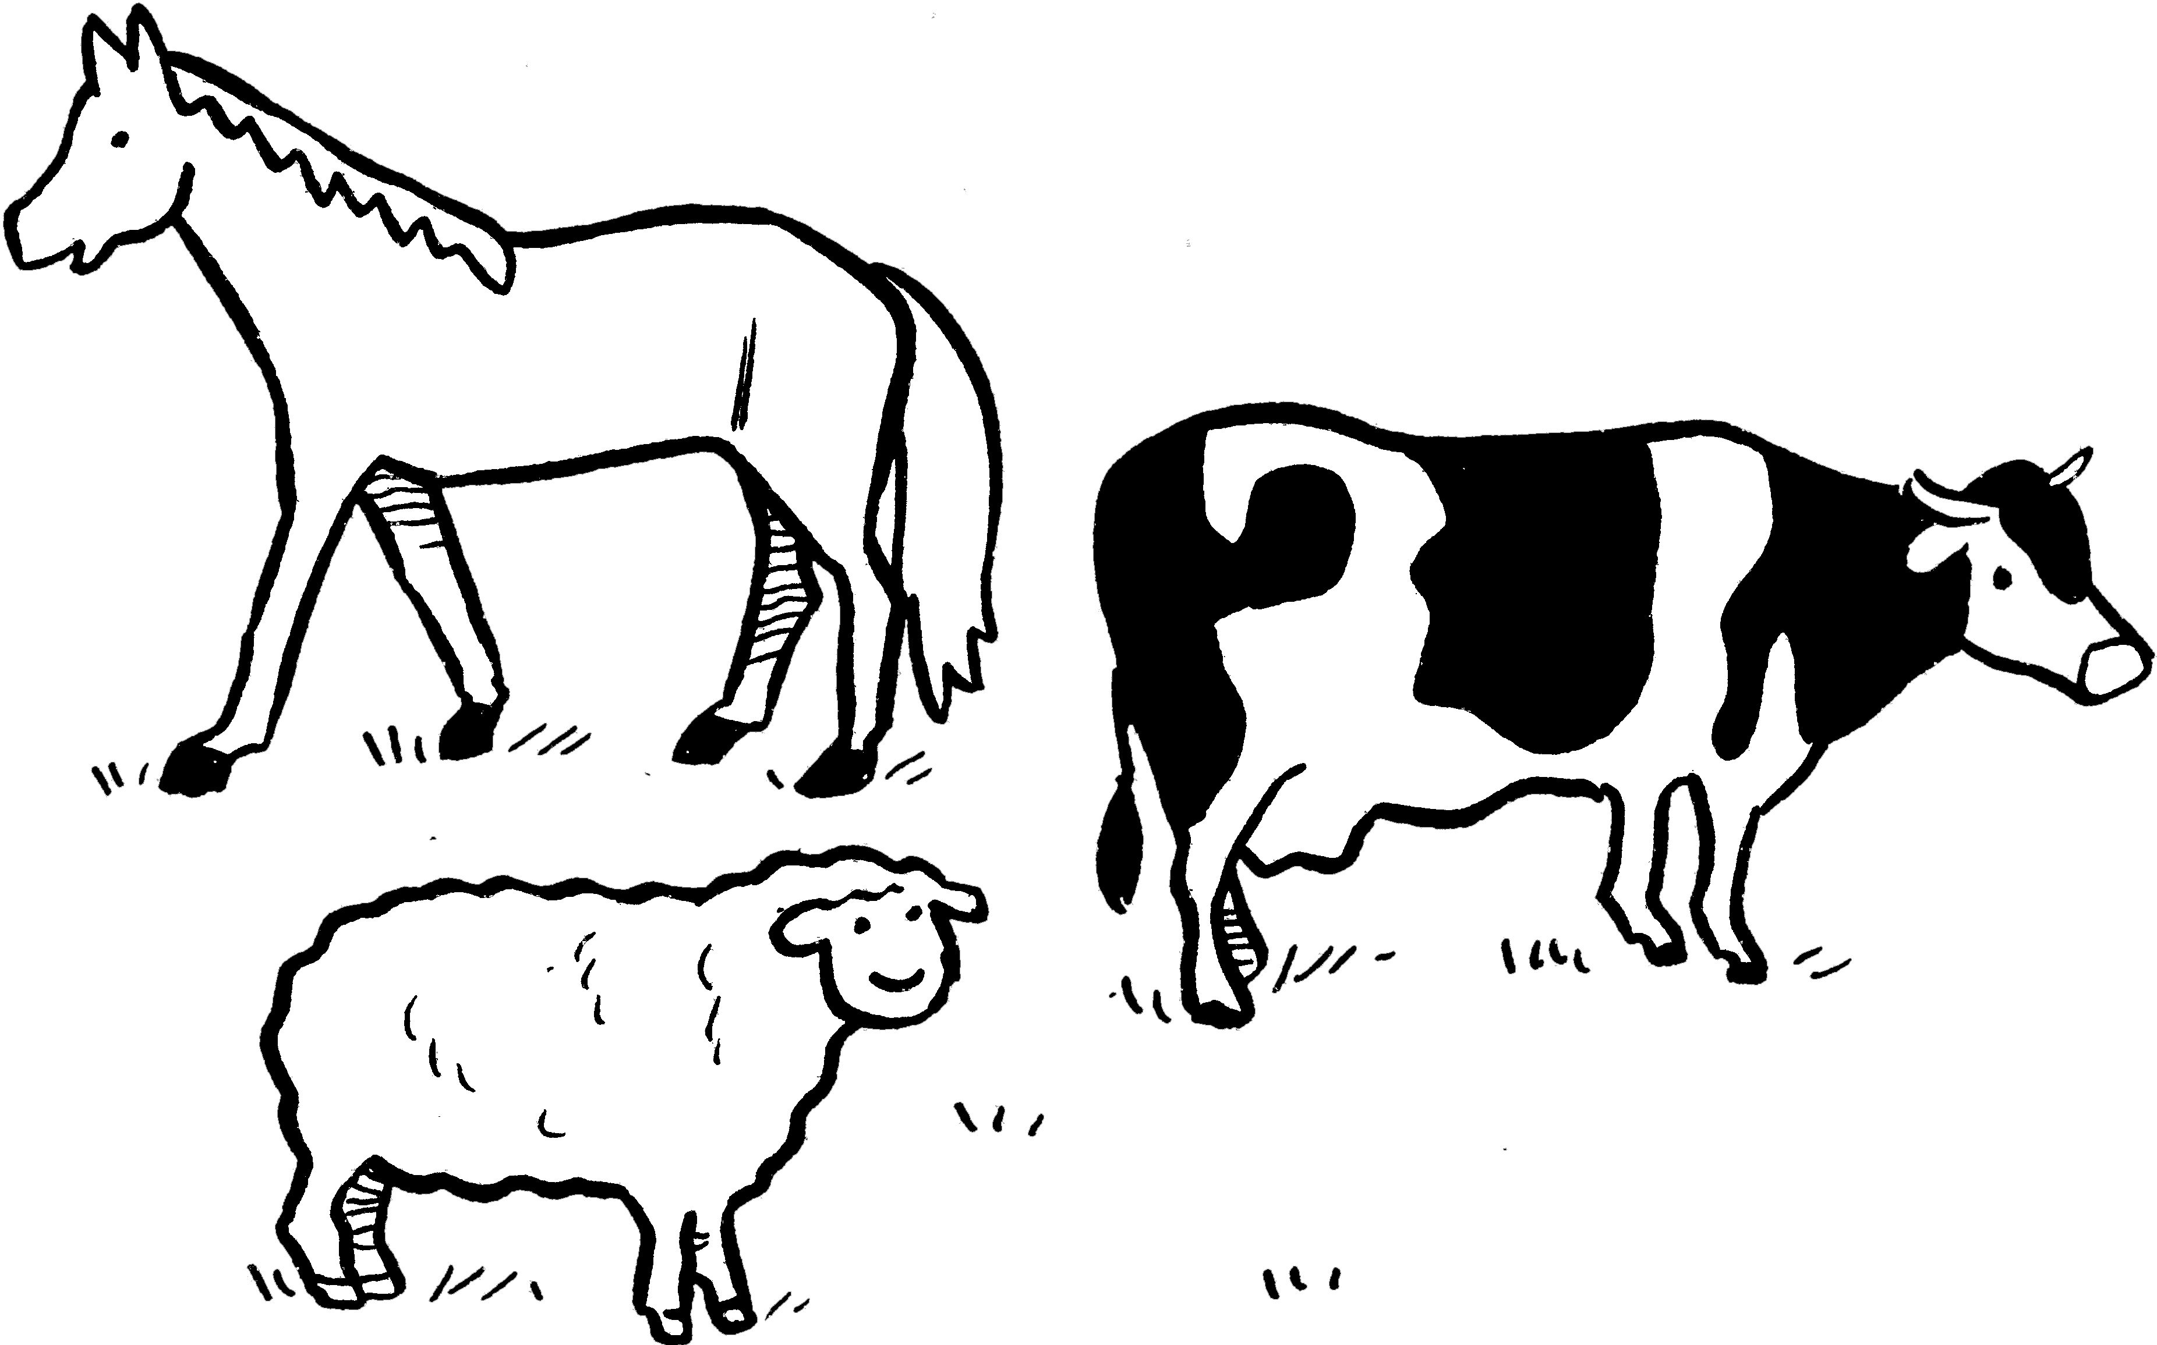
• Discuss with a partner how to solve each problem.
•Write an explanation to tell someone else
how you solved each problem.
NOW TRY THIS!
$\frac{3}{8}$$\frac{1}{4}$$\frac{1}{\text{10}}$$\frac{5}{\text{12}}$$\frac{1}{3}$$\frac{2}{7}$$\frac{1}{5}$$\frac{1}{3}$In field A: of the animals are horses

of the animals are cows

$\frac{1}{\text{16}}$ of the animals are sheep.

There are goats.
5
In field B: of the animals are horses

of the animals are cows

of the animals are sheep.

There are goats.
9
In field C: of the animals are horses

of the animals are cows

of the animals are sheep.

There are goats.
19
Farming fractions

