
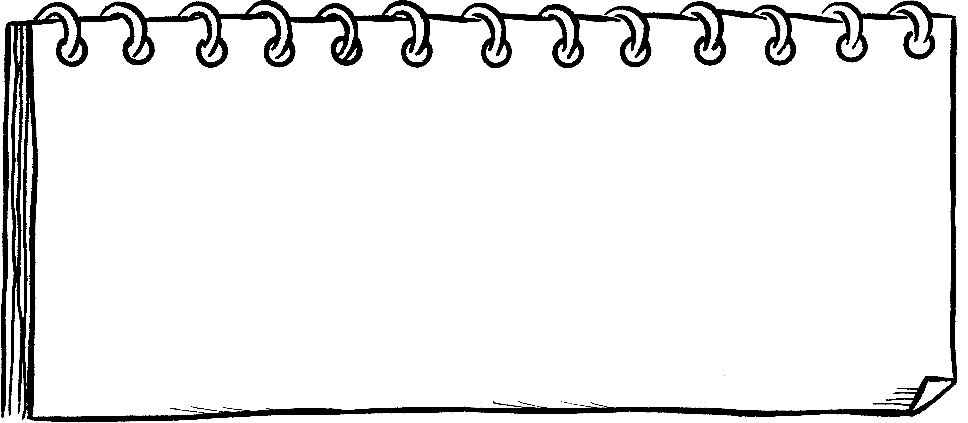
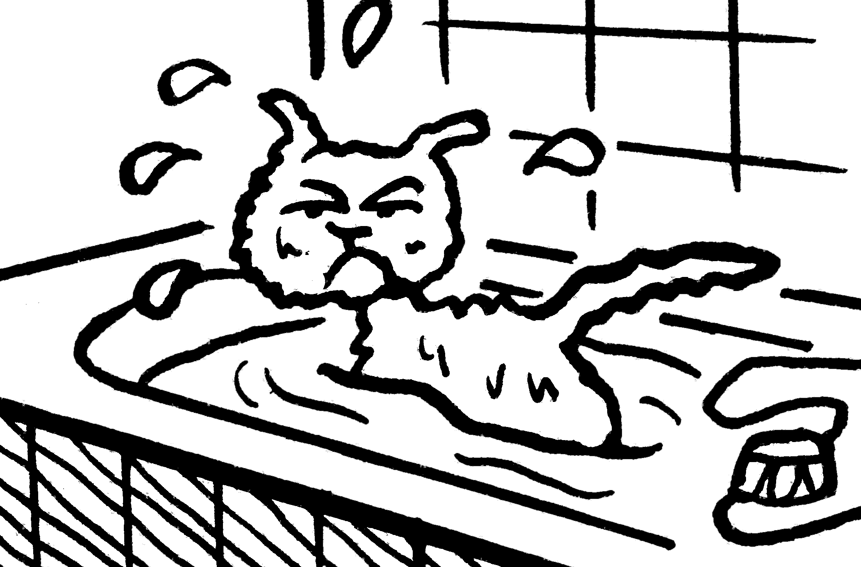
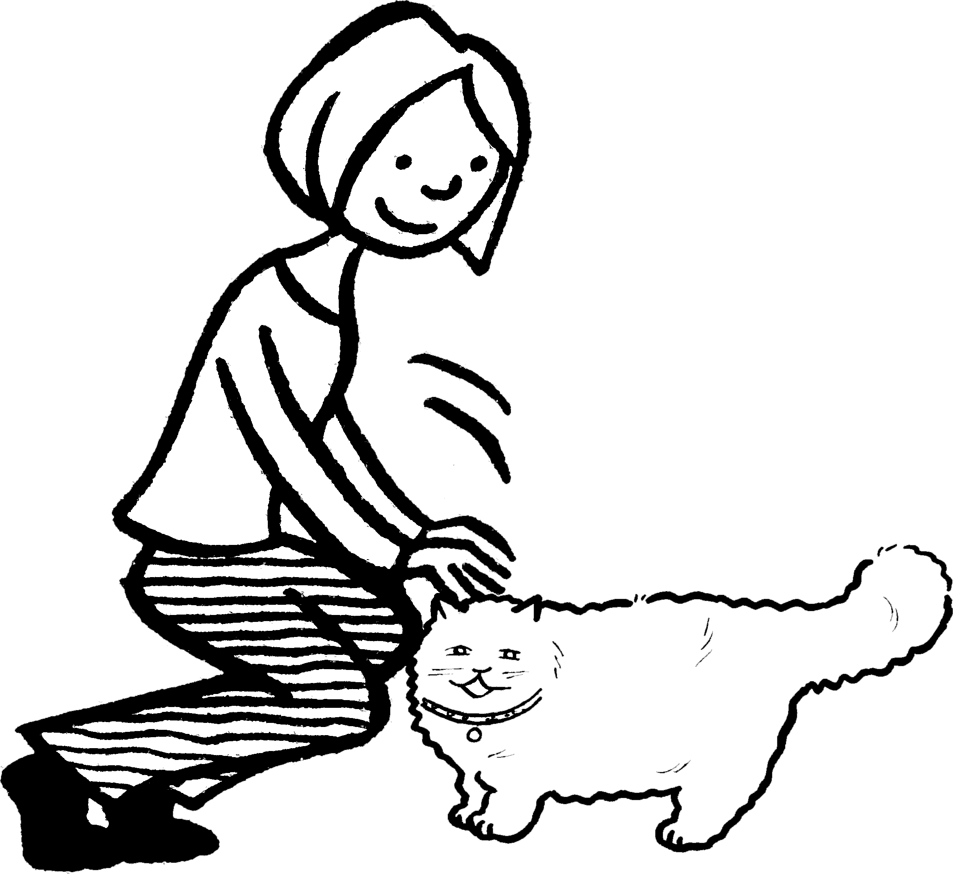
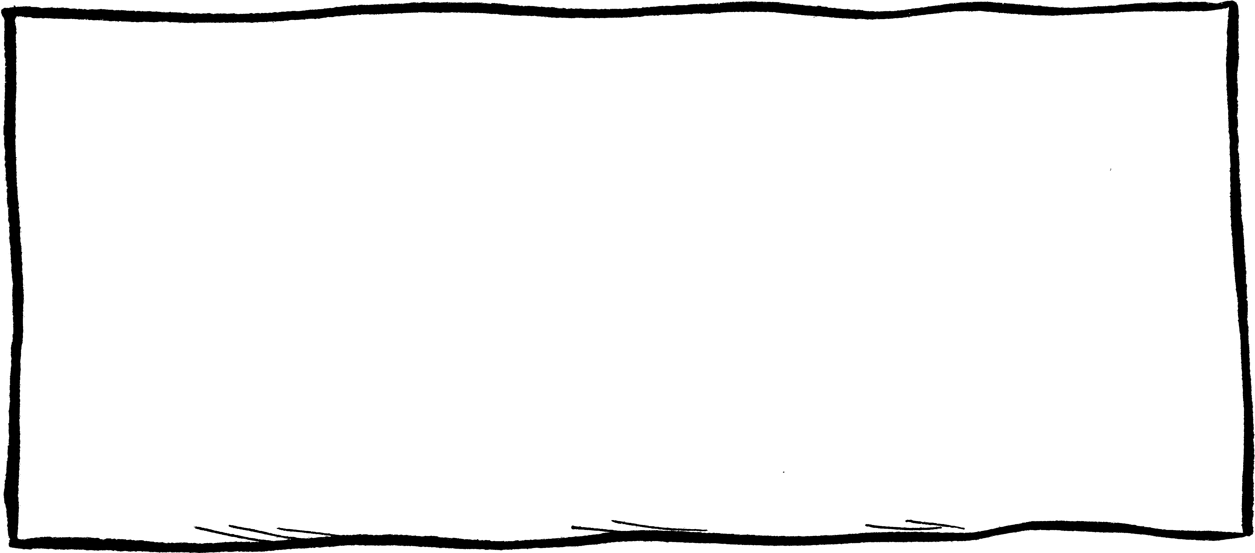
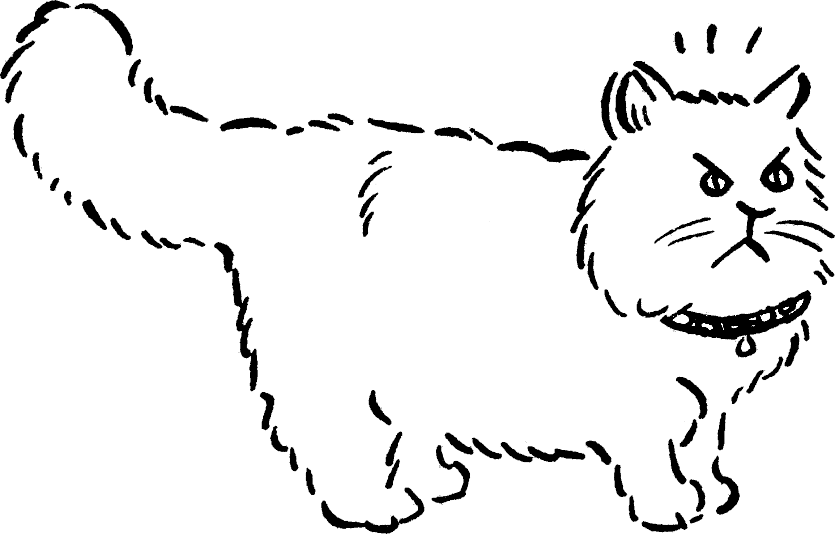
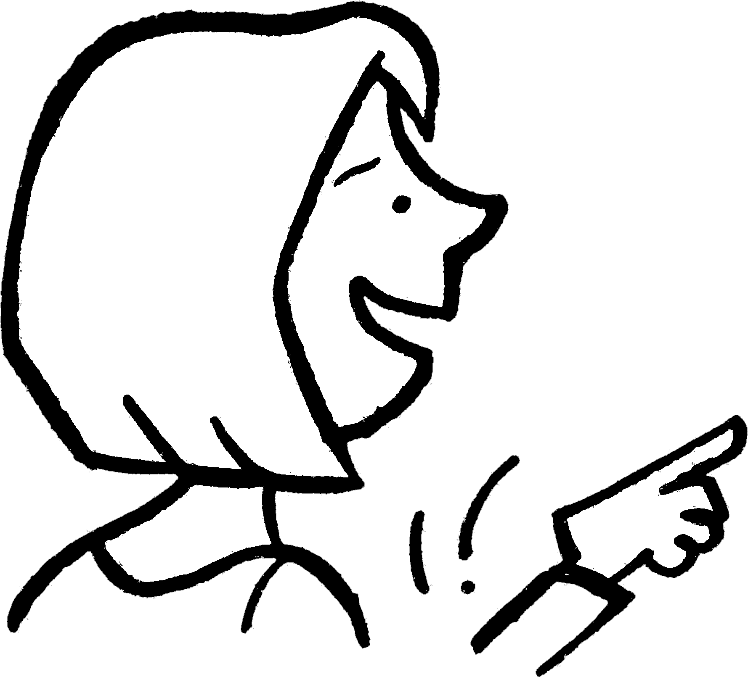
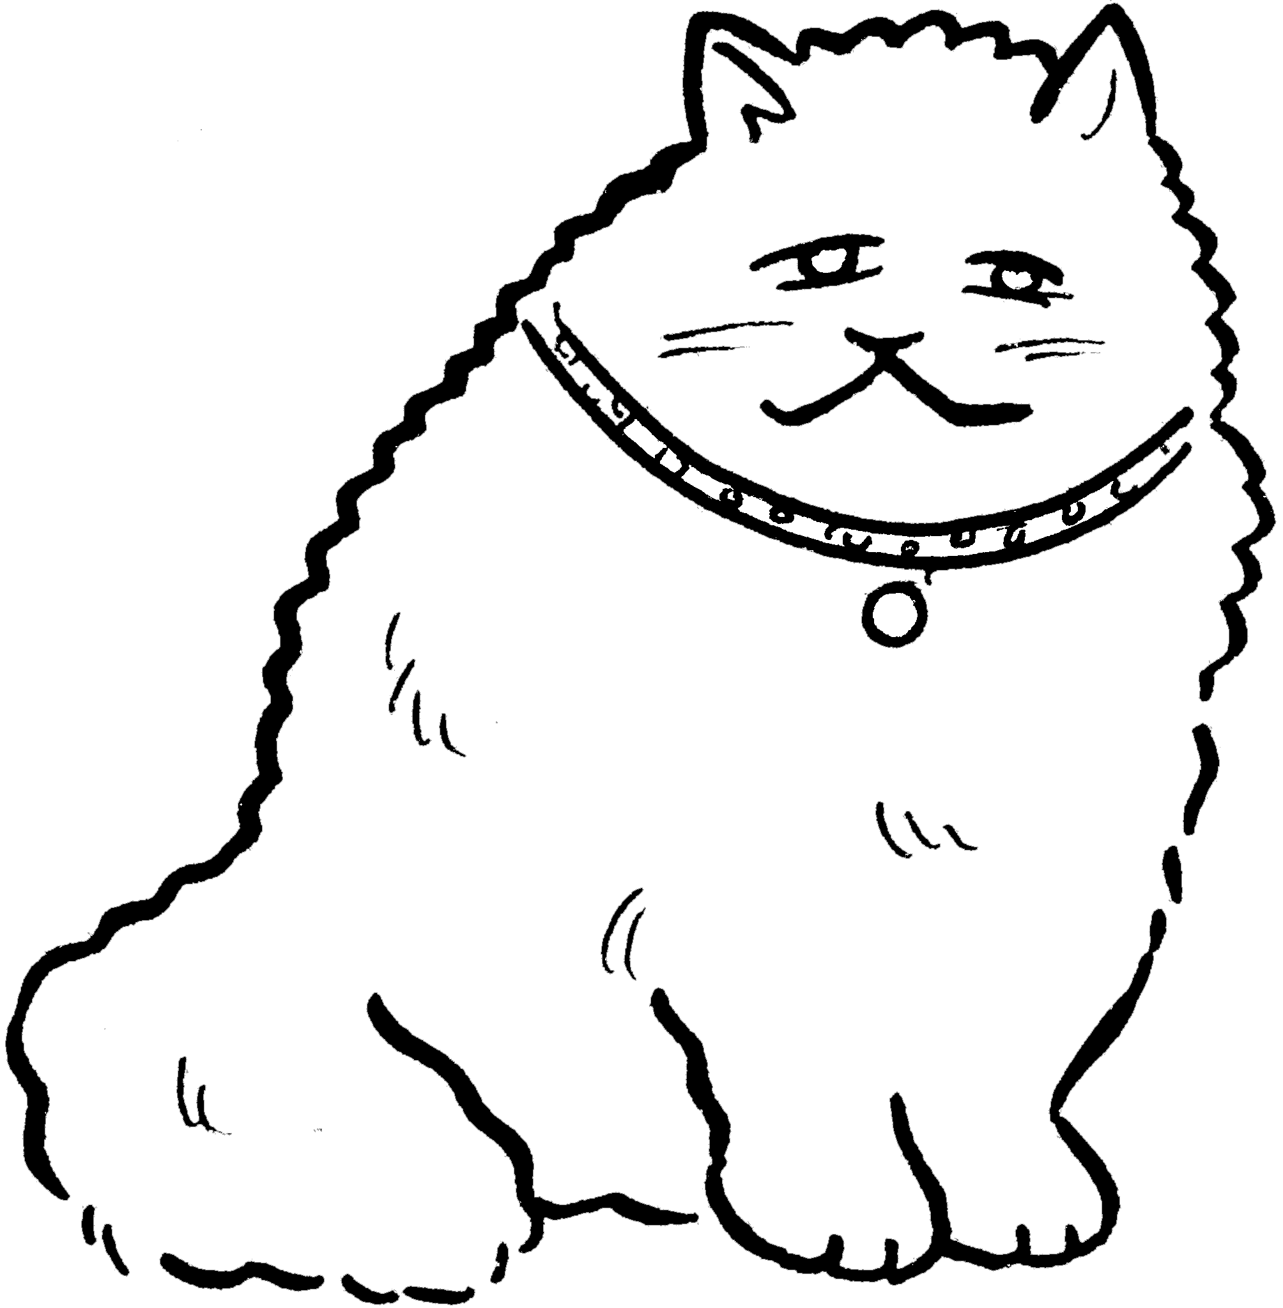
Emma is photocopying a picture to
change its size.The measurements
of the original picture are shown.
1 First, Emma sets the photocopier to 50%.
The lengths of the new picture are 50% of the original.
2 Then she sets the photocopier to 150%.
She photocopies the new picture (not the original).
3 Then she sets the photocopier to 50%.
She photocopies the most recent picture produced.
4 Finally, she sets the photocopier to 110%.
She photocopies the most recent picture produced.
200 mm
300 mm
160 mm
240 mm

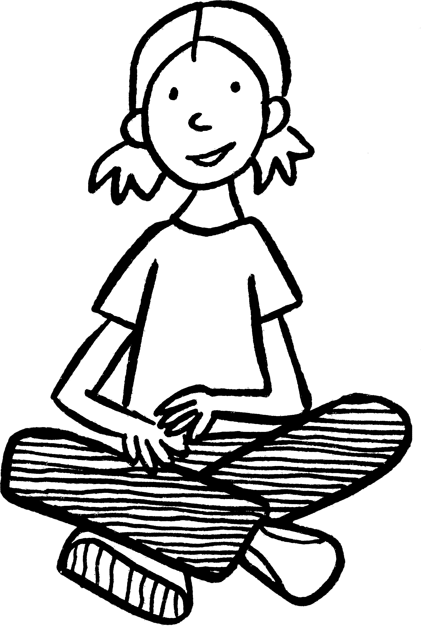
• Follow the descriptions below to
find the size of the final picture.
Show your workings here.
Copy cats
•Repeat the investigation
for this picture:
NOW TRY THIS!

