








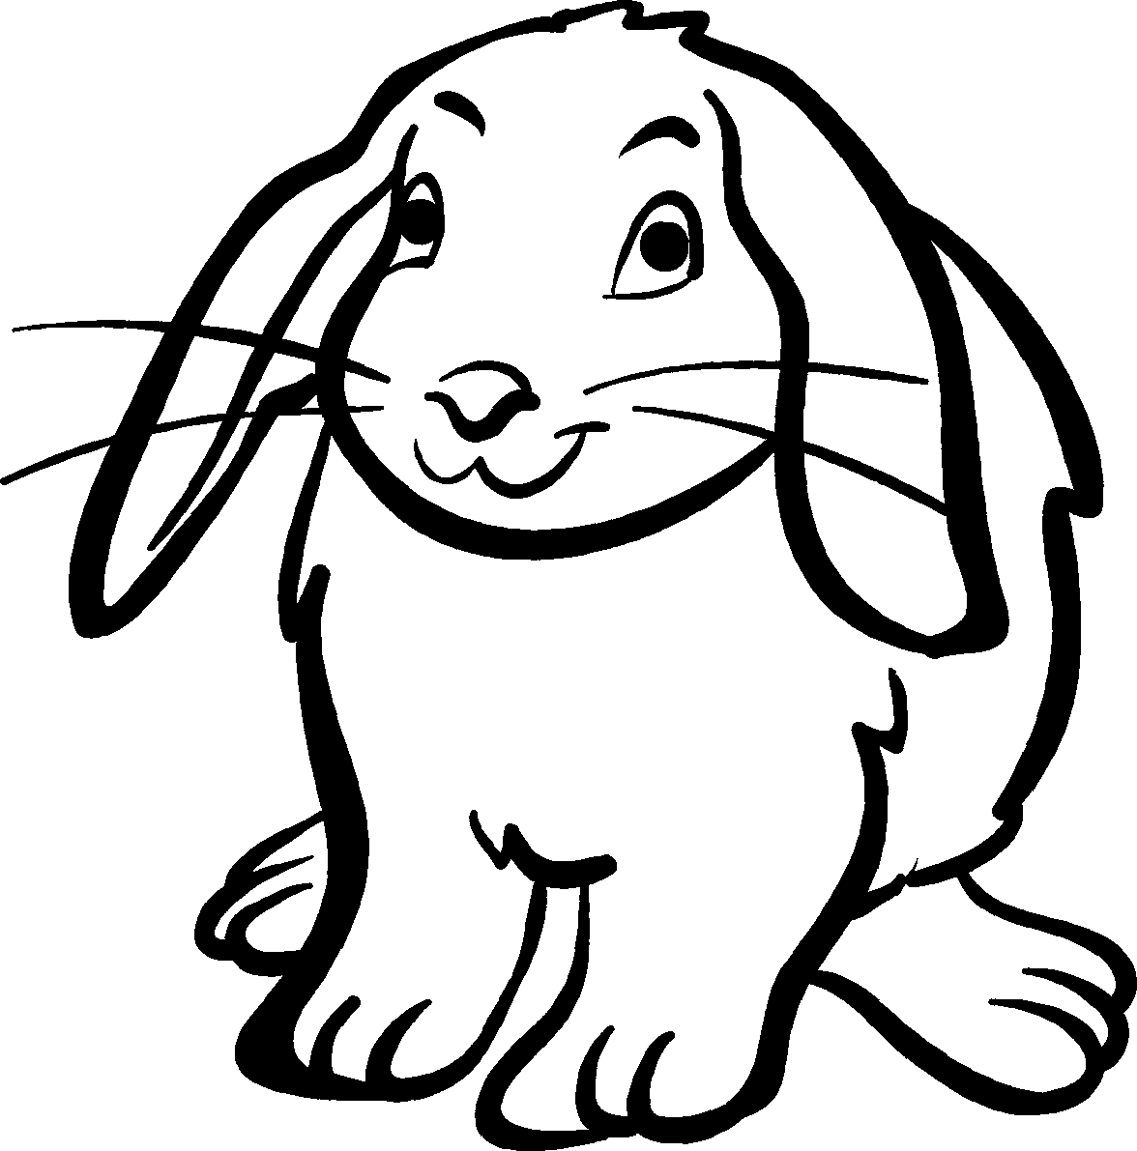
• Tick the number sentence that you would use to solve the
problem, then answer the problem.
Animal masses

1 A dog weighs 2 –12 times  more than a cat.  If the cat weighs 9 kg,  how heavy is the dog? _______ |  | 2 Two dogs weigh 18 kg each.  A third dog weighs 7 kg more.  What is the total mass of the  three dogs? _______
a 2.5 × 9 | b 9 + 9 + (9 ÷ 2) | a (18 ÷ 2) + 7 | b (18 × 2) + (18 + 7)
c (9 × 2) + (9 ÷ 2) | d 2–12 + 9 | c (18 × 3) + 7 | d 18 + 18 + 7
3 Three guinea pigs together  weigh 2 kg. If two guinea pigs  weigh 750 g each, how heavy  is the lightest guinea pig? _______ |  | 4 A baby rabbit is three times  heavier than a guinea pig.  If the rabbit weighs 1 –12 kg,  what is the mass of the  guinea pig? _______
a 2 × 750 | b 2000 – 750 – 750 | a 3 × 1.5 | b 3 ÷ 1–12
c 2000 – (750 × 2) | d 3 × 2 × 750 | c 1.5 ÷ 3 | d 1500 ÷ 3
5 Three dogs together weigh  51 kg. The heaviest weighs  28 kg, and the lightest is  one-quarter of the mass of the  heaviest. How heavy is the  other dog? _______ |  | 6 A kitten weighs one-third of  the mass of its mother. If the  kitten weighs 900 g, what is  the total mass of the  kitten and its  mother? _______
a (51 – 28) ÷ 2 | b 51 – 28 – 7 | a (900 × 3) + 900 | b 900 ÷ 3
c 51 – 28 – (28 ÷ 4) | d (51 + 28) ÷ 2 | c (–13 × 900) + 900 | d 900 × 4

