


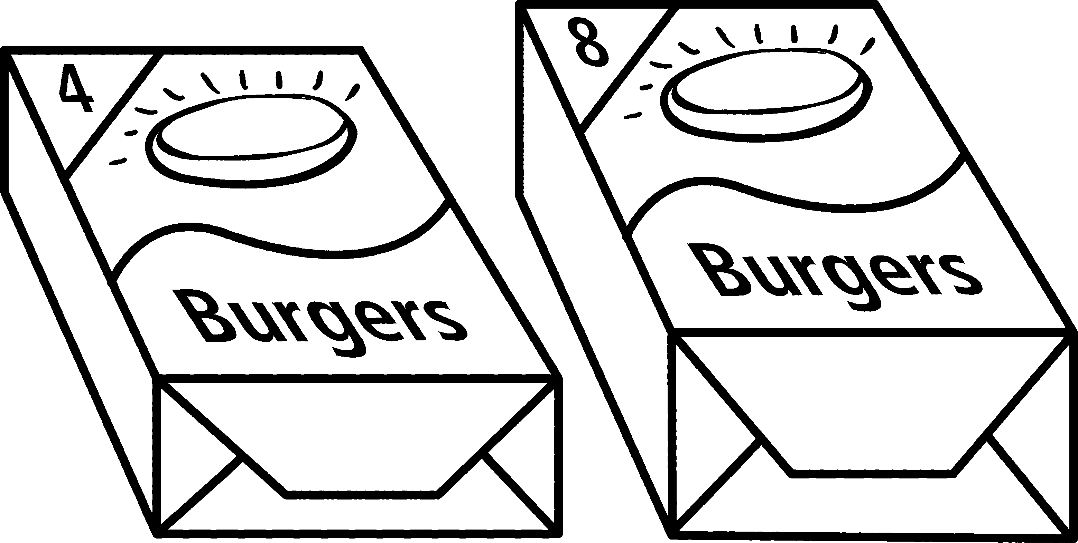

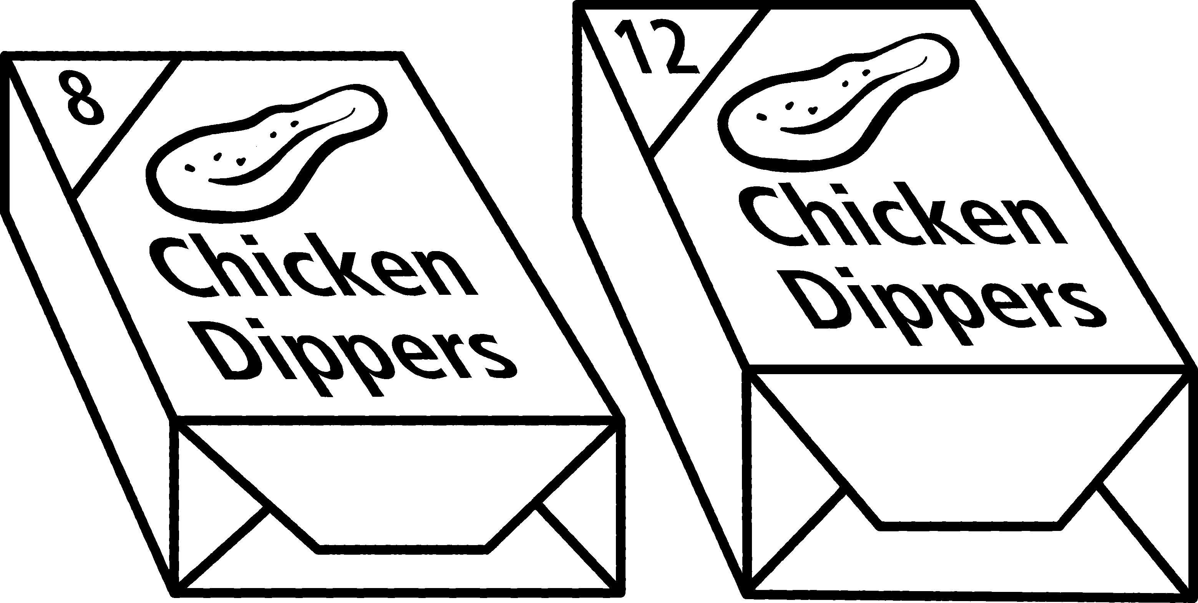

1 In a supermarket freezer there are ten boxes of
burgers. Some of the boxes hold four burgers,
the rest hold eight. If there are 56 burgers
in total, how many of each box are there?
There are four possibilities.
Find both.
Show your working here.
Make sure that you give the correct total.

2 In a supermarket freezer there are ten boxes of
dippers. Some of the boxes hold 8 dippers,
the rest hold 12. If there are 92 dippers
in total, how many of each box are there?
Frozen foods
•On the back of this sheet, write your own
‘freezer’ question for a partner to solve.
NOW TRY THIS!

