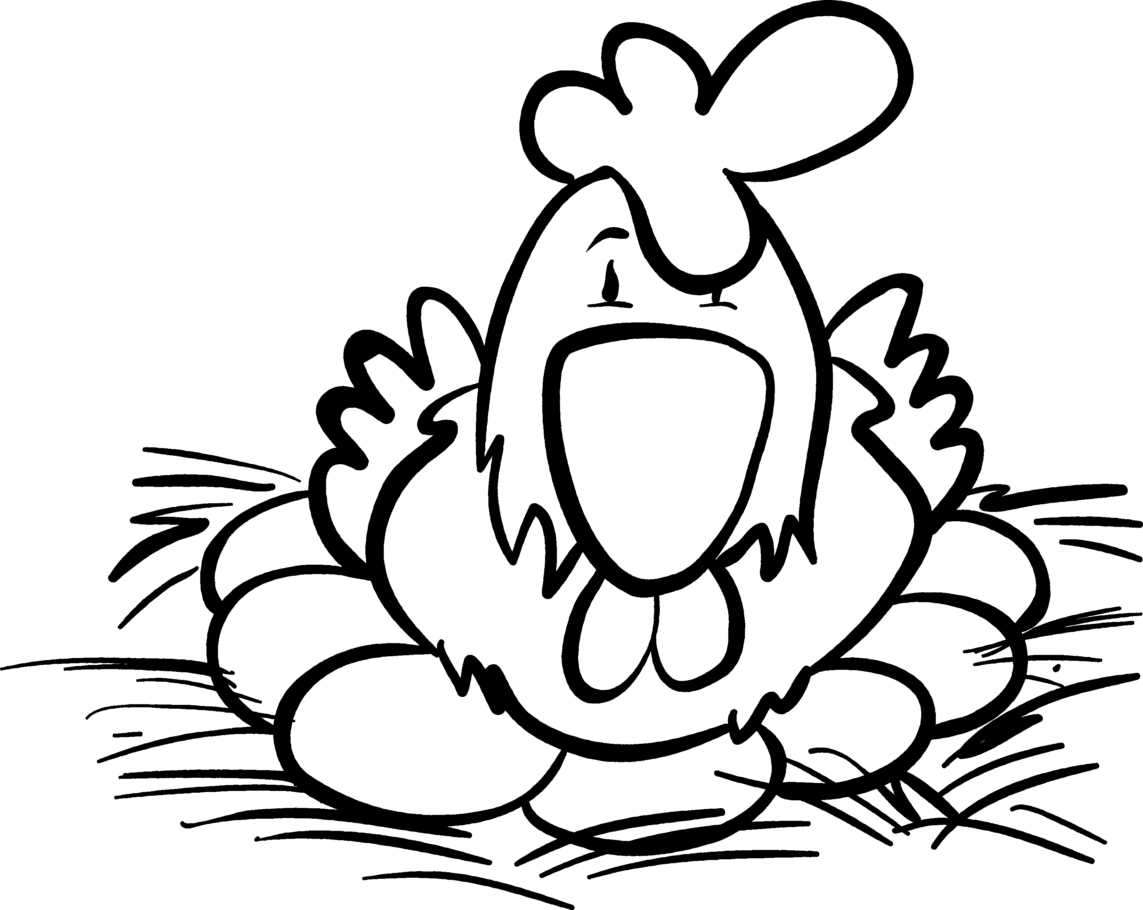
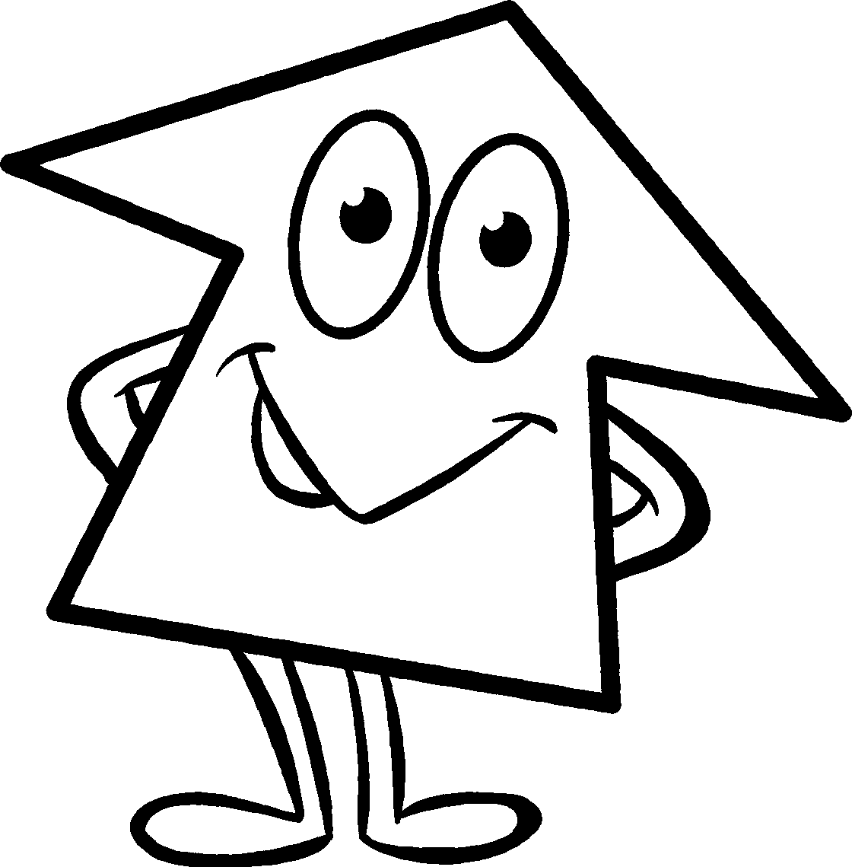
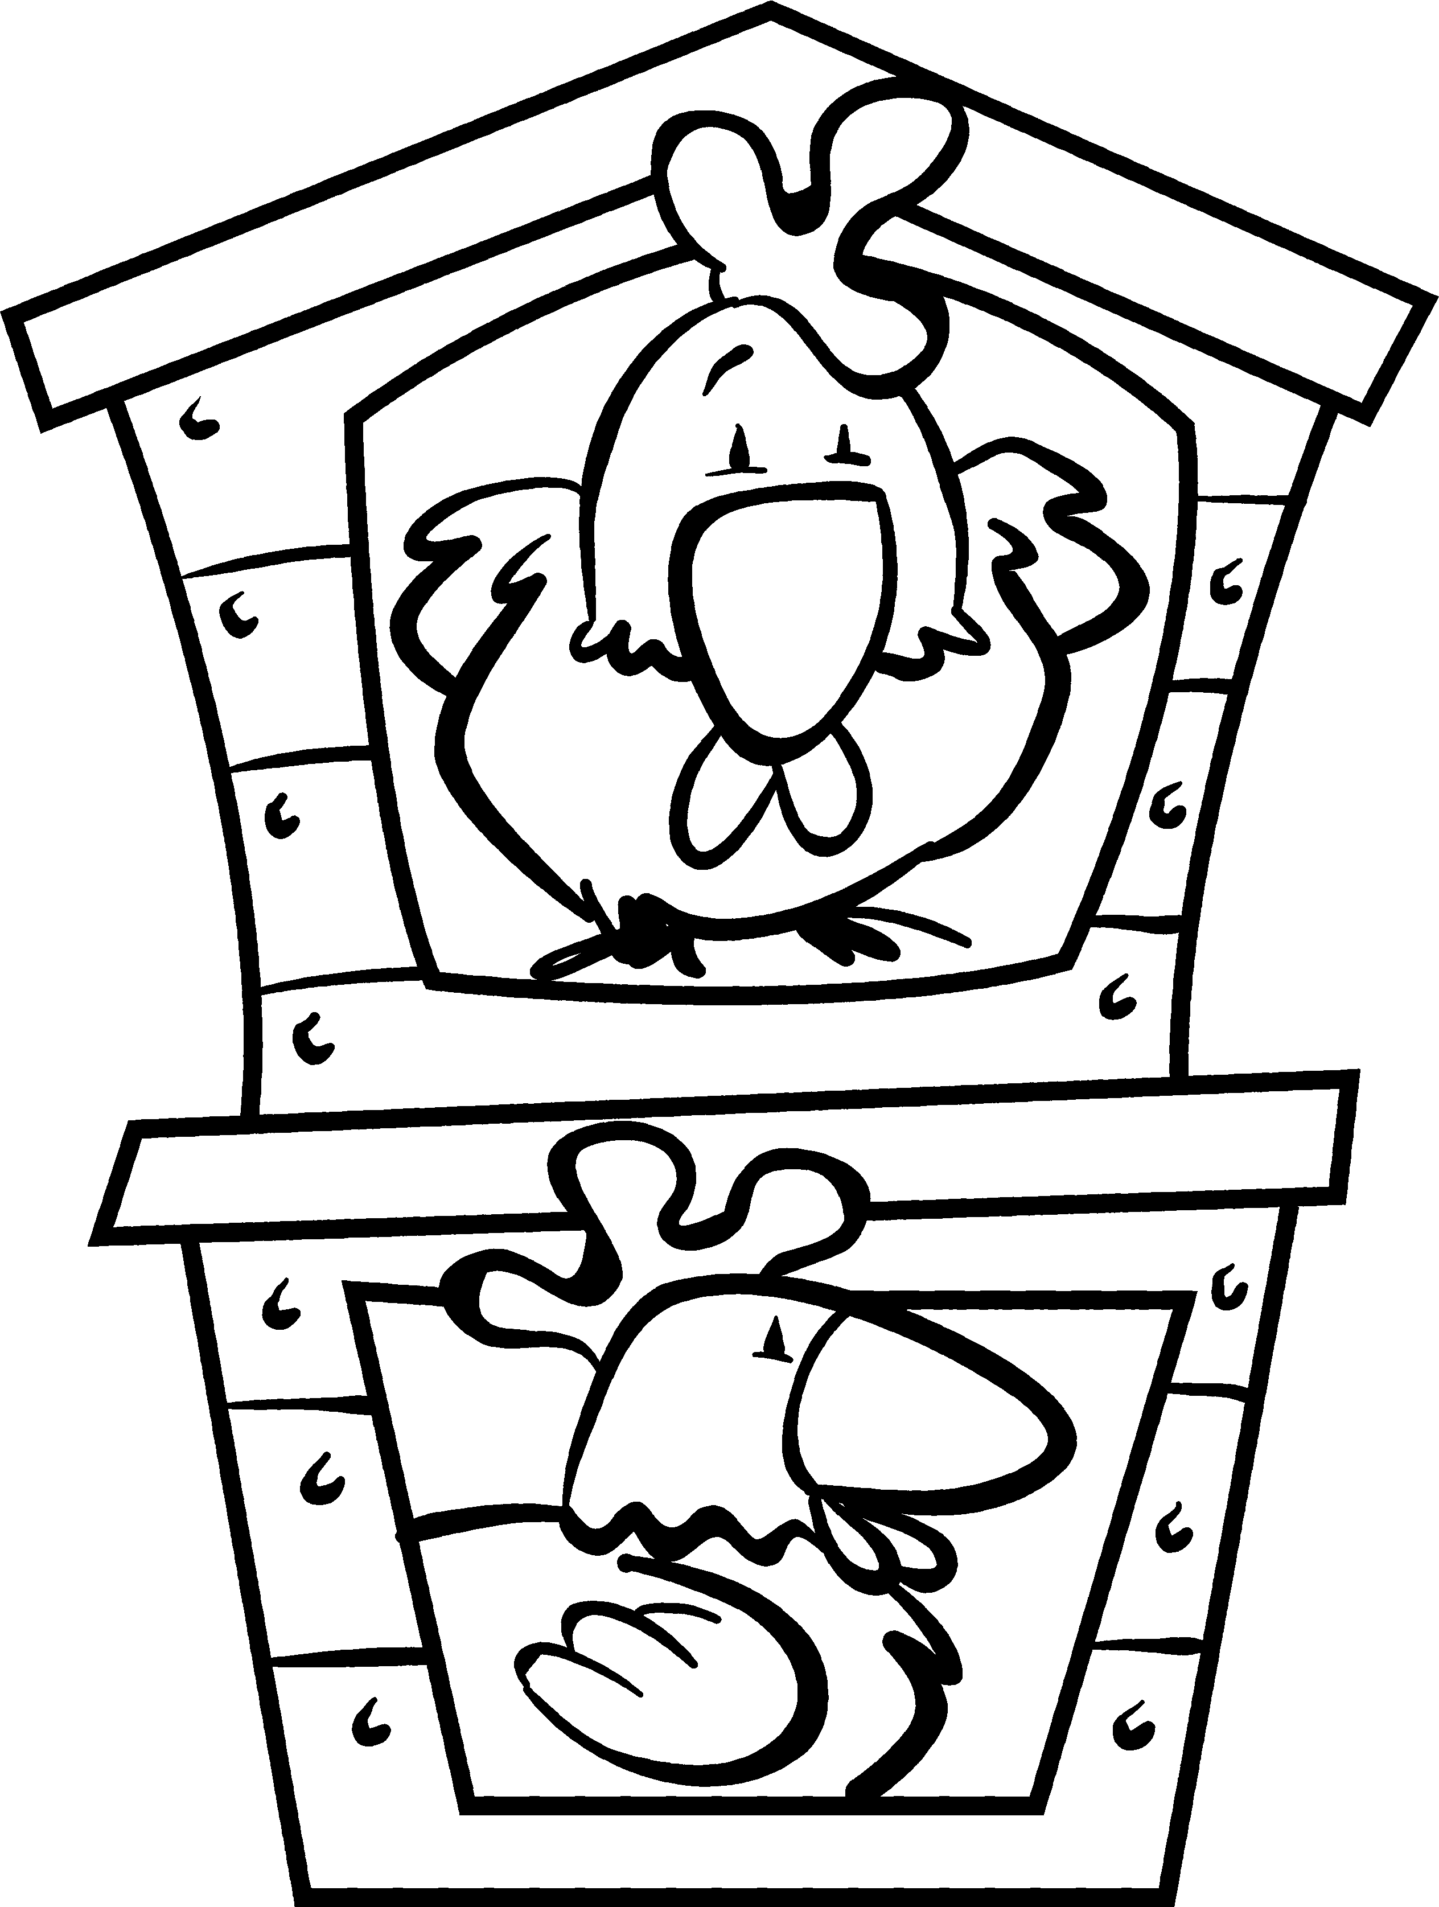
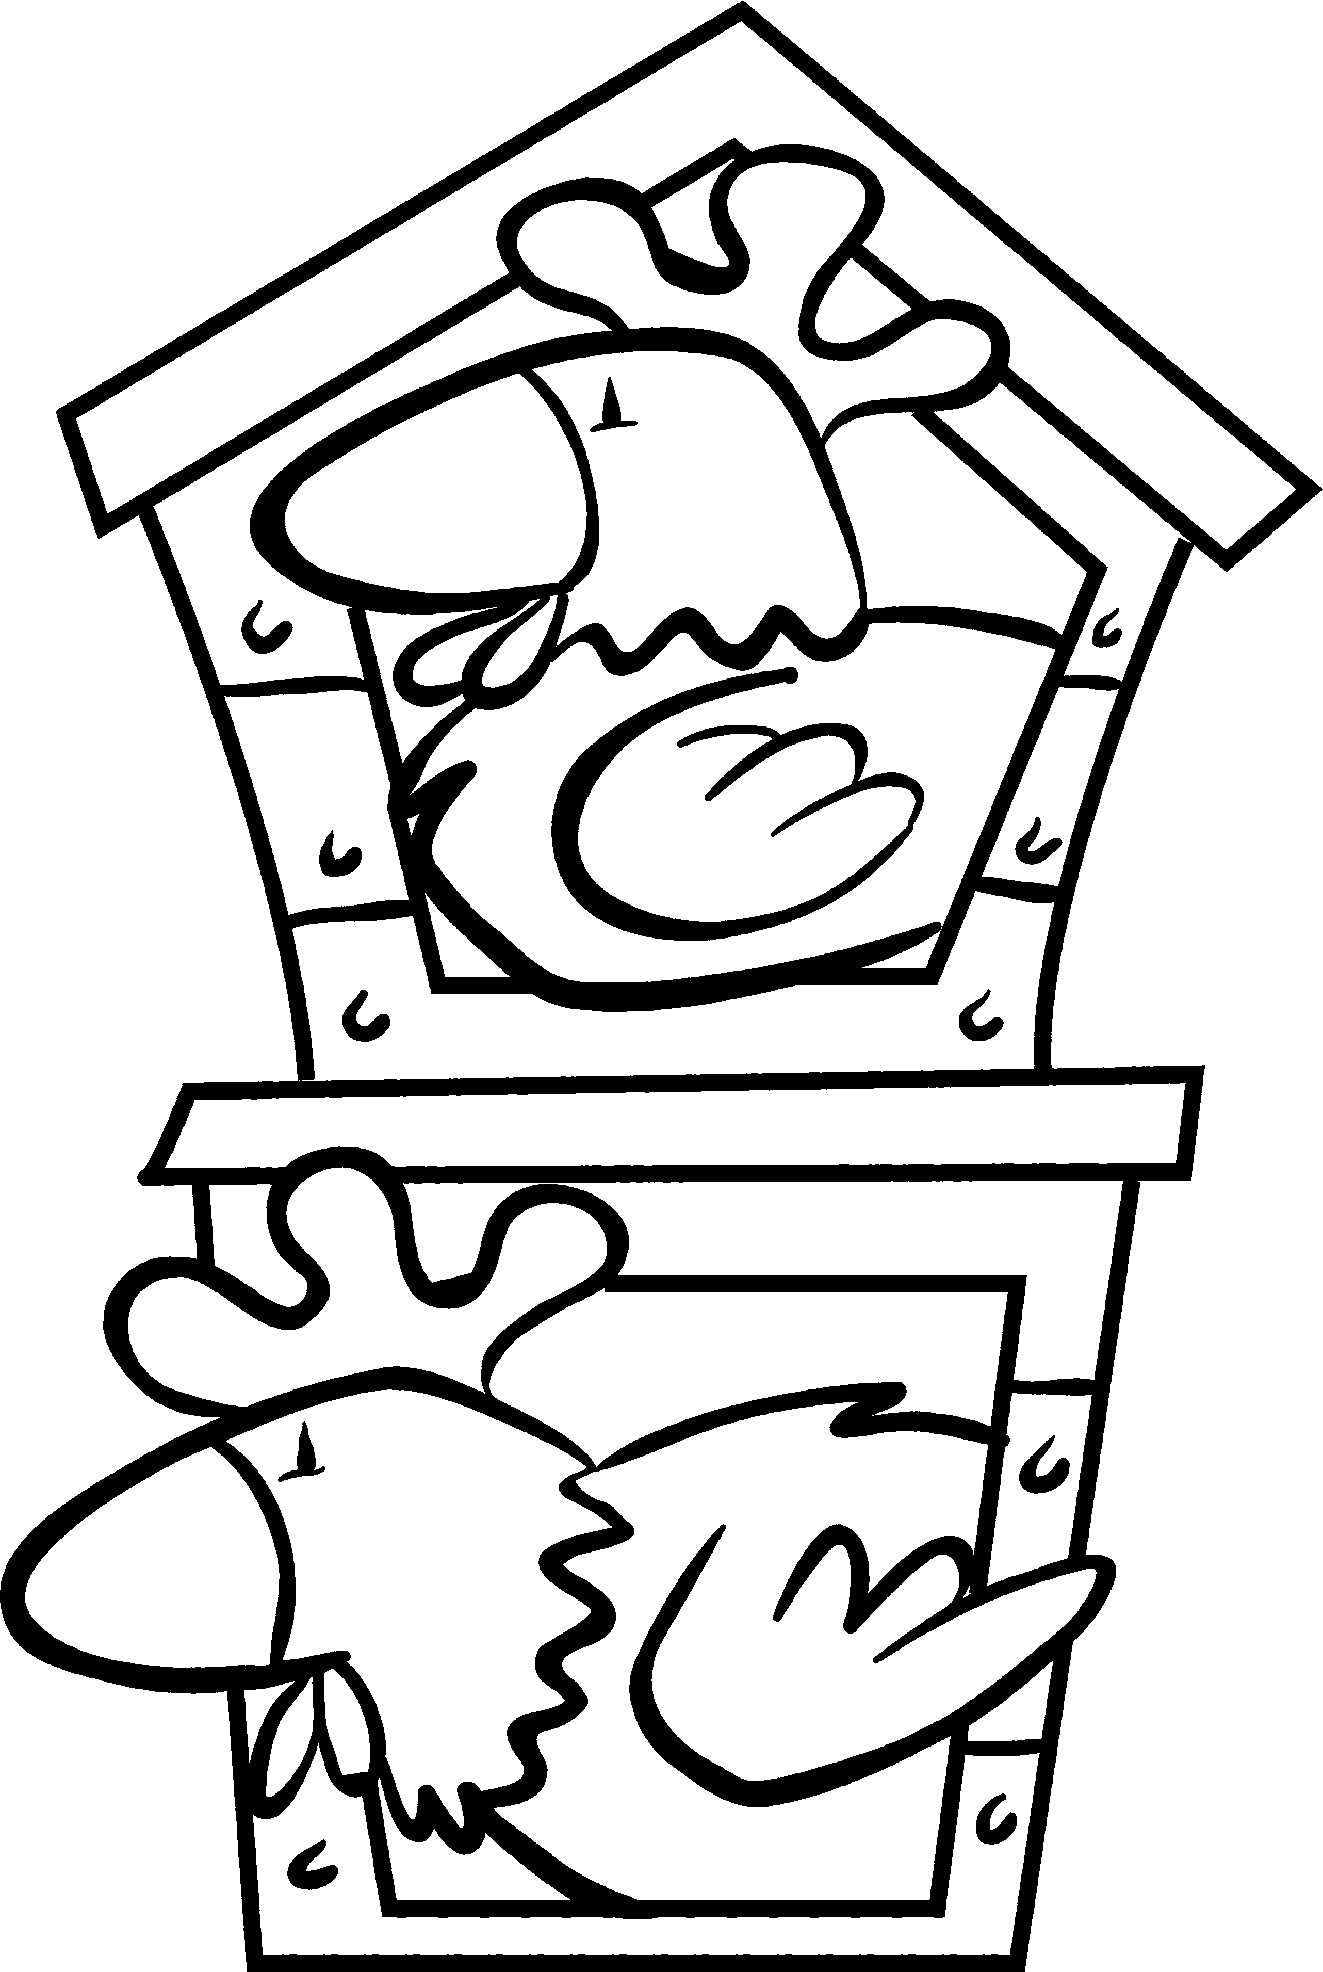
• Fill in the missing numbers to match these rules.
Rule the roost: 1
•Use the top two rows
to work out the rules.
•Then fill in the missing
numbers.
The square is always three times the triangle in the same row.
The circle is always the sum of the square and the triangle in
the same row.

3
1
3

6

7

5

28

6
3
12
9
20

40

4

7

12

• Find the rule for the hexagon and complete the grid.
Can you find different
rules for each shape?

The hexagon is ____________________________________________________ .
NOW TRY THIS!
4
2
8
6

