





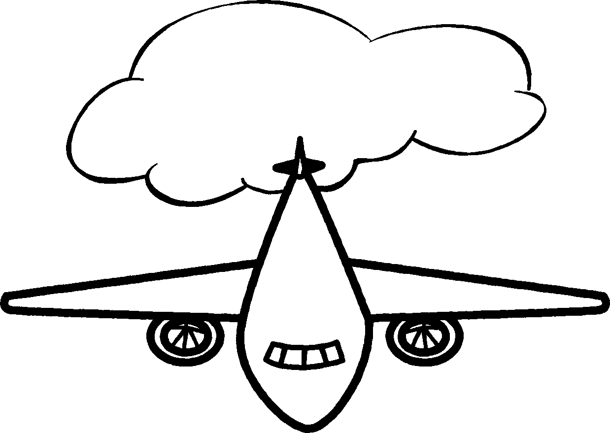

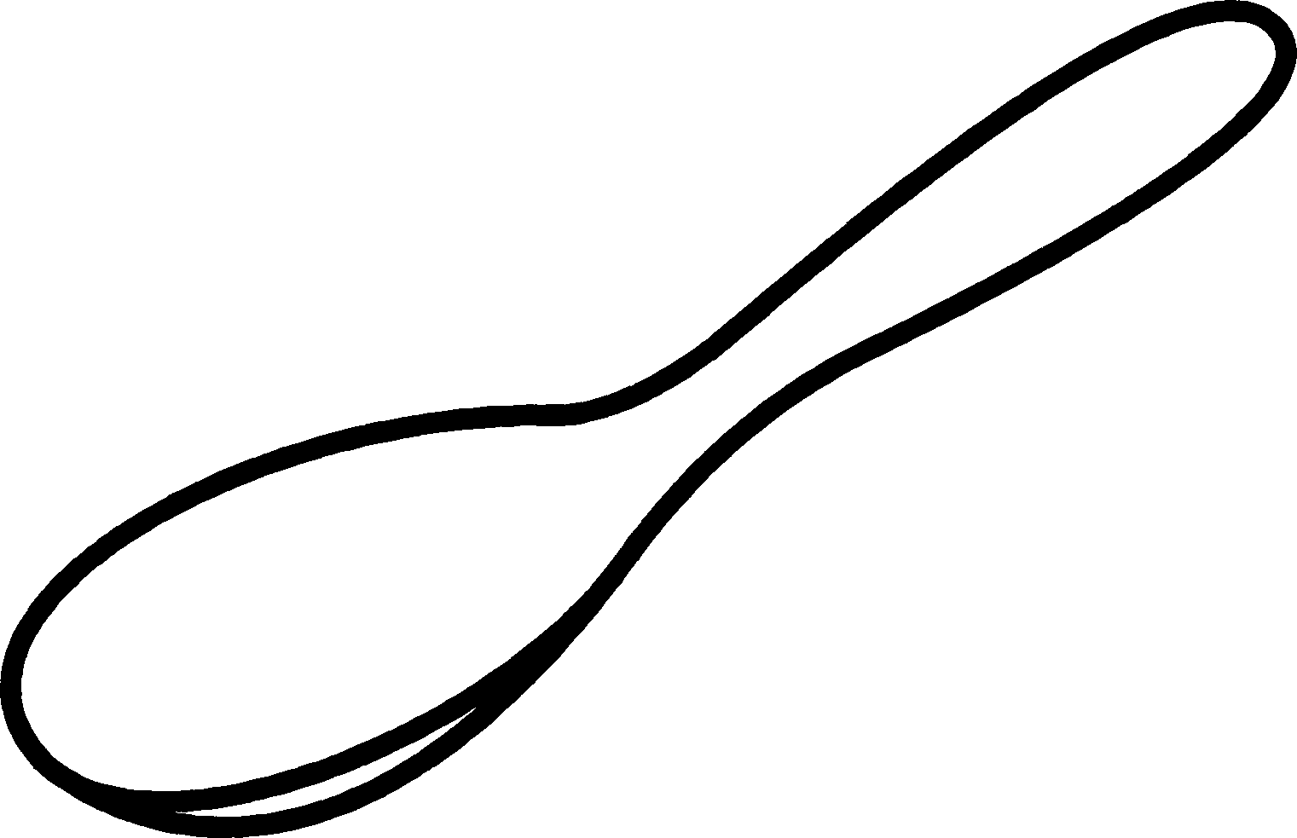

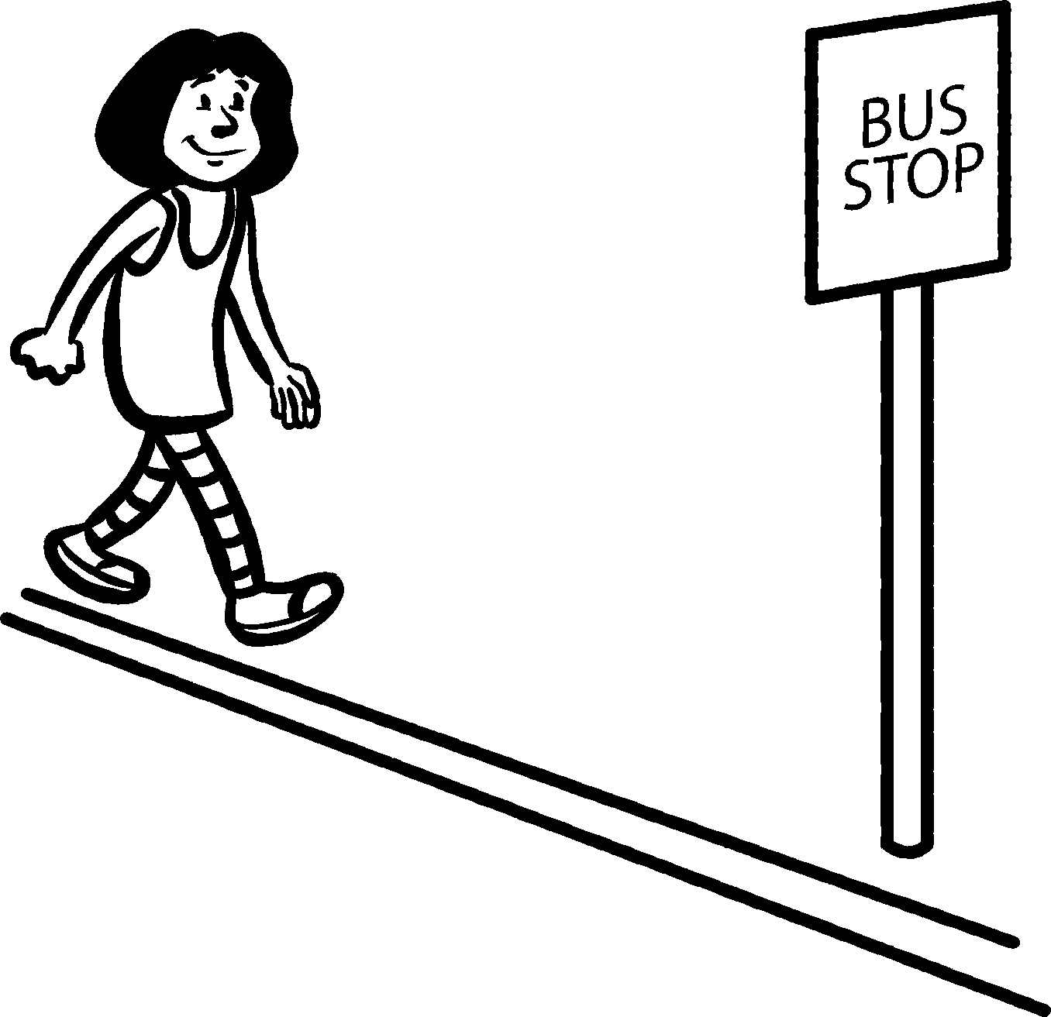
• Show how each question could be answered.
Use numbers or diagrams to help explain your working.

Measuring queries
•How many minutes less than 3 hours
is the total of these times? ____ minutes
–14 hour 10 minutes 0.5 hours 90 minutes

1 How many 5 ml spoonfuls of medicine
can be filled from a bottle holding –14 l?
2 How many 50 g scoopfuls of flour can be
taken from a bag containing 0.8 kg of flour?
3 Each day Li walks –14 km from her house to
the bus stop, and then –14 km back again.
How many days will it take her to walk 3500 m?
4 It takes 15 minutes for an aeroplane to fly 120 miles.
At this speed, how far would it fly in 2–12 hours?
NOW TRY THIS!

