

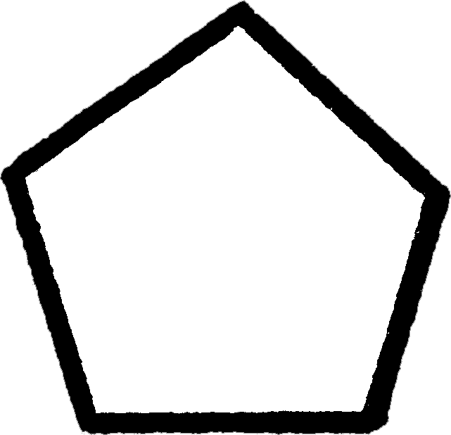
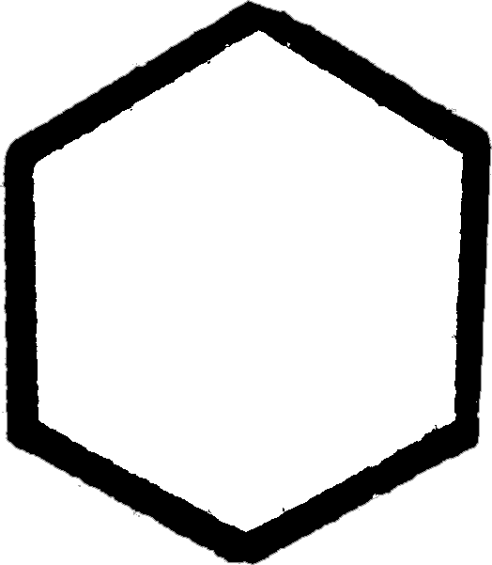
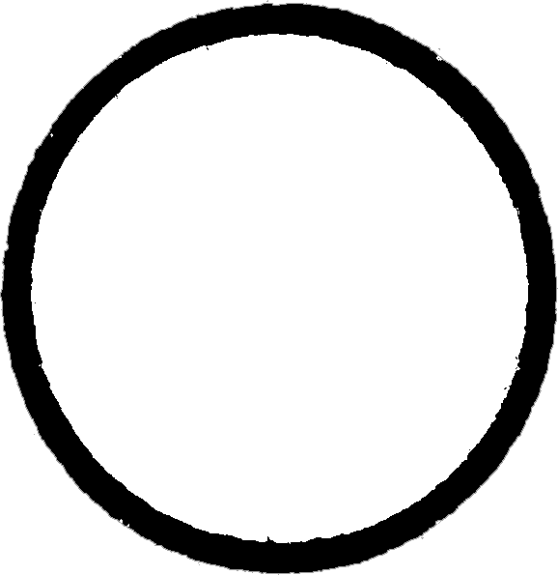

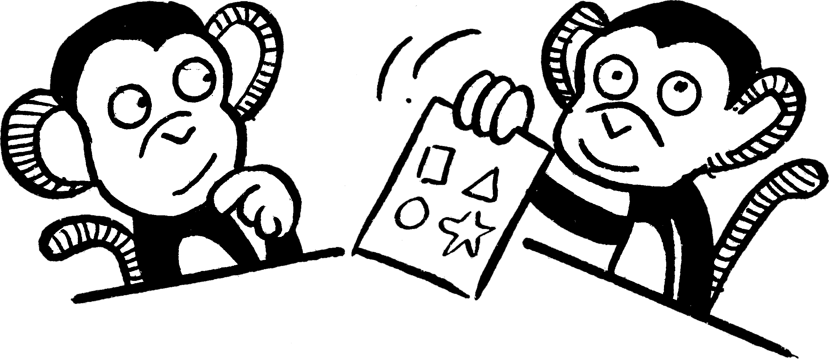
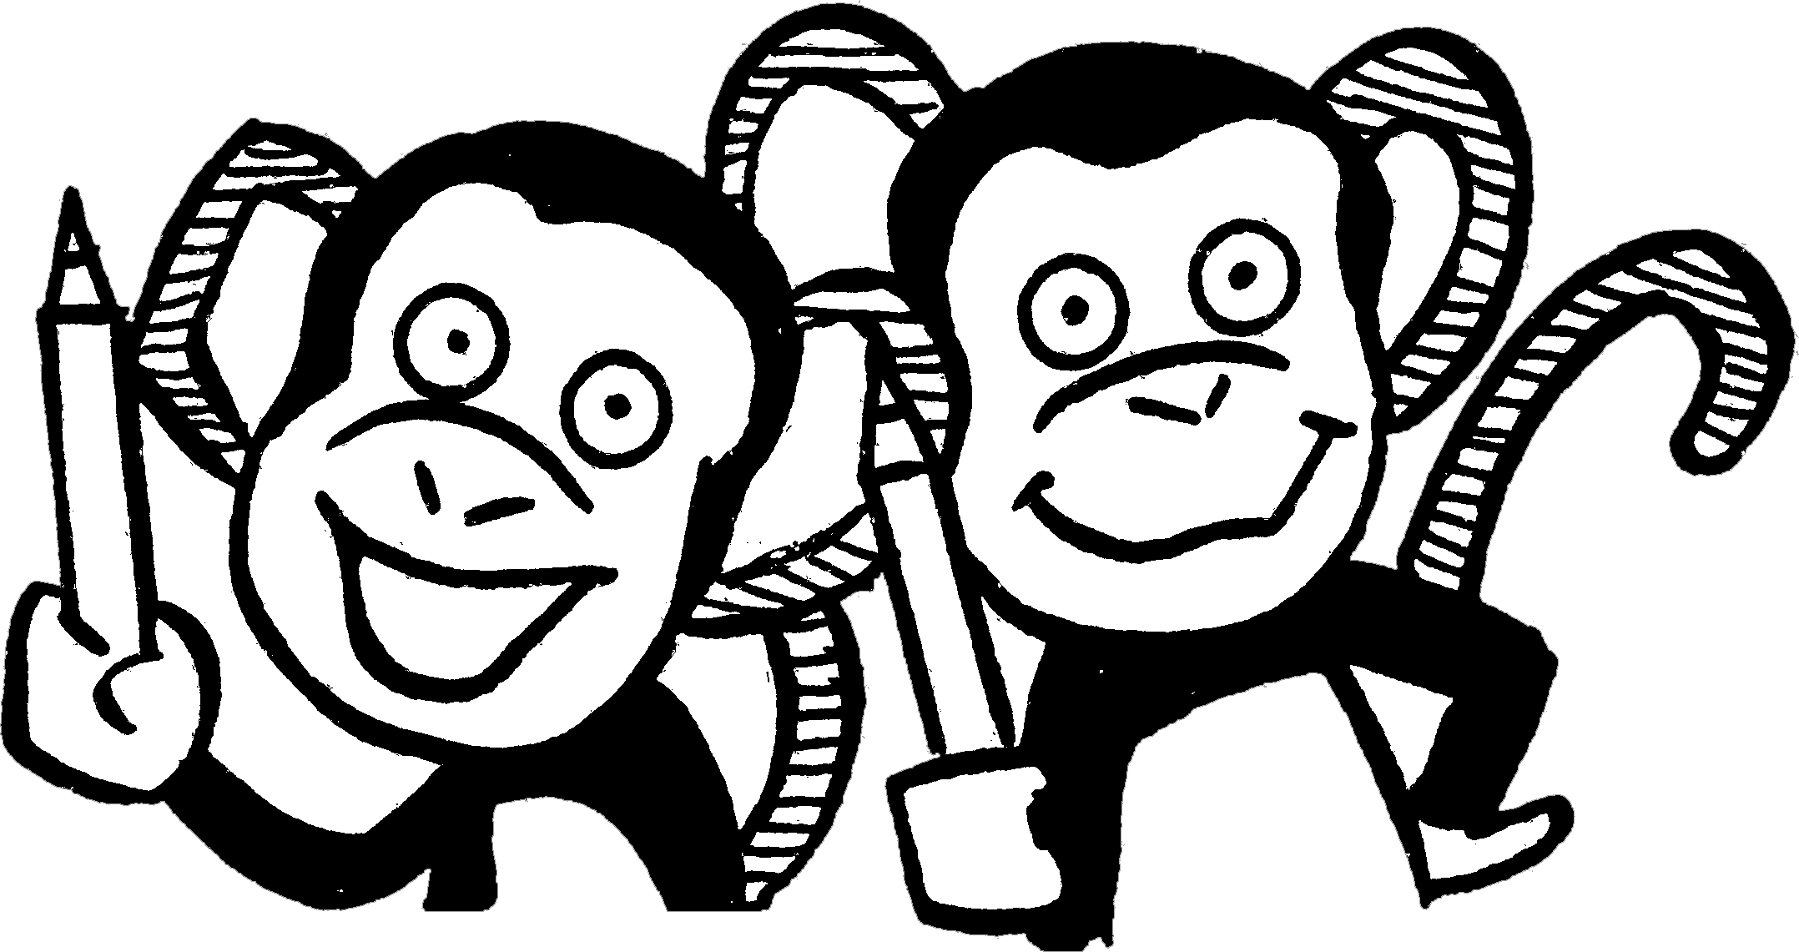
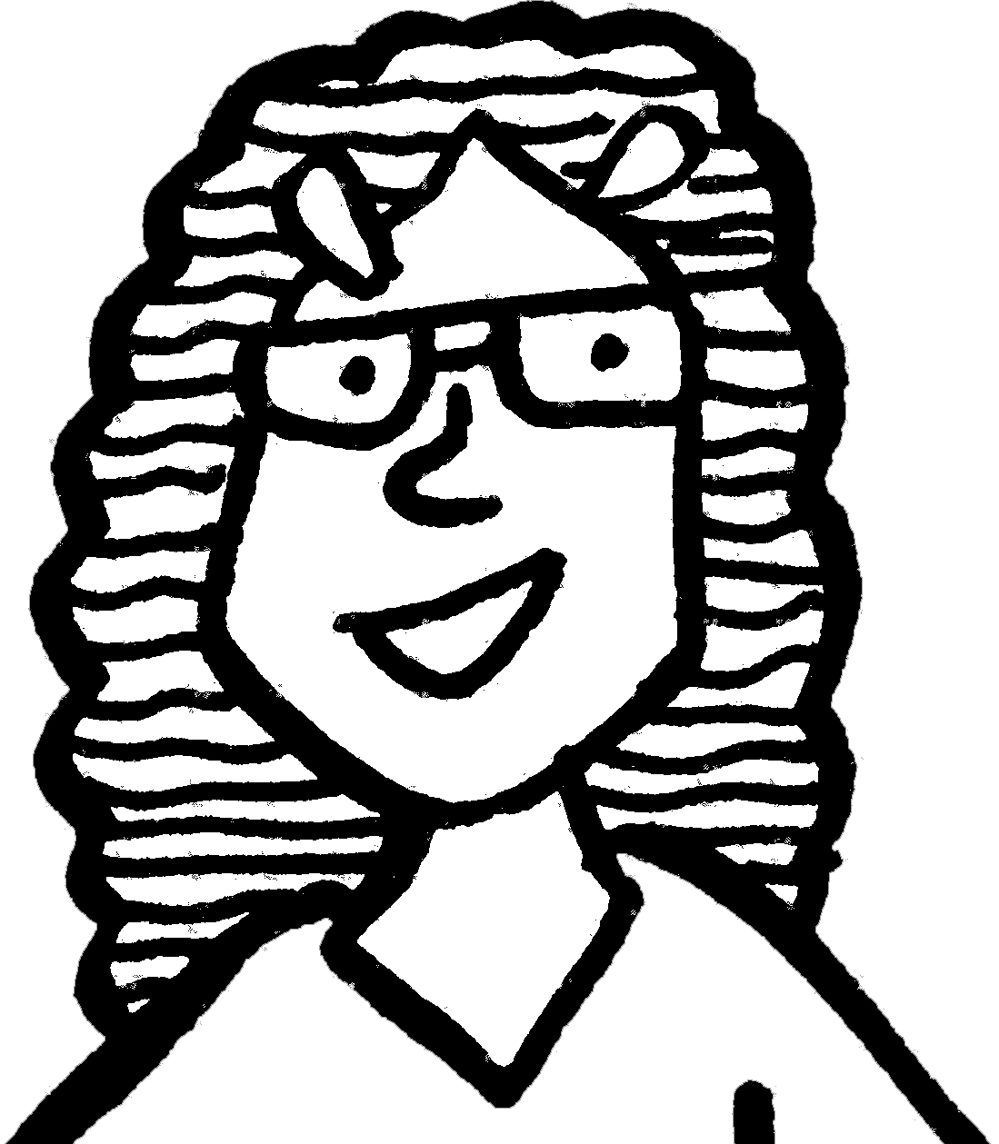
• Use the clues to help you colour
each pattern in the correct way.
Work with
a partner.
•Make up some colour puzzles of
your own for a partner to solve.
NOW TRY THIS!
1  No circle is yellow.  Yellow is between two reds.  There are three greens in a row.  One circle is pink.  Under one green is a blue. | 2  Blue is not next to a star.  No stars are the same colour.  Neither green is next to blue.  Two hexagons are red.  Yellow is between two reds.  Pink is next to a green hexagon.
3  Six shapes are green.  Between two greens is a red.  No pentagons are red.  One star is pink.  Yellow is not next to red or pink.  Between two greens is a yellow. | 4  There are eight different colours: red,  orange, yellow, green, blue, pink,  white and purple.  Red is not next to pink or blue or orange.  Orange is above pink and to the right  of blue.  Green is not next to white or red.  Yellow is above purple and to the  right of red.
Logical thinking

