


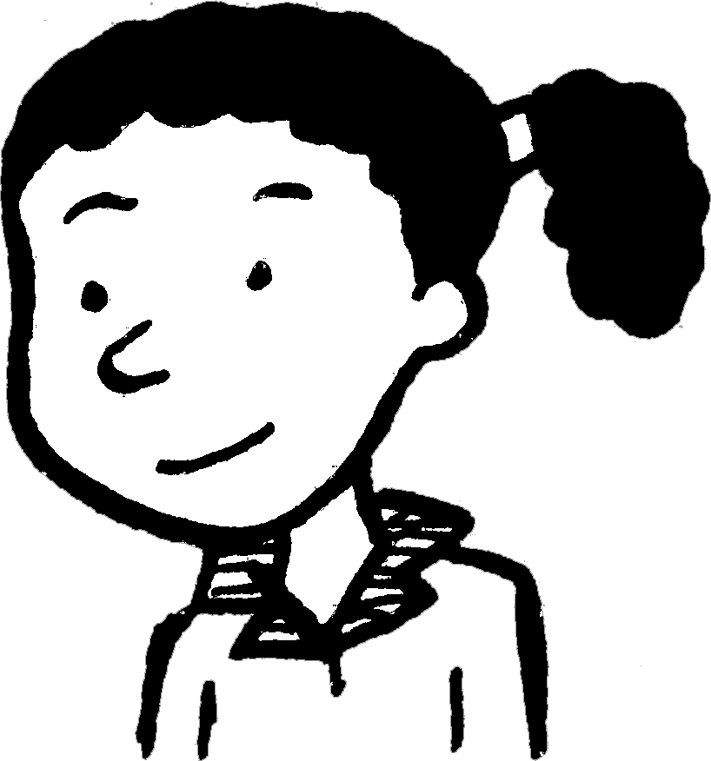
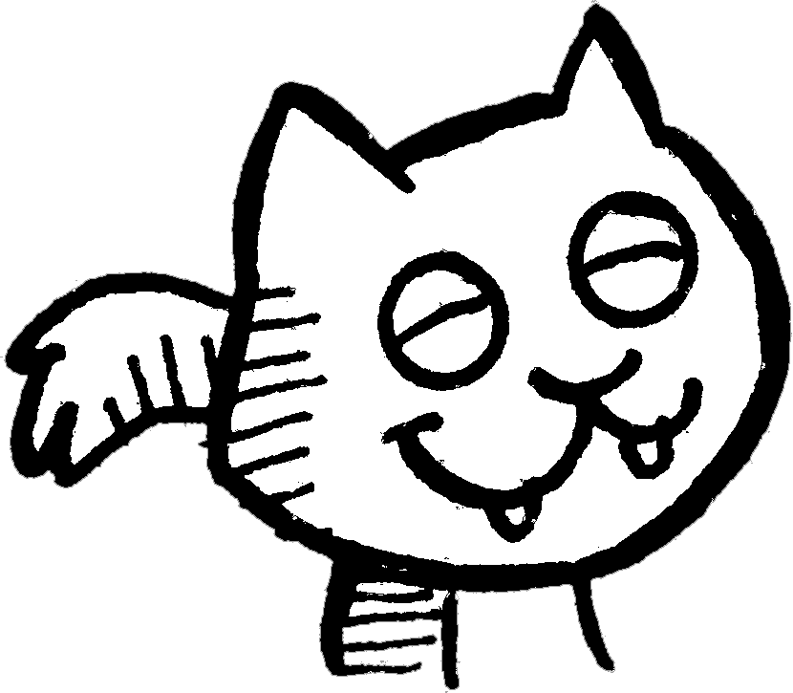
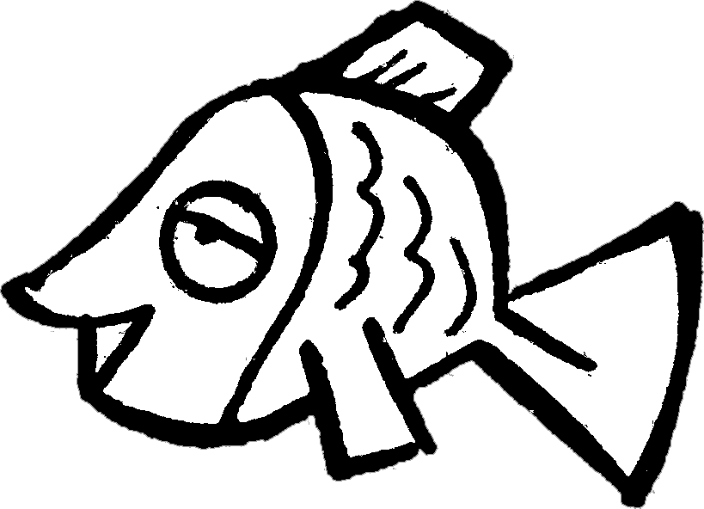
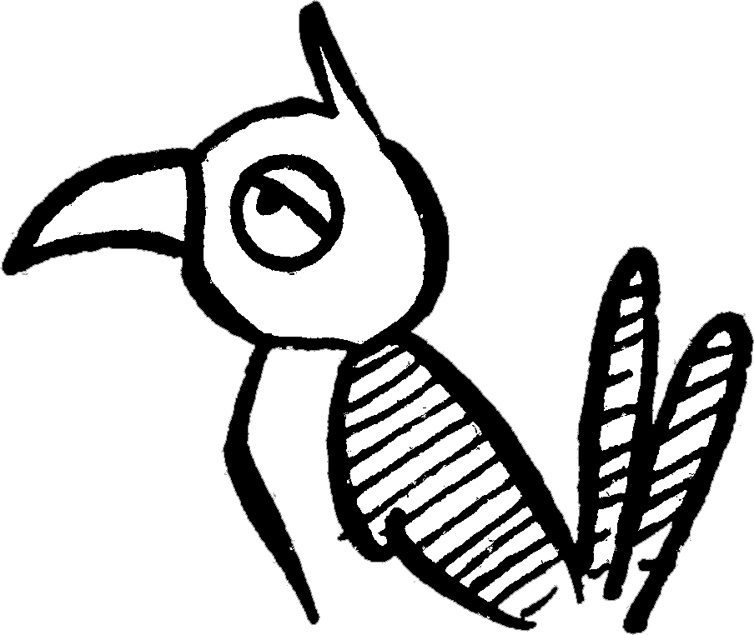
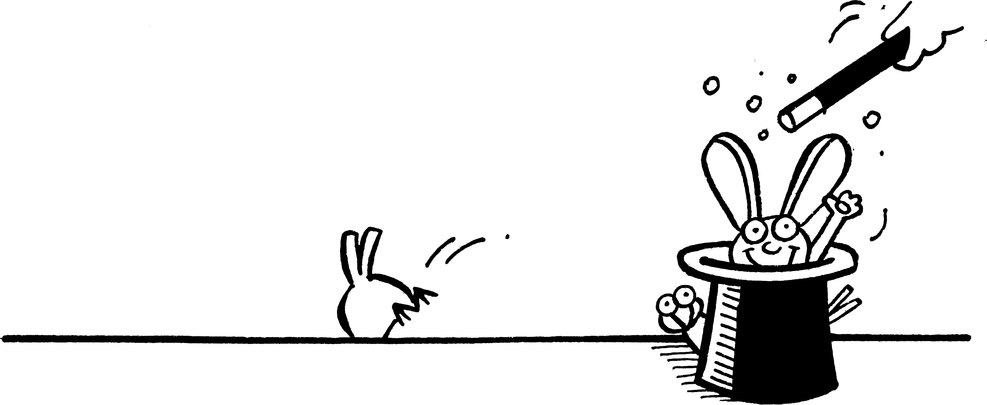
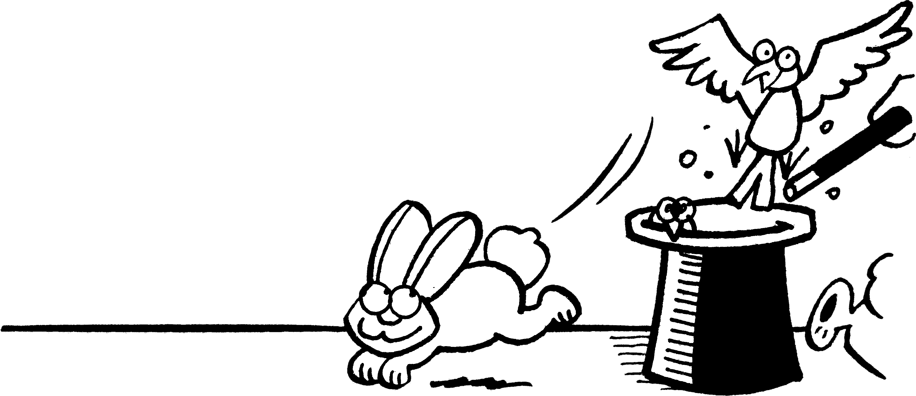
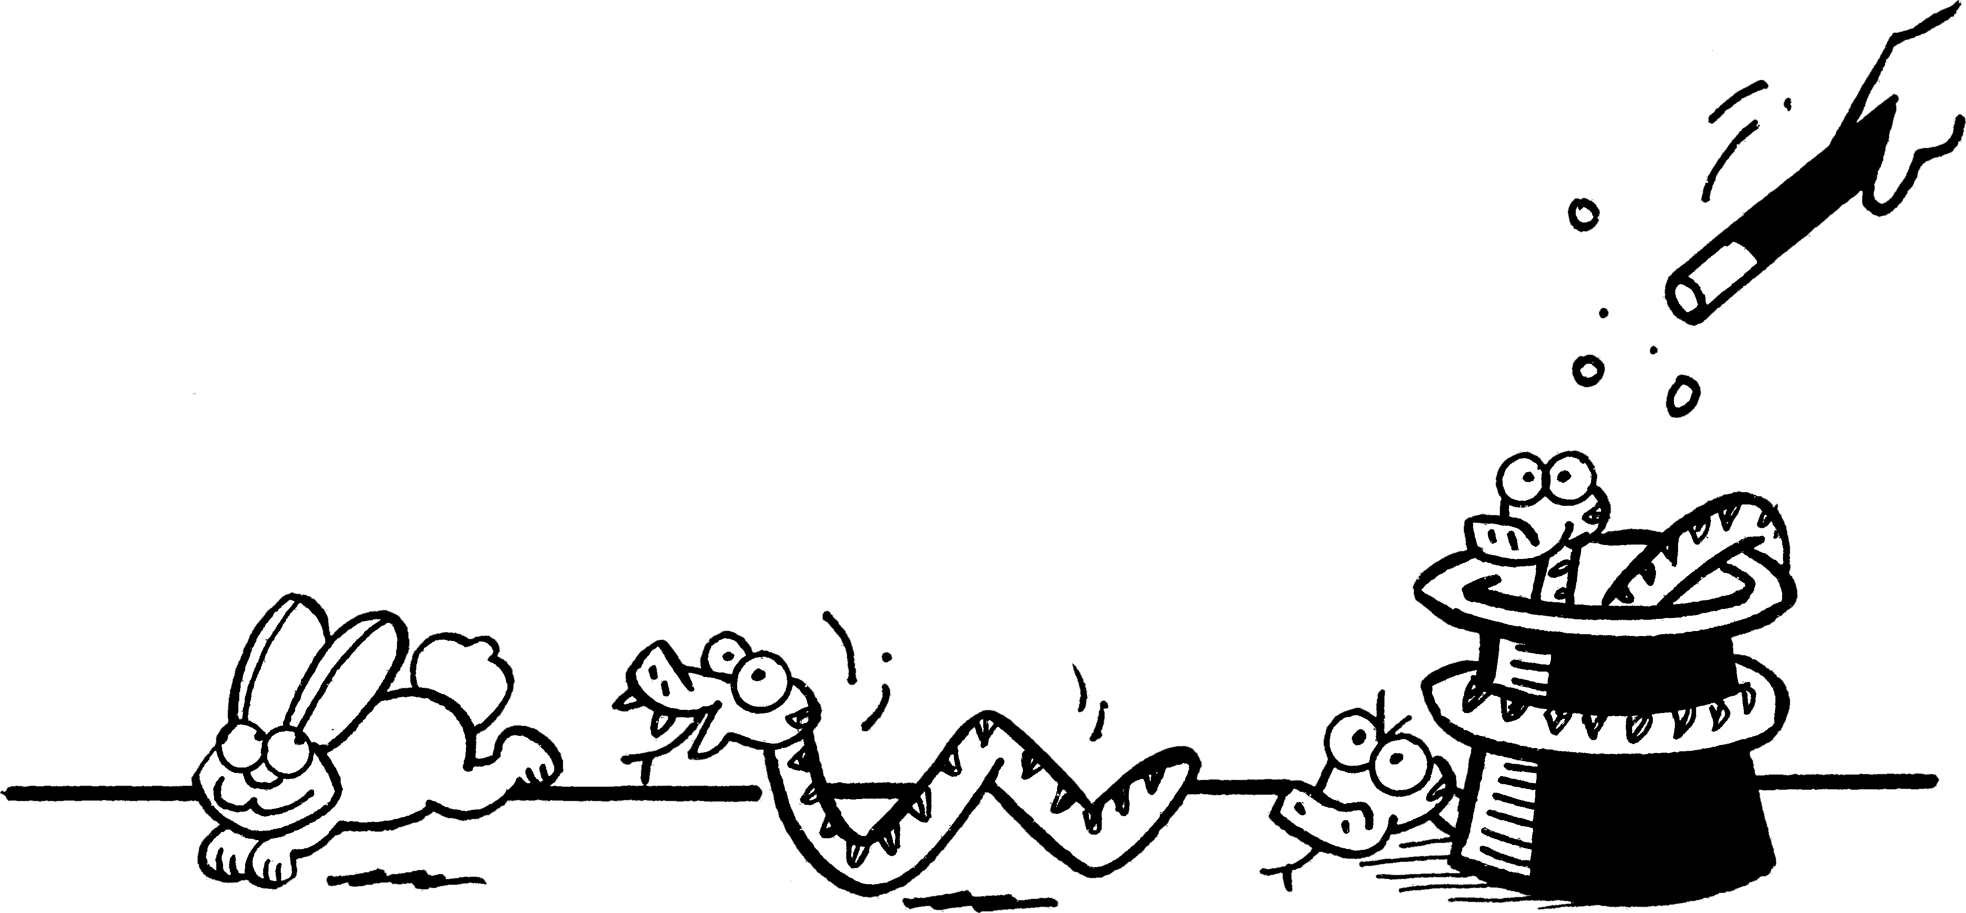
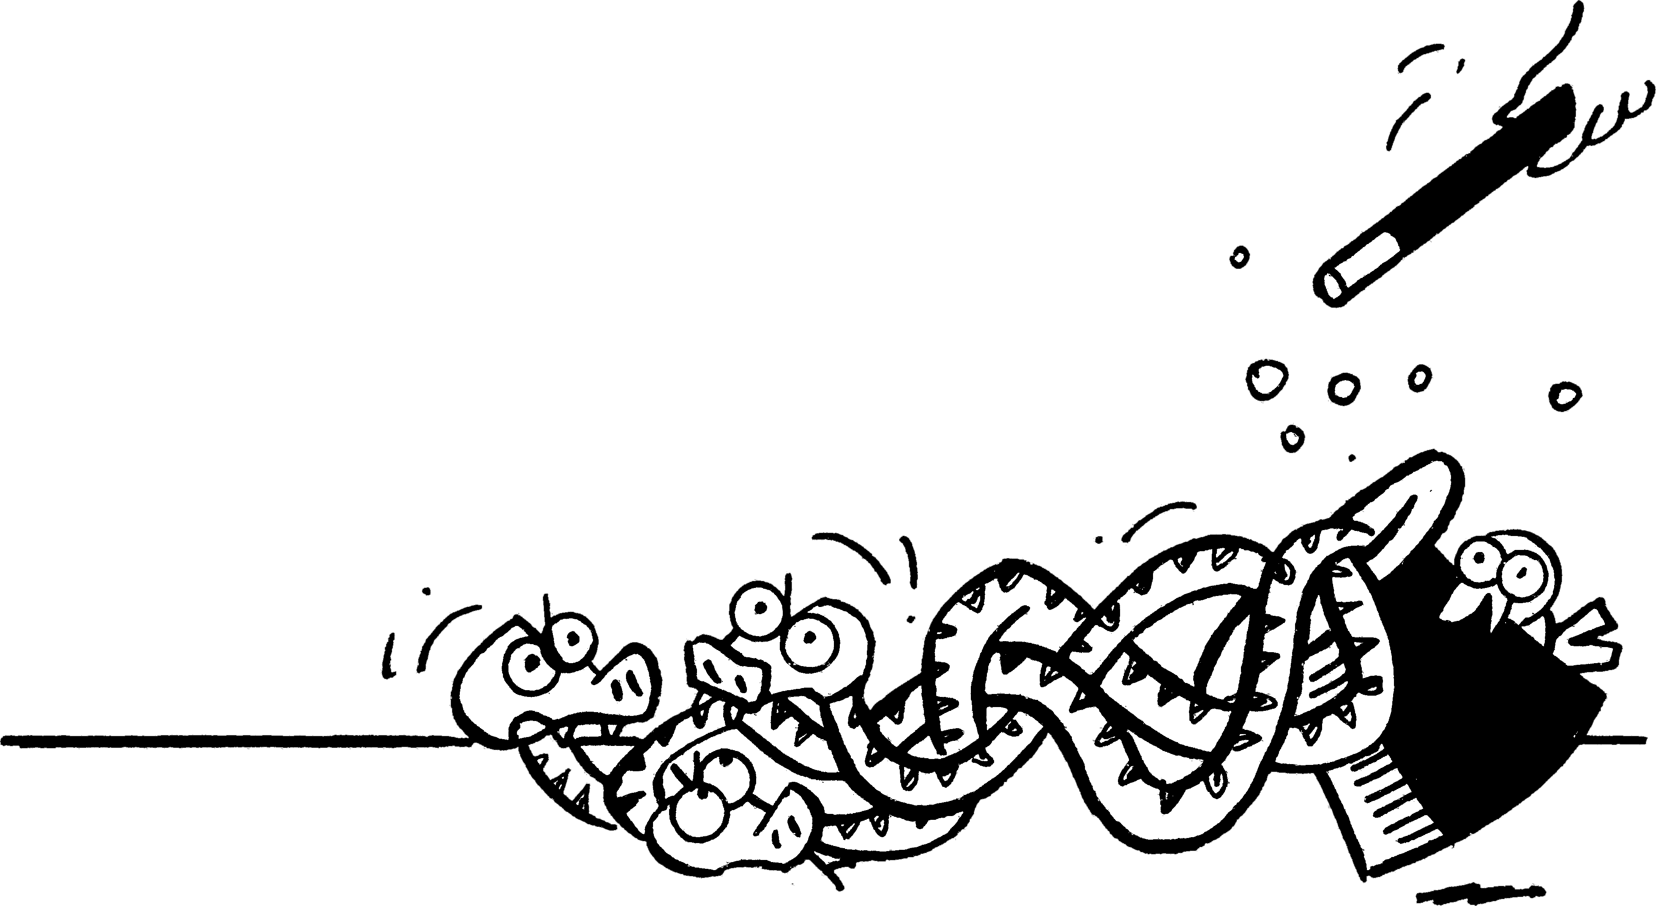
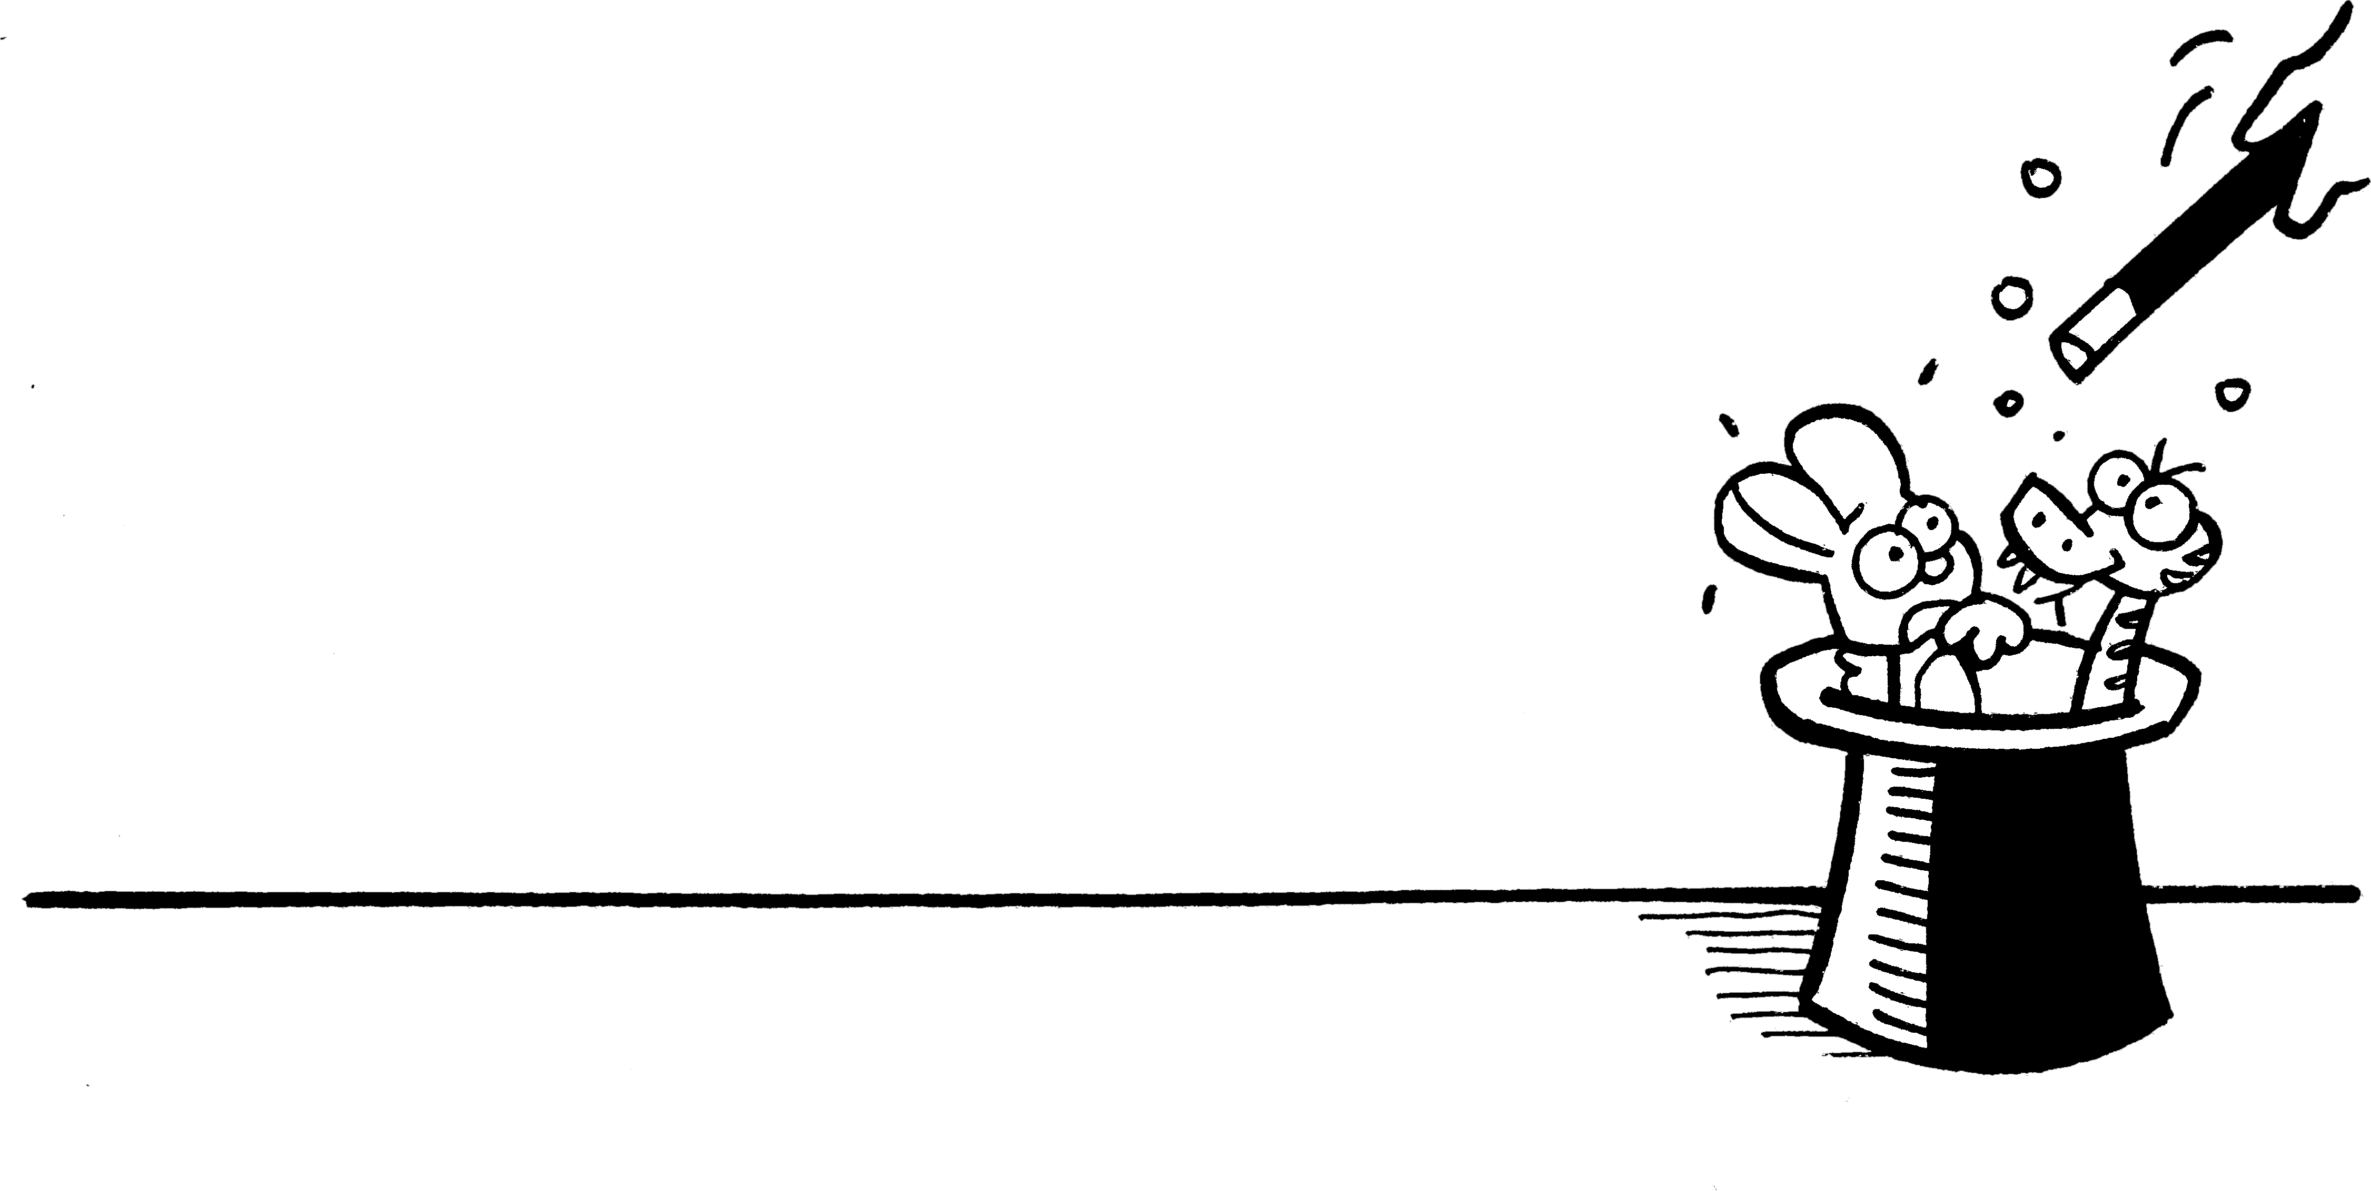
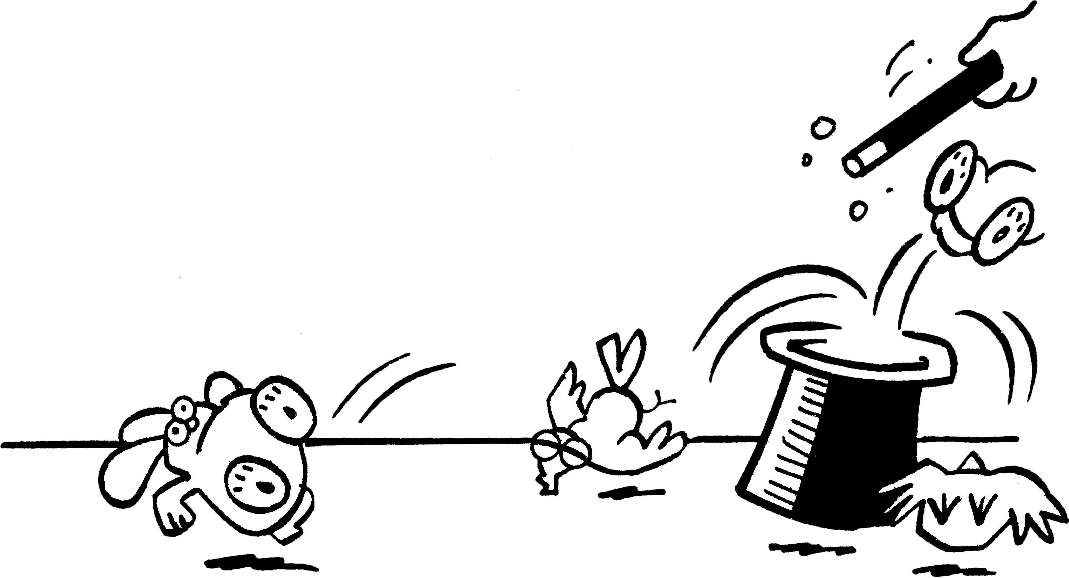
• Work with a partner to solve these puzzles.
•Make up your own puzzles using cats,
fish and birds, and tails, eyes and legs.
NOW TRY THIS!

1 In this hat there are some rabbits  and some doves.  There are 12 legs and 8 wings.  a How many rabbits? ____  b How many doves? ____ | 2 In this hat there are some rabbits  and some doves.  There are 26 legs and 16 eyes.  a How many rabbits? ____  b How many doves? ____
3 In this hat there are some rabbits  and some snakes.  There are 20 legs and 14 eyes.  a How many rabbits? ____  b How many snakes? ____ | 4 In this hat there are some snakes  and some doves.  There are 14 wings and 24 eyes.  a How many snakes? ____  b How many doves? ____
5 In this hat there are some rabbits  and some snakes.  There are 24 legs and 20 eyes.  a How many rabbits? ____  b How many snakes? ____ | 6 In this hat there are some rabbits  and some doves.  There are 20 eyes and 34 legs.  a How many rabbits? ____  b How many doves? ____
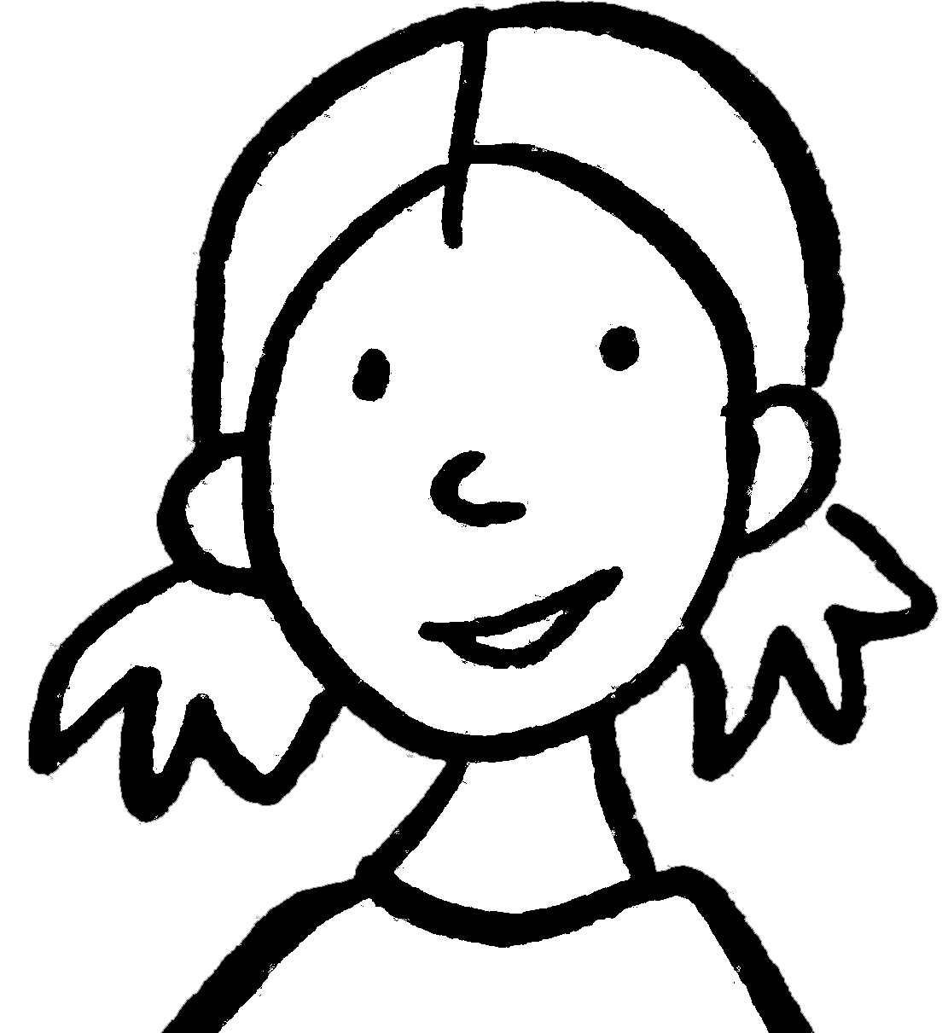
• With your partner, write an explanation
of how to solve this type of problem.
Animal magic

