Name ______________________________________

**Space**

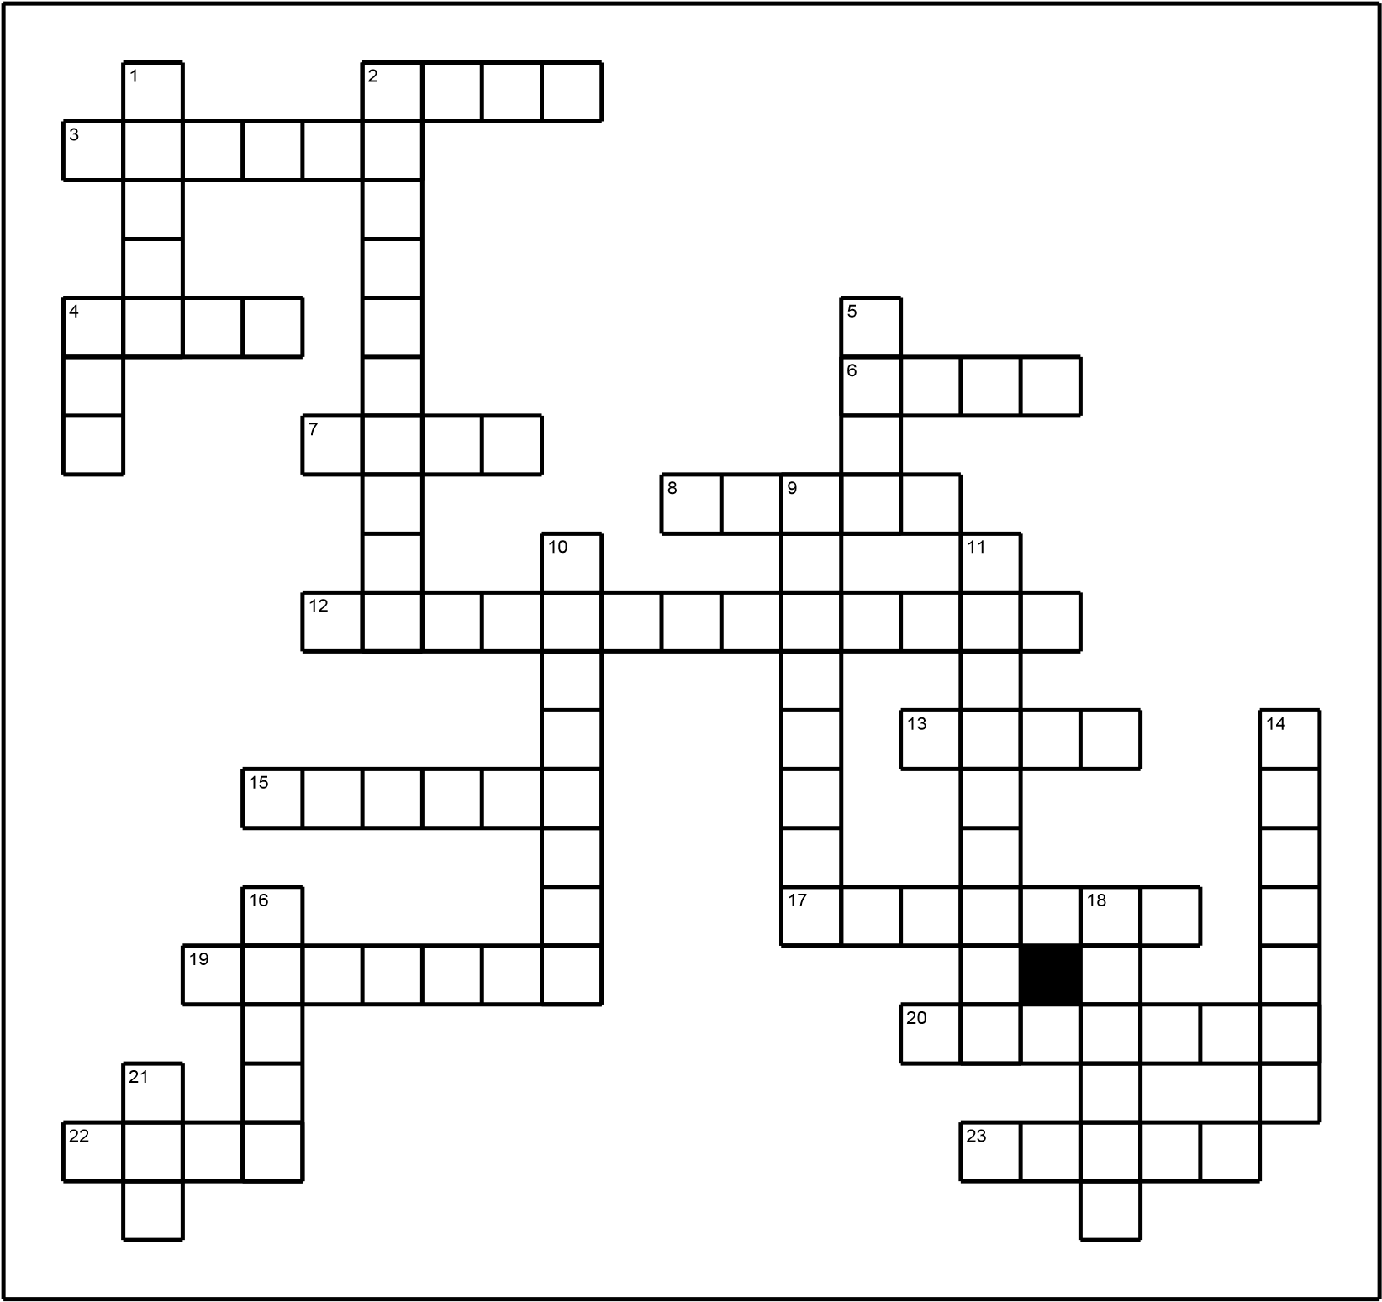

|  |  |
| --- | --- |
| **Across** | **Down** |
| 1. An imaginary line drawn throught the earth from the North to the South pole. 2. This planet is between Saturn and Neptune. 3. A sun seen from a great distance. 4. On earth the sun appears to rise in the ___. 5. Gravity on this is one sixth of what it is on earth. It takes 28 days to go round the earth. 6. This used to be called a planet but is not now. 7. This type of force keeps the sun and planets in their places. 8. The time it takes for the earth to go round the sun.   15. A group of stars.  17. This is caused by a shadow and causes either the sun or the moon not to be seen.   1. The planet nearest the sun. 2. The 8th planet from the sun. It spins in a different direction from the other planets. 3. This is the next planet out from the sun after earth. 4. The blue planet. It has water on it. | 1. The path of a planet round the sun. 2. The general name for someone who studies space. 3. The centre of our solar system. 4. On earth, the sun appears to set in the ____. 5. This contains everything. 6. The group of stars which includes the sun (5,3). 7. An object which travels round a planet.   Some are used for communication.  14. The largest planet.  16. The hottest planet. One day is longer than a year.  18. A giant planet with rings.  21. The time it takes for the earth to spin round once on its axis. |

Photocopy back to back with wordsearch.

Name ______________________________________

**Space**

|  |  |  |  |  |  |  |  |  |  |  |  |  |  |  |  |  |  |
| --- | --- | --- | --- | --- | --- | --- | --- | --- | --- | --- | --- | --- | --- | --- | --- | --- | --- |
| P | J | M | | I | L | K | Y | W | | A | Y | H | M | | J S | | D |
| P | D | W | | Q | S | A | T | E | | L | L | I | T | | E M | | V |
| U | M | E | | R | C | U | R | Y | | X | A | B | S | | W W | | E |
| P | D | O | | R | B | I | T | F | | J | S | S | A | | U | L | B |
| L | A | S | | J | S | N | E | E | | U | T | M | O | | O | N | J |
| U | Y | T | | F | U | E | Z | C | | P | R | A | B | | L | T | B |
| T | V | A | | U | N | P | E | L | | I | O | X | U | | C | W | U |
| O | E | R | | N | I | T | P | I | | T | N | I | R | | N | O | P |
| N | N | W | | U | V | U | N | P | | E | O | S | A | | M | J | G |
| T | U | K | | L | E | N | D | S | | R | M | E | N | | A | P | A |
| T | S | J | | X | R | E | N | E | | L | E | H | U | | R | E | L |
| H | W | E | | A | S | T | F | U | | A | R | Z | S | | S | A | A |
| T | O | R | | P | E | O | B | W | | M | Y | E | A | | R | R | X |
| G | R | A | | V | I | T | A | T | | I | O | N | A | | L | T | Y |
| Y | U | W | | E | S | T | Y | S | | A | T | U | R | | N | H | K |
| venus | | | | day | | | | | | star | | | | | satellite | | | | |
| orbit | | | | gravitational | | | | | | axis | | | | | saturn | | | | |
| year | | | | universe | | | | | | mercury | | | | | sun | | | | |
| mars | | | | earth | | | | | | pluto | | | | | astronomer | | | | |
| uranus | | | | eclipse | | | | | | milky way | | | | | galaxy | | | | |
| moon | | | | neptune | | | | | | jupiter | | | | | east | | | | |