**English**

* Read books and share stories as much as possible.
* Listen to a story about a space adventure ‘Roaring Rockets’ by Tony Mitton.

<https://www.youtube.com/watch?v=ko306WcHRns>

* Build a reading den or fort using blankets, chairs and boxes. Be inventive! We’d love to see some photos of your reading dens!

Here are some ideas:

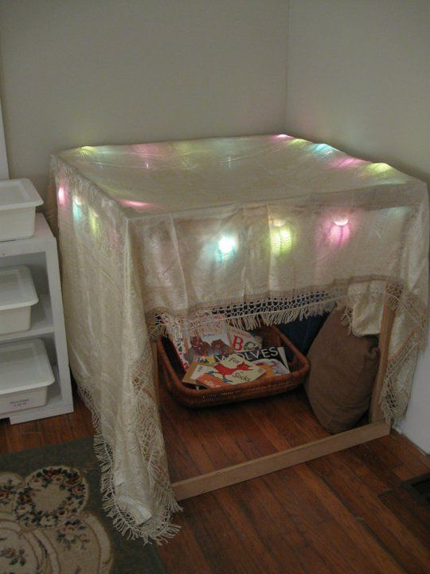 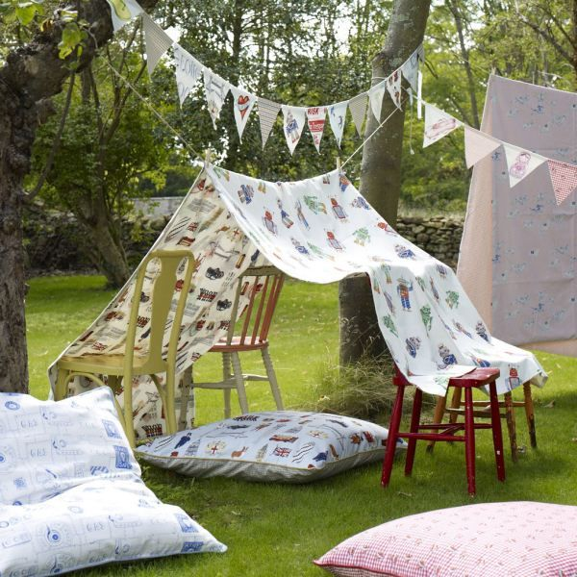

* Set up an account with Oxford Reading Owl for lots of free ebooks and readers.

<https://home.oxfordowl.co.uk/reading/>

* **Poem** – I’m a Little Rocket and Climb Aboard (Say in high/low, fast/slow, angry/kind voice)

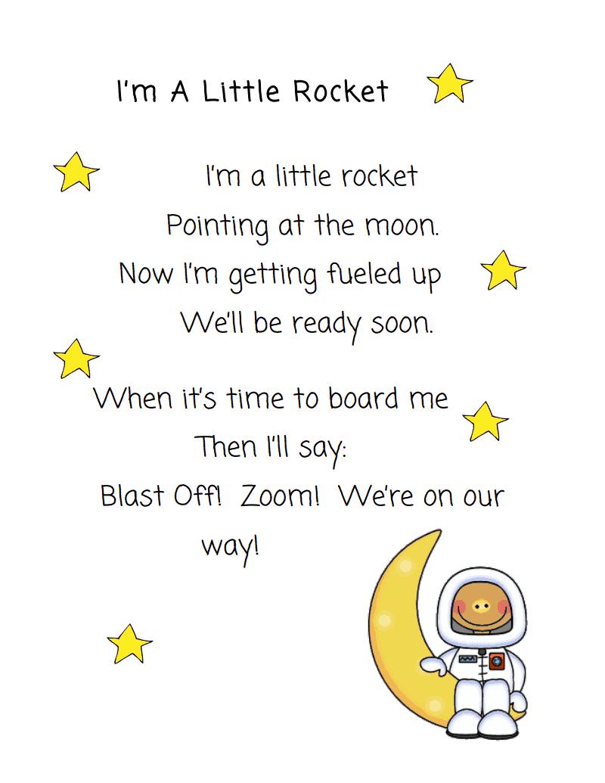 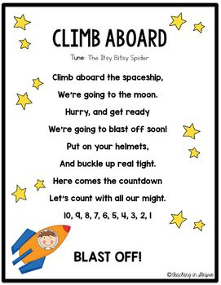

* Make a list of things you would need to bring with you if you were going on a space adventure.
* Write a postcard to your friend telling all about your pretend space adventure! Don’t forget to tell that all the things you saw!
* Keep a diary – draw pictures and write a sentence about what you did or your favourite part of that day/week.
* Alphablocks: Watch some alphablocks videos on youtube- pause the video at different stages and see can your child sound out the word.

<https://www.youtube.com/watch?v=_ovFXpsWmS0>

<https://www.youtube.com/watch?v=VxBEmaaSh1c&t=21s>

* Geraldine the Giraffe: Watch Geraldine the Giraffe learns oi and ay on youtube. Go for a sound hunt and see can you find any things in your house that have the sounds oi and ay in it e.g. **oi**l, t**oi**let, tr**ay**, spr**ay.**

<https://www.youtube.com/watch?v=MTCP8i4Nwgc>

<https://www.youtube.com/watch?v=IRTITdRL_cU>

* Here are some tricky words to practise at home:

|  |  |  |  |
| --- | --- | --- | --- |
| it | down | The | my |
| likes | this | can | at |
| am | here | me | some |
| he | she | In | but |
| Today | yes | no | so |
| It | Down | Get | do |
| That | Yes | No | from |
| was | be | He | then |
| You | has | had | not |
| him | her | said | have |
| with | his | our | they |
| little | an | come | there |
| got | of | by |  |
| them | says | are |  |

* Tricky words word hunt: Write some tricky words on pieces of card and hide the around the house. Children have to collect and read the words. Can you put these tricky words into sentences?
* Tricky words slap: Write some tricky words on pieces of paper and lay them out on the table. Each player has a wooden spoon. Adult calls out the word and players have to slap the word as fast as they can. Fastest player keeps the card. Child with the most cards at the end of the game wins.
* **Snap**: Divide the words equally between you and your parent/brother/sister/teddy. Turn over one each on top of each other. Say snap and hit the deck if there are two in a row the same.
* **Spelling: Look-Say-Cover-Write-Check Challenge**: Pick a tricky word, Look at and say the word, Cover the tricky word and have a go writing it again, Check to see if it’s right or wrong.

**Phonic Spelling Challenges**

Choose the ones your child can do. If your child can’t do it, you write it and let them copy. Do it every day that you have time.

* Parent calls out single letters and child writes it down.
* Parent calls out words (sun, mud, up, mat, jam, cat, dog, gar den) and child writes it down.
* Parent calls out sentence (I sat in the sun) and child writes it down.
* Say the sound oi and write oi. Draw some pictures with the oi and ay sounds e.g. tray, spray, oil, toilet etc.

**Maths**

* **Rainbow Number formation:** Practise writing the numbers 0- 10.Pick a number, roll a dice and write the number in different colours.

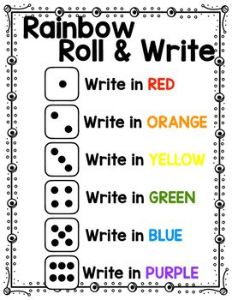

* **2D Shapes:** Go for a shape hunt around your house. Can you find any circles, squares, rectangles or triangles? Draw some 2D shapes and cut them out using a scissors. Make a picture using your shapes e.g. a house or a robot.
* **Number 10:** Can you find the number ten in your house? Make the number ten with your fingers. Describe it. Get out 5 forks and 5 forks. Count them. How many are there all together? Divide them in two groups as many ways as you can (5 +5, 4 +6, 7+ 3, 2 + 8)
* **Videos about number 10:**

Sesame Street Number 10 (Number of the Day song) <https://www.youtube.com/watch?v=kRiUEr89ep0>

Charlie and the Number 10 <https://www.youtube.com/watch?v=NoOVTArLNxA>

* **Robot Addition:** Play the Robot Addition game (addition up to 10) on the top marks website.<https://www.topmarks.co.uk/addition/robot-addition>
* **Teddy Bears Hiding game:** Get ten small teddy bears (or small toys) and a box. Close your eyes and one person hides some of the teddy bears. Open your eyes and guess how many are hiding. E.g. 6 bears are not hiding which means 4 teddys must be in the box as 6 plus 4 equals 10.
* **Number line** – Write the numbers 1- 20 on small pieces of paper. Mix the numbers up and put them in the correct number. Close your eyes and turn over one of the numbers. Can you guess which number is missing?
* **Active Counting:** Children can take a trip to the number gym.

Pick a starting number and finishing number (either counting backwards or forwards)

Pick an activity e.g. jogging on the spot, star jumps, “weight-lifting”, squats etc. Children count while engaging in the physical activity.

**Music:**

Learn the song Zoom Zoom Zoom, We’re going to the moon. See can you make up any actions to go with the song!

<https://www.youtube.com/watch?v=DEHBrmZxAf8>

**Art & Crafts:**

* Make an Alien: Using a toilet roll holder and some paint/ crayons, create an alien. Cut out circle shapes for their eyes and stick them on.

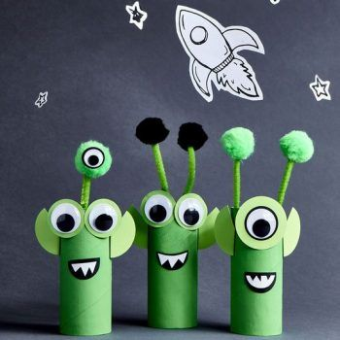

* Create a space pack: Using an old box, a toilet roll holder, tinfoil, some string and some paper, try to create a jet pack for your mission to space. Don’t forget to draw some dials and buttons on it!

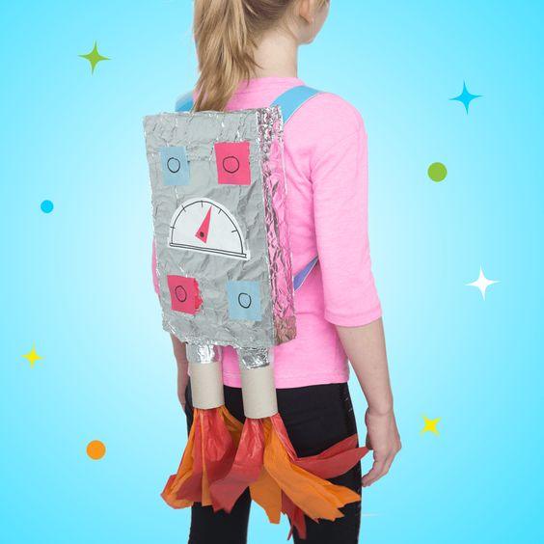

**Physical Activity**

* PE with Joe Wicks- Watch live every day at 9am (lots of saved videos available too!)

<https://www.youtube.com/watch?v=QvWzWqLk8iQ>

* 10@10 - daily 10minute exercise videos. (<https://rtejr.rte.ie/10at10/>)
* What’s your Name? Spell out your name and do the activities for each letter.

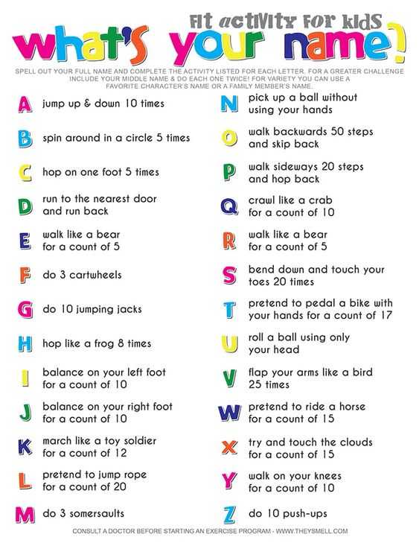

* Simon Says: Play an active game of Simon Says e.g. Simon Says do 10 jumping jacks/ 5 squats/ 7 high knees.
* Skipping- If you can get your hands on a skipping rope, now is a great time to learn how to! Here are some skipping rhymes to help you count your skips

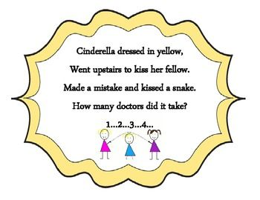 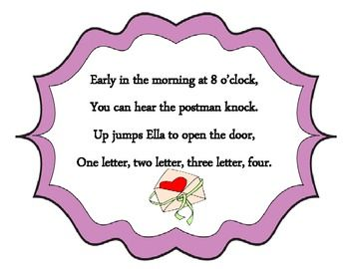

**Other Activities: The following are activities that are excellent for developing the children’s logic skills, creativity as well as aiding with academic development.**

* Jigsaws
* Water and Sand-play
* Building with Lego and blocks
* Learn to tie your laces
* Nature walk/Scavenger walk
* Make a list of things to look out for on a walk. (Children could help to write the list)
* Take a photo of what you find or draw pictures when you come home.