**English**

**Story:**

We are going to cover two different stories over the next two weeks- ‘**The President’s Cat** and ‘**The Gruffalo’.**

For the first week the focus is on ‘The Presidents Cat’ by Peter Donnelly.

**The President's Cat** is a picture book. The forgetful **President** is at it again – he has returned from his holidays in Kerry without his **cat**! As **the President's cat** tries to get back to Áras an Uachtaráin, he takes readers on a colourful adventure around Ireland, visiting some of our best known landmarks.

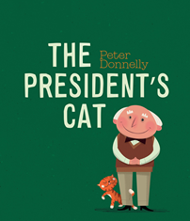

Just follow the link to the story:

<https://www.facebook.com/dlrlibraries/videos/the-presidents-cat-a-sailor-went-to-sea-sea-sea/216105549483342/?__so__=permalink&__rv__=related_videos>

**or** you can look at the video of **Ms. Martin** reading “**The Presidents Cat**” in the “**News**”

section.

Here are some activities that you can do together at home. We would love it if you could send us any photographs or pictures of work that you are doing at home and then we could put them on the website.

* Talk about the story together and ask questions about event s that happened in the story, for example ‘Who is the main character? Who are the other characters? What part of the story did you like the most? How do you think the President felt when he realised he left his cat in Kerry? How did he feel when his cat came home?’.
* Can you draw a picture of your favourite part of the story or can you draw a picture of your favourite character in the story?
* Can you identify the beginning, middle and end of the story or can you sequence the main events in the story?
* The President has an excellent website with a section for children; <https://president.ie/en/childrens-section>. Log on and see what you can find out about the President of Ireland. You can also take a virtual tour of Áras an Uachtaráin and see inside the President’s house; <https://president.ie/en/explore-visit/interactive-tour>.

For the second week it’s ‘The Gruffalo’ by Julia Donaldson. The Gruffalo is a children's book by writer and playwright Julia Donaldson, illustrated by Axel Scheffler, that tells the story of a mouse, the protagonist of the book, taking a walk in the woods.

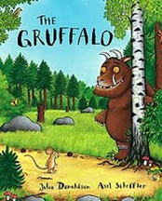

Here is a link to the story: <https://www.youtube.com/watch?v=s8sUPpPc8Ws>

# Here is a link to the short clips that are from the movie’ The Gruffalo’: <https://www.youtube.com/watch?v=yHoyg_pwT2w>

There is a selection of different activities that you might choose to do read/watch the story a few times over the week and do a different activity at each reading.

1. Tell the children the name of the author and illustrator. Look at the cover and talk about what you can see. Read the ‘blurb’ at the back of the book and tell them that’s how you find out a short bit about the story inside the book.
2. Ask questions for e.g: What do you think this will be about?
3. Listen to the story and then talk to the children about the different characters in the story. Sample questions: Who is the main character? Who are the other characters? Where is the story set? What time of year is it? What are the characters doing? What part of the story did you like the most? What do you think will happen after the end of the story?
4. Draw pictures of what happens in the story. Divide a piece of paper in three and label each section like this

|  |  |  |
| --- | --- | --- |
| First  *Draw a picture of the beginning of the story.* | Then  *Draw a picture of what happens next.* | Finally  *Draw a picture of how the story ends.* |

1. Talk about the different animals in the story. Draw a picture of one of them and write a short sentence: e.g The cat is brown. / The mouse is small. / I like the cat. / I see the mouse. etc.
2. Draw a picture of the animal and write a sentence about it.
3. Draw a map of where the cat went on her journey or draw a picture map to show all the different animals that the mouse met along the path.
4. Here is a link to show you lots of different activities that you can do based on the story of ‘ The Gruffalo’: <https://www.gruffalo.com/activities/activities>

**Phonics:** Practice one or two sounds each day.  For example, s & a on Monday, t & i on Tuesday and so on. The children can sing the song that goes with the sound and do the action. See how many words they can think of that begin with the sound. Can they think of any words that have the sound at the end or in the middle?

(Jolly Phonics order of sounds:  s,a,t,i,p,n,c,k,e,h,r,m,d,g,o,u,l,f,b,j,z,w,v,y,x).

**Word work:** For the first week practice blending 3 letter words ending in ‘et’- bet, get, let, met, pet, set, wet etc.

For the second week practice blending 3 letter words ending in ‘en’- den, hen, men, pen, ten etc.

Write out one of the words. They should blend the sounds, with no gaps, to make the word. They can try writing out some of the words as they stretch out the sounds aloud.

There are a lot of activates that you can find for CVC words. The following websites might be useful:

[www.twinkl.ie](http://www.twinkl.ie)

[www.nessy.com](http://www.nessy.com)

[www.theschoolrun.com](http://www.theschoolrun.com)

Alphablocks on you tube have great short videos to learn about CVC words. Here is a link to one of the many short videos that they have based on CVC words:

<https://www.youtube.com/watch?v=CJQxUSd70u4>

**Writing;**Continue to practice the ‘curly caterpillar’ letters c,o,a,g,d that you have been doing.

Now we should be moving on to the ‘One armed Robot Letters’: r, n, m, h, b, k, p

For the first week please focus on the letter formation on r,n,m, h.

For the second week you can practice b,k,p.

You should be practicing writing your letters on the line and keeping the letter formation neat and tidy.

When writing your sentences remember the good writing tips:

1. The sentence should start with a capital letter.
2. Your letters should be on the line.
3. Remember your finger spaces between each word.
4. Remember to put a full stop at the end of your sentence.

Check out this YouTube clip for the right way to form the letters: <https://www.youtube.com/watch?v=kpu8W15h41M>

This video shows the correct way to hold the pencil. <https://www.youtube.com/watch?v=DP5htYZ5jjQ>

**Tricky Words:**

You can go over the tricky words that you already know: the, I, and, like, here.

For week one go over the following words: is, we, look, see, it.

For week two go over the following words: love, a, in, go, to.

You can practice writing out these words, putting them into sentences, finding them while you are reading stories, or looking for them in different types of print around your house (in a newspaper, on a letter etc.).

**Poem:**

Clumsy Cleminta

Clumsy Clemtina tripped over the cat,

Up flew her ice- cream opps, bump, splat,

Cone in her hair,

Ice- cream on her clothes,

And a chocolate flake stuck up her nose!!!

I wonder if you could add some actions to the poem? Could you video youself saying the poem with your own actions and sent it into us so we could see.

**Other activities;** The children can draw pictures of something beginning with the sounds they have been practicing. The children can talk about their news for the week and draw a picture of it. Have a go at labeling parts of the picture e.g. mam, dad etc. Mam or Dad can write down what is happening in the picture.

You can practice writing the sentences to go with your news: Today is _.

Yesterday was _. Tomorrow will be _. It is a (Type of weather) _ day.

**Maths**

For this fortnight we will continue to practise our counting, our days of the week and our numbers. We will also be learning about money.

**Days of the Week/ Months of the Year;** Its a great idea to go over the days of the week and the months of the year everyday. Try using the language ‘before/after’. Questions to ask: What day comes before Monday? After Tuesday? What month comes before March? After October? Here are some songs you can sing; <https://www.youtube.com/watch?v=qNJRGHk7sN8> and <https://www.youtube.com/watch?v=Fe9bnYRzFvk>

**Counting;** Practise counting forwards 1-20 and backwards 20-0. When you are practising counting start and finish on different numbers, maybe start at 3 and count to 16 or start on 8 and count to 17. Why not try some active counting. Punch each arm up high as you count or clap your hands and slap your lap as you count. Can you think of other ways to do active counting?

**The Story of 1- 5 (Recap):**

Can you tell me any stories about the numbers? Lots of repetitive work on this area helps the children understand number stories.

1 (1+0=1, 0+1=1), 2 (1+1=2, 2+0=2, 0+2=2), 3 (0+3=3, 1+2=3, 2+1= 3, 3+0=3), 4 (0+4=4, 4+0=4, 3+1=4, 1+3=4, 2+2= 4), 5 (0+5=5, 1+4=5, 2+3=5, 3+2=5, 4+1=5, 5+0=5)? Can you use your fingers to show me the number 1,2,3,4,5? How many different ways can you make the numbers 1,2,3,4, and 5 with your fingers? Can you write them down? Can you find other objects around your house that you could make the story of 1,2,3,4, 5 with? Can you write the story down? Remember to use your signs : + (plus, add, and) = (equals, the same as). Can you add items up to 5?  E.g: 2 forks and 3 spoons

**Money**

For the next two weeks we will be learning about money. The children will learn to identify the 1c, 2c and 5c coins.

Here are some of the words we will use: one, two, three, four, five, cent, how much? Buy, sell, spend, coins, count, the same as, sort, more, less. These words are important as they are the language that the students would be learning in school to talk about money.

Talk to the children about money, what we use it for, what it looks like and why we need it.

Gather up all the 1c 2c and 5c you can find. These activities can be done over and over again.

* Let the children examine the coins and tell you what they notice. Talk to the children about how they are different sizes, how they have numbers on one side. Tell them the names of the coins 1 cent, 2 cent and 5 cent. Have the children sort it, putting all the 1c coins together, all the 2c together and all the 5c together.
* Do some coin rubbings with the children. Put some 1c,2c and 5c coins under a page and colour over them with some crayons or pencils. A picture of the coin will come through on the page. Talk to the children about the different coins and the numbers on them, which are bigger and smaller.
* Give your child lots of 1,2 and 5c coins and ask them to give you a 1c coin or 2c coin or 5c coin until they have given you all the coins. Then swap around and they can ask you for the coins, ask them to check to make sure you don’t give them the wrong one by mistake!
* Play shop. Make a shop with toys or items from around the house. The children can make price tags for the items for sale. Use only 1c,2c and 5c. Then take turns at being shop keeper and customer. The customer can use coins to pay for their shopping and the shopkeeper must check that they have the correct coins.
* Use a purse of small bag to practise using coins. Ask your child to put in 1c or 5c or 2c. Practise this a lot. Try writing down the amount you want the child to put in the purse.

**Aistear: Camping**

This month in Aistear we are focusing on the theme of : **Camping.**

**Mr.Kelly** has made a video to show us what he takes with him on his camping adventures.Check out this video in the “**News”** section.

Here is a list of the vocabualry that we would be focusing on in class: tent, camping camping chair, tent peg, fire, logs, saucepan, rucksack, sleeping bag, picnic table, roll mat, compass and torch.

* Can you hear Mr. Kelly list all the new words in his camping video?
* What task did Mr. Kelly have for you at the end of the video? Draw a picture of each thing you would bring camping from home and tell mammy and daddy about why you would bring each of them.
* Can you make a campsite using some of your toys at home? What other things can you find around your home for your campsite and why would you use them? Ask your children to tell you why they are using different figures in their campsite and see can they use their new vocabulary when playing or camping in the back garden.

There are a lot of ideas and suggestions on the twinkl website for the theme of camping. Here is a link that could help you: <https://www.twinkl.ie/resource/roi-l-175-the-campsite-aistear-planning-template>

**Art – Camping**

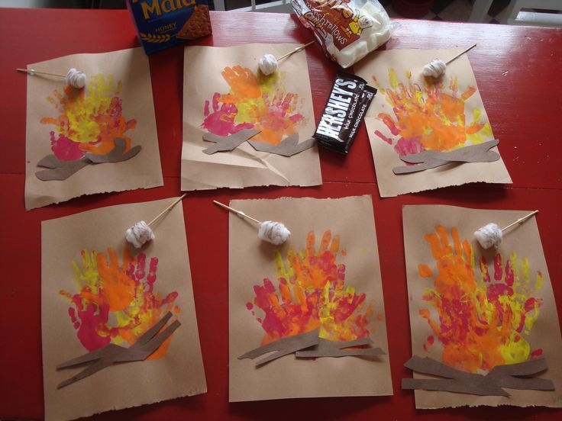

* Can you make a log fire with your hand prints and paint? Use a twig and some cotton buds to make some marshmallows roasting over the fire.

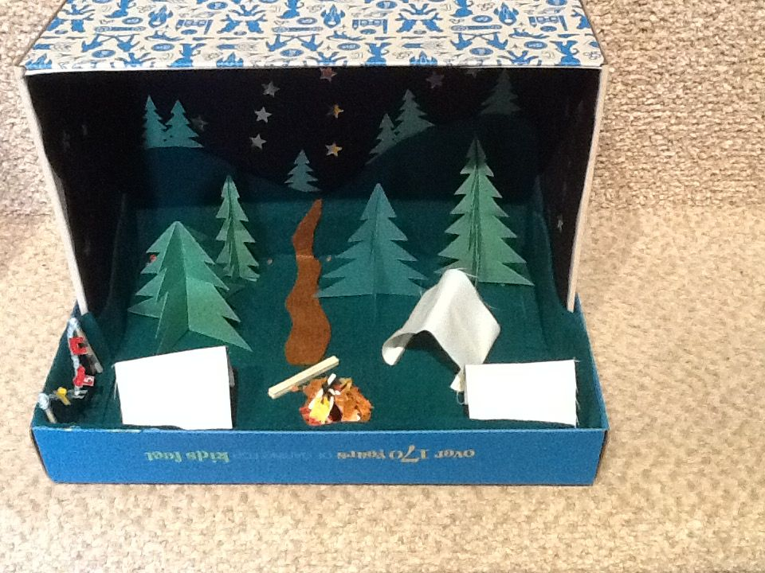

* Do you have any spare shoeboxes at home? Could you make a campsite using paper and paint like this one?

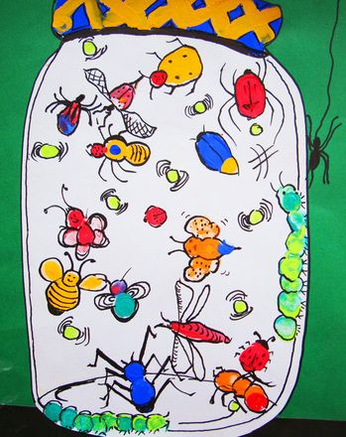

* Can you draw or paint pictures on 'What might you collect in a jar on a camping trip similar to this one?

**SESE**

**Mapwork**

This week we have been learning about adventures and what you need to bring on an adventure. One of the most important things to have with you is a map so that you know where you’re going. **Watch the short video Ms. Martin has uploaded about maps (in the “News” section) and then try out one of the following activities.**

* Create a map of Ireland and draw pictures of all of the things that the President’s cat saw on his way from Kerry to Dublin. Why not mark in places in Ireland that you have been or any landmarks that you have seen?
* Create a map of your bedroom or your house and mark in where all of the furniture is.
* Create a map of your area and mark in where your house is, where our school is and where the shops are.
* Create a map of a world you have created, you could add in mountains, lakes, rivers and towers.
* Have a look on Google maps and find your house. Can you spot anything else on the map that you recognise?

**Gaeilge**

* Keep going with your 10@10 as Gaeilge and watching shows as Gaeilge on Cula4.
* This week we’ve been talking about going on adventures and Mr. Kelly talked us through everything we needed when going camping. Why not watch the ‘Cat and the Hat’ going camping <https://www.cula4.com/en/watch/player/?pid=5761094130001&teideal=Cat%20a%27%20Hata,%20Ag%20Camp%C3%A1il&series=Cat%20a%27%20Hata,%20Ag%20Camp%C3%A1il&dlft=35>.
* A lot of boys and girls love watching YouTube and watching gamers playing online. If that’s the case, why not watch gamers playing as Gaeilge? Check out <https://www.youtube.com/watch?v=ndgS-N5vC5Y> playing Minecraft as Gaeilge.

**Music**

This month we are learning about camping. When people go camping they often have a sing song around the campfire. Here are two campfire songs you can learn

A Camping We Will Go

<https://www.youtube.com/watch?v=x4JDQO7DjzE>

Do Your Ears Hang Low - <https://www.youtube.com/watch?v=CFAkAZPR2tk>

If you were camping near a lake you might see some swans and at this time of year you might see some baby swans. A baby swan is called a cygnet. Here is a clip from the ballet ‘Swan Lake’ called Dance of the Cygnets. <https://www.youtube.com/watch?v=Xd2nTXsivHs>

What do you think of this music? Is it loud or quiet? Can you tap a steady beat? How does it make you feel? Do you want to dance to it? Can you copy the dance in the music or even better make up your own dance? Send us in a video of your dance or draw a picture of how the music made you feel. [kids@stphilipsjns.ie](mailto:kids@stphilipsjns.ie)

**P.E.**

* The weather is lovely and sunny at the moment, so now is a great time to get out into the garden and start exercising. You could build an obstacle course using things you have in your house or get outside and go for a walk, a jog, a cycle or a scoot.
* Grab a football and practise some football skills. If you have a wall, practise kicking the ball against it, both off the ground and out of your hands. Find someone in your family and practise throwing the ball to each other and catching it.
* Why not have a disco at home? Ask everyone in your family to pick their favourite songs and get dancing!
* Take part in Amanda’s GAA challenge videos.
* Set up an obstacle course or go on a scavenger hunt around your home!