*Mon 27th April 2020*

Hello boys and girls.

Here are a few suggested activities for you to try over the next week.  
You do not need to do all of them, just pick a couple to try out each day.

If you do try out any of the activities we would love you to show us your work.

Send a photo/video with teachers name in the subject box to [**kids@stphilipsjns.ie**](mailto:kids@stphilipsjns.ie). We can't wait to see what you have been up to!

**English**:

**Reading:**

It is so important to keep up a little bit of reading each day.    
Read with your parent, an older brother/sister or on your own.

Remember:

* Reading a book that your child finds easy is good for building up their fluency.
* Reading a book with some difficult words is good for problem solving.
* Reading a book that is too difficult is not beneficial.
* **Reader:**Read a few pages of your reader/any other book each day.  
  Chat to your Mam/Dad about the story. Mam & Dad can ask you questions, or you can try asking Mam & Dad questions about the story too!
* **Online reading:** If you are finished your assigned reader for home, go to <https://home.oxfordowl.co.uk/>. Parents can set up an account and then you can browse ebooks for your age and complete activities.
* **Two little frogs Workbook:** Continue with the next unit from your book this week.
* **Sounds Scavenger hunt**:

Find something in your house that

* begins with ‘c’
* begins with ‘ch’
* ends with ‘m’
* ends with ‘n’
* has ‘e’ in the middle, eg. Pen
* has ‘u’ in the middle, eg. Cup
* **Tricky words**

These are the words that we have covered so far this year.

|  |  |  |  |
| --- | --- | --- | --- |
| The  to  and  he  a | I  you  it  of  in | was  said  his  that  she | for  on  they  but  had |
| at  him  with  up  all | look  is  her  there  some | out  as  be  have  go | we  am  then  little  down |
| do  can  could  when  did | what  so  see  not  were | get  them  like  one  this | my  would  me  will  yes |
| big  went  are  come  if | now  long  no  came  ask | very  an  over  your  its | ride  into  just  blue  red |
| from  good  any  about  around | want  don't  how  know  right | put  too  got  take  where | every  pretty  jump  green  four |

Games to help practice tricky words:

* **Tricky Word Bingo**: Draw out a 3x3 grid and pick out 9 words to write in the spaces.

Call out a selection of words from the box and the child crosses out the word once they hear their word called.

* **Tricky Word Hunt**: pick a tricky word and see where you can find it e.g. in books, newspapers, etc.
* Practice **Spelling** the words, using the following method:Look-Say-Cover-Write-Check

Pick a tricky word

Look at and say the word

Cover the tricky word and have a go writing it again

Check to see if it’s right or wrong.

**Writing**:

* **My News:** Write a recount of something interesting that happened over the last few days. Use these questions to guide the child. What day is it today? What is the weather like? What did you get up to at the weekend? Afterwards, you can draw a nice picture and colour it in.
* **Diary**: Continue to write a Diary of what you are doing during these weeks. Just write a few sentences about what you are doing each day. It will be very interesting to read it someday!
* **Write about a picture**: Find a picture that you would like to write about. It could be a picture from your book, a picture from a magazine. Write a few sentences about the picture.
* **Procedure writing**: How to make the best sandwich ever. Help Mam/Dad to make a sandwich for you. Now write about what ingredients and utensils you needed and what steps you carried out. For example: First you get two slices of bread. Then you put butter on them. Next you put a slice of cheese on the bread. Etc.
* **Free writing**: Write about something you want to write about.

Give the child complete control over what they would like to write about. During this activity, there is no need to focus on the children’s spellings. The important thing is that they write freely about something they are interested in. At the end, get the child to read what they have written back to you.

Some things your child may be interested in writing about:

* a story
* a postcard
* a note/message for Mam/Dad
* words from your favourite story/song
* make a list
* label a picture

**Maths:**

**Check out the new videos on the school website, uploaded by Ms. Williams for 1st Class maths ideas and activities**

**Counting:**

* Counting forwards in 1’s up to 100.
* Consider starting at different numbers.
* Start at 36 and count forward to 45.
* Start at 87 and count to 93.
* Counting backwards in 1’s from 100.
* Again start at different numbers,
* Start at 34 and count backwards to 27.
* Start at 62 and count backwards to 55.
* Counting in 10’s up to 100.
* Start with different numbers.
* Start at 8, ….. 8, 18, 28, 38
* Start at 13,……… 13, 23, 33, 43, 53

**Counting Games:**

* **Buzz off, Sit down!**  
  Your child might have played this in school with their class and could play it with an adult or an older sibling or even in a group.

Pick a target number to count to.

Now pick another number to start counting from and take turns counting until you reach the chosen number. When you reach the target number, the person who has said that number, gets to turn to the next person and say “Buzz off sit down!” and they’re out of the game.    
Eg. The target number is 43. Everyone in the game/circle takes a turn saying a number until you get to 43.

* **Bingo:** Split the page into nine boxes. Put a number in each one. Bingo master can call out numbers until one player has got all the numbers and says: Bingo!
* **Snap:** Good for number recognition and quick thinking.
* **Snakes and ladders:** Very good for counting and fun for all the family!

**Addition:**

* Practice your **doubles** eg. 6 + 6 = 12, 8 + 8 = 16.
* Practice your **Numbers in Love** (numbers facts that make 10)  
  3 + 7 = 10. 9 + 1 = 10.
* Addition with **pack of cards**

Add 2 or 3 cards together and write a sum.

Go fish (to make 10). If you have 4, you ask for 6 so you can make 10. If you have a 2, you ask for an 8, etc.

**Subtraction:**

* Practice subtraction sums **within 20**.  
  Remember - Keep the big number in your head, count backwards and use your fingers to help keep track of the number you are taking away.  
    
  19 – 3 =  
  14 – 7 =  
  12 – 4 =

**Word problems**

* Jack had 8 dinosaurs and he was given 6 more. How many does he have altogether?
* My brother scored 9 goals. I scored the same amount. How many goals did we score altogether?
* Mary has 3 dolls, Jill has 5 dolls and Beth has 4 dolls. How many dolls do the girls have altogether?
* Granny gave Tom 25 cent but on his way home he lost 10 cent. How much does he have now?
* Mam has 15 roses growing in her garden. Granny has 7 less than that. How many roses has granny in her garden?
* Erin has 8 red apples and 5 green apples. How many more red apples has she than green?
* There are 10 football cards in a set. I have 4 cards. How many more do I need to have a full set?

**Other Maths Activities:**

* Practice **Telling the time** – Can you remember how to tell if it is ‘o’ clock’, or ‘half past’?
* **Money**:  
  Set up a shop at home, using some coins up to 20c.  
  -Work out how much it costs to buy what you would like.  
  -What coins would you use to make up that amount?  
  -Have you enough to buy 2 of the oranges/apples etc?  
  -What change will you get?

**ICT games Website:**

* Save the whale <https://www.ictgames.com/saveTheWhale/index.html>
* Whack a mole <https://www.ictgames.com/mobilePage/whackAMole/index.html>
* Shark Numbers ( up to 99) <https://www.ictgames.com/sharkNumbers/mobile/index.html>

**Twinkl Website Worksheet suggestions:**

<https://www.twinkl.ie/resource/t-n-1346-tens-and-units-worksheet>

<https://www.twinkl.ie/resource/t-n-2544731-counting-in-tens-activity-sheets>

<https://www.twinkl.ie/resource/t-n-1347-place-value-tens-and-units-cut-and-stick-worksheet>

<https://www.twinkl.ie/resource/roi-n-092-patchwork-elephant-addition-to-20-colour-by-number>

<https://www.twinkl.ie/resource/roi-n-5550-missing-number-addition-within-20-activity-sheet>

<https://www.twinkl.ie/resource/t-or-131-jakes-first-day-subtraction-to-20-colour-by-number>

<https://www.twinkl.ie/resource/t-n-2544952-oclock-and-half-past-activity-sheets#tabbed_content>

<https://www.twinkl.ie/resource/roi-n-5276-up-up-and-away-money-addition-problems-activity-sheet>

**Irish:**

***\*\*\*See News page for an Irish conversation video with Ms. Watson and Mr. Conneelly\*\*\****

* Continue to practice songs/poems learnt in school. Eg. “Ceann Gualainn Glúin is Cos”
* Comhrá: ‘Cad is ainm duit?’ ‘Cén aois thú?’ ‘Conas atá tú?’ ‘An maith leat úll?’
* ‘Cen rang in a bhfuil tú?’ ‘Tá mé i rang a hAon’
* ‘Cén lá atá inniu ann?’ ‘Inniu an Luan.’
* ‘Cén sort lá atá ann?’ ‘Tá an lá grianmhar’
* Look at programmes on TG4 and in particular, Cúla 4 online
* Stories on Seidean Si <https://www.seideansi.ie/>

**SESE:**

**Trees:**

This week we will be focusing on trees.

Can you name any different types of trees? Why are trees important? How do some trees change during different seasons? Can you see any trees near where you live? Can you name any different parts of a tree? How many trees can you see outside your window? What does a tree feel like?

Look at this video all about trees: [https://www.youtube.com/watch?v=5I7u5FMQxHA](https://www.youtube.com/watch?v=5I7u5FMQxHA%20)

Write down 5 facts about trees that you learned from watching the video

Twinkl activity sheet: <https://www.twinkl.ie/resource/roi-sc-20-the-parts-of-a-tree-activity-sheet>

**Music:**

Have you a favourite song? Why not try and learn the words to it? Go on youtube and search for a karaoke version of the song. Your child may be able to sing/read along with the words.

Here are a couple of Disney favourites you might like to sing along to!

The Bear Necessities: [https://www.youtube.com/watch?v=7ivNpDnvEvA#](https://www.youtube.com/watch?v=7ivNpDnvEvA)

How Far I’ll Go: <https://www.youtube.com/watch?v=yUX97-5DFdI>  
I Just Can’t Wait To Be King: <https://www.youtube.com/watch?v=-XIdSNU446w>  
Do You Want To Build a Snowman: https://www.youtube.com/watch?v=B19-jwaWESU

**PE:**

* ‘PE with Joe’ streamed live each morning at 9am on 'The Body Coach TV' Youtube channel.  
  And every Friday is ‘Fancy Dress Friday’ so you can dress up in your costume while exercising!
* 'Go Noodle' online channel for guided dancing
* 'Cosmic Kids Yoga' online channel
* 10@10 on Rte player, 10 minutes of guided exercise
* Walk, jog, run, cycle around your local area.
* Practice your football/basketball skills in your garden.
* Playground games your child may know: The Bean Game, Sea-Ship-Shore, Sprouts, Flush
* Obstacle course: Get the children to set up an obstacle course for themselves to play in

**Art:**

* Still life: Weather permitting, it could be a nice idea to set up an art desk outside and getting your child to draw or colour something they can see in their environment.
* Shadow tracing:

With all the lovely sunny weather we have been having recently, has anyone noticed their shadow? Why not try to trace the shadow of your favourite toy? <https://www.pinterest.ie/pin/441352832229055052/>

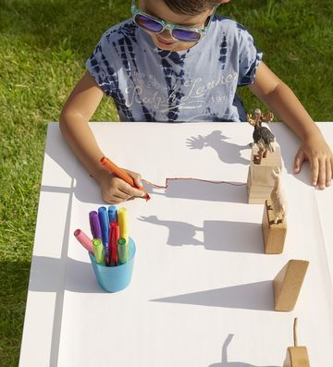

* Blended oil pastel tree: (Can use crayons, pencils or markers)

<https://artprojectsforkids.org/blending-colors/>

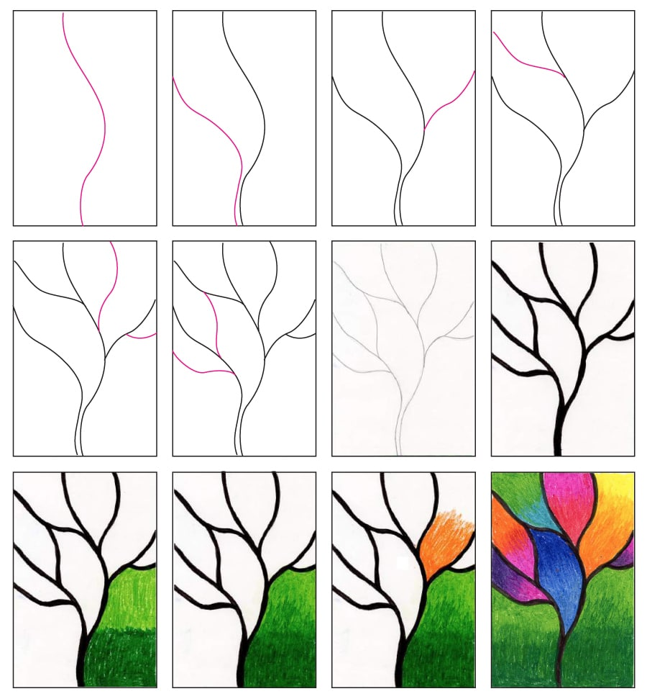

**Kandinsky Tree Collage:**

<https://artprojectsforkids.org/kandinsky-tree-collage/>

