**Home learning 3**

**Hello children and parents** welcome back to the Junior Infant page and part 3 of our home learning.  Ms Deery, Ms Martin, Mr Kelly and Ms O’Sullivan all say hello and hope you had a lovely Easter break.

We hope you will find this guide useful. We have listed lots of different activities but do not feel that you have to do everything. Please remember that the most important thing for you all to do is to just do the best that you can.  We would love to see some of the children’s work so if you would like to take a photo or short video clip you can send it to us at [kids@stphilipsjns.ie](mailto:kids@stphilipsjns.ie) putting the teacher’s name in the subject box. We hope that you are all keeping well and are enjoying the activities and links that we have on our web page for you.

Take care,

Ms. O'Sullivan, Ms. Martin, Mr. Kelly and Ms. Deery

**English**

**Story:**

We are going to cover two different stories over the next two weeks- ‘Farmer Duck’ and ‘What the Ladybird Heard’.

For the first week the focus is on ‘Farmer Duck’ by Martin Waddell.

A famous author called Michael Rosen is here to read it for you. Just follow the link to the story:

<https://www.youtube.com/watch?v=wn4b9AqiUbw>

For the second week it’s ‘What the Ladybird Heard’ by Julia Donaldson. Here is a link to the story: <https://www.youtube.com/watch?v=bzNIERZUyEM>

Here is a link to the song that is performed by the author Julia Donaldson herself and her husband: <https://www.youtube.com/watch?v=7NbyiDpY6Ww>

Here is a link to a short animated version of the story ‘What the Ladybird Heard’: <https://www.youtube.com/watch?v=-gRfCIUKDuY>

There is a selection of different activities that you might choose to do Read/watch the story a few times over the week and do a different activity at each reading.

1. Tell the children the name of the author and illustrator. Look at the cover and talk about what you can see. Read the ‘blurb’ at the back of the book and tell them that’s how you find out a short bit about the story inside the book.
2. Ask questions for e.g.:  What do you think this will be about?
3. Listen to the story and then talk to the children about the different characters in the story. Sample questions: Who is the main character? Who are the other characters? Where is the story set? What time of year is it? What are the characters doing?  What part of the story did you like the most? What do you think will happen after the end of the story?
4. Draw pictures of what happens in the story. Divide a piece of paper in three and label each section like this

|  |  |  |
| --- | --- | --- |
| First  Draw a picture of the beginning of the story. | Then  Draw a picture of what happens next. | Finally  Draw a picture of how the story ends. |

1. Talk about the different animals in the story. Draw a picture of one of them and write a short sentence: e.g. The duck is good; the cow is big.
2. Draw a picture of the animal and write the sound that it makes.
3. Draw a map of where the ladybird went on the farm: Here is a link to show you how: https://images.app.goo.gl/QELFKc8xdKaFDCGc7

**Phonics:**Practice one or two sounds each day.  For example, s & a on Monday, t & i on Tuesday and so on. The children can sing the song that goes with the sound and do the action. See how many words they can think of that begin with the sound. Can they think of any words that have the sound at the end or in the middle?

(Jolly Phonics order of sounds:  s,a,t,i,p,n,c,k,e,h,r,m,d,g,o,u,l,f,b,j,z,w,v,y,x).

**Word work:**For the first week practice blending 3 letter words ending in ‘in’- bin, din, fin, pin, tin etc.

For the second week practice blending 3 letter words ending in ‘ip’- dip, hip, nip, pip, rip, sip etc.

Write out one of the words. They should blend the sounds, with no gaps, to make the word. They can try writing out some of the words as they stretch out the sounds aloud.

**Writing;**Continue to practice the ‘curly caterpillar’ letters c,o,a,g,d that you have been doing.

 Over the next two weeks try the letters q, e and s.

Then you will be able to do all the ‘curly caterpillar’ letters and will be ready to move on to the ‘One- armed Robot Letters’.

Check out this YouTube clip for the right way to form the letters: <https://www.youtube.com/watch?v=kpu8W15h41M>

This video shows the correct way to hold the pencil. <https://www.youtube.com/watch?v=DP5htYZ5jjQ>

**Nursery Rhyme**: Little Boo Peep - <https://www.youtube.com/watch?v=fjN2qXGFp24>

**Other activities;** The children can draw pictures of something beginning with the sounds they have been practicing. The children can talk about their news for the week and draw a picture of it.  Have a go at labelling parts of the picture e.g. mam, dad etc. Mam or Dad can write down what is happening in the picture.

**Gaeilge**

* We are sticking with the theme of the farm this week, both in English and as Gaeilge. So why not log on to YouTube and watch <https://www.youtube.com/watch?v=addijqQsRaQ>. I think you will all know this song in English, so why not try to sing along as Gaeilge? Can you find out what the Irish words are for ‘farmer’ and ‘dog’?
* We have a lovely art lesson for you, which you can watch as Gaeilge. Find out how you can make a moneybox in the shape of a muc (pig) at home on <https://www.youtube.com/watch?v=iDVtHsPdLC8&list=PLbcLsUBW9b3ARZ7SWB1Xw9rAulsx5VZH-&index=7>.
* What shows have you watched on Cula4 so far? We’re looking forward to hearing about them when we get back. Why not choose another show to watch on <https://www.cula4.com/en/>? Listening to píosa beag Gaeilge every day is an excellent way of encouraging the boys and girls to practise their Gaeilge.
* Keep going with your 10@10 as Gaeilge and stay active indoors.

**Maths**

**Days of the Week/ Months of the Year;** Its a great idea to go over the days of the week and the months of the year everyday. Try using the language ‘before/after’. Questions to ask: What day comes before Monday? After Tuesday? What month comes before March? After October? Here are some songs you can sing; <https://www.youtube.com/watch?v=qNJRGHk7sN8> and <https://www.youtube.com/watch?v=Fe9bnYRzFvk>

**Counting;** Practise counting forwards 1-20 and backwards 20-0. It is a great idea to use the words ‘before and after’ when you are working on counting. What number comes before 7? After 4?

**Recap Numbers 0- 5;** Over the next 2 weeks we are looking back over numbers 0-5. Here are some video links for you to practice counting; 5 Little Monkeys (<https://www.youtube.com/watch?v=sfFwo7iQsDw>), 5 Little Ducks (<https://www.youtube.com/watch?v=pZw9veQ76fo>) 1,2,3,4,5 Once I Caught a Fish Alive (<https://www.youtube.com/watch?v=9ir_l7qTiZ4>) and 1, 2 buckle my shoe (<https://www.youtube.com/watch?v=dS5oyXCfrB4>)

**The Story of 1- 5 (Recap):** Can you tell me any stories about the number 1 (1+0=1, 0+1=1), 2 (1+1=2, 2+0=2, 0+2=2), 3 (0+3=3, 1+2=3, 2+1= 3, 3+0=3), 4 (0+4=4, 4+0=4, 3+1=4, 1+3=4, 2+2= 4), 5 (0+5=5, 1+4=5, 2+3=5, 3+2=5, 4+1=5, 5+0=5)? Can you use your fingers to show me the number 1,2,3,4,5? How many different ways can you make the numbers 1,2,3,4, and 5 with your fingers? Can you write them down? Can you find other objects around your house that you could make the story of 1,2,3,4, 5 with? Can you write the story down? Remember to use your signs : + (plus, add, and) = (equals, the same as). Can you add items up to 5?  E.g: 2 forks and 3 spoons

**Making sets:** Make sets of objects long and short or Tall and small **(**e.g. Find 5 things in your bed room that are the long/tall and find 5 things that are short/small). Ask your child why they made their sets in that particular way. Children can then draw pictures of their sets.

**Numeral Formation:** Practice writing all of your numbers 0-5 and remember all numbers start at the top of the line.

Around to my left to find my hero,

back to the top, now I have made zero.

A downward stroke, that was fun,

Now I have made the number 1.

Half a heart says “I love you”.

Draw a line, now I have made the number 2.

Around the tree and around the tree,

Now I have made the number three.

Down and across and down one more,

Now I have made the number four.

Draw his back, his belly and his hat.

My number five might come alive.

**Length:** Here is the language you should use with your child:  
Long, short, tall, wide, narrow, longer, shorter, wider than, longest, shortest, longer, shorter, nearly as long as, nearly as short as.  
  
These words are important as they are the language that the students would be learning  in school to talk about measurement.

* Find 5 items in your living room - put them in order starting with the longest - shortest or Tallest to smallest. Which is Taller? Which is smaller?
* Ask your child to help you sort the washing: Find the long trousers. Can you find some that are shorter? Which trousers are the shortest?
* Build a tower with your child using blocks or boxes: Can you make a taller tower? A shorter tower?
* Ask who is the shortest/tallest in our house? Who is taller than ___, who is shorter than ____ etc
* Make a paper aeroplane with someone at home and test it to see how far it flies. Measure the distance using your steps.
* Who can throw a ball the furthest in your garden? Why is it important to stand at the same spot when throwing the ball? Measure the distance using your steps.
* Put taller teddies in one group, shorter teddies in another and teddies of the same height in the third group. After heights have been compared invite your children to suggest other ways that the teddies could be compared. For example: bigger or smaller feet, longer or shorter legs. Then put their teddies in order. Ask your children why they ordered them in such a way.
* Create trains using blocks or cubes. Compare these trains by the number of blocks using the appropriate language for example longer, shorter, the same. Encourage children to explain their comparisons. How do you know that your train is shorter or longer? How could you make your train longer than this train? How could we record our trains after we put away our blocks? Children can draw pictures of how long or short their trains were.
* Go on a scavenger hunt around your house and find objects that are the same size as your train or your teddy. Make a list (pictures) of what you found that was the same length. Make a list of things you found that were longer and shorter than your train/teddy.

<http://www.compasslearningodyssey.com/sample_act/math_k/grade/subject/mak_04_03_03.htm> Measure with Chef Pierre

<http://resources.hwb.wales.gov.uk/VTC/2008-09/maths/puppies/FullRelease-v104/tallestPuppy-en.htm> - Find the tallest puppy

<https://www.twinkl.ie/search?term=junior+infants+length> – Resources on length

**SESE**

* Ms O Sullivan went on lots of walks over the last few weeks and guess what she saw? A mammy duck and her babies!

One day Ms O Sullivan was walking along the canal and she heard lots of quacking and chirping. When she looked she saw a mammy duck with lots of ducklings swimming around her. The mammy duck was quacking for them to come back to her.

Here is the mammy duck with 5 of her babies. Do you remember the song ‘5 Little Ducks’?

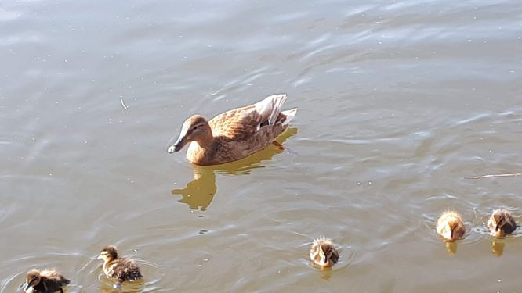

Here is a picture of the mammy and the daddy duck with all of the ducklings. There are 11 ducklings.

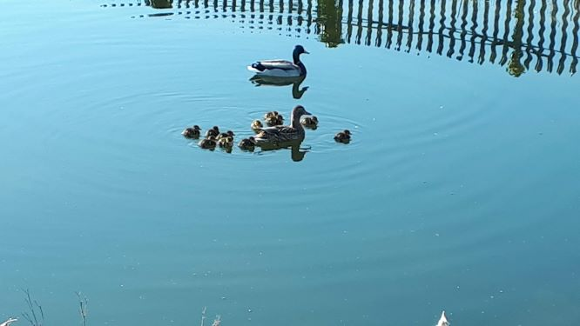

The mammy duck is called a hen and she is brown and white. The daddy duck is called a drake and he is grey and white and black and green.

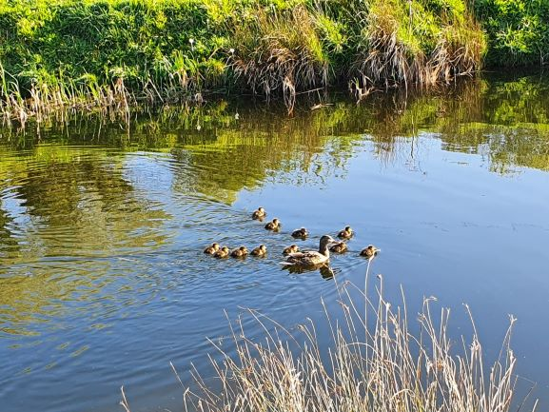

Here is the mammy with all of her ducklings. Ducks eat lots of different things. They eat plants, seeds, insects, worms and snails.

Can you draw a duck? This YouTube clip might help you. <https://www.youtube.com/watch?v=O_BA5NzVfio> Send your pictures to [kids@stphilipsjns.ie](mailto:kids@stphilipsjns.ie) and put your teacher’s name in the subject box.

Did you go on a walk over the Easter break? Tell us about it by drawing a picture or even make a short video about it and send it to [kids@stphilipsjns.ie](mailto:kids@stphilipsjns.ie).

* Here is a YouTube clip about farm animals. <https://www.youtube.com/watch?v=hewioIU4a64> Can you guess the animal from it’s silhouette?
* In this clip Ellie tells us all about farms. <https://www.youtube.com/watch?v=8M8siMgbVkA> Can you remember the difference between a fruit and a vegetable? A fruit has seeds inside it while vegetables can be roots, stems or leaves. Can you sort the fruit and vegetables in your house?  Food that comes from a cow’s milk is called dairy food. Can you look in your fridge and draw pictures of all the dairy food?
* The Explorers programme from [folensonline.ie](http://www.folensonline.ie/) has good resources for SESE.  Have a look at activity 7, Plants for history, geography and science.  You need to register as a teacher first using the code Prim20 for roll number.

**Art**

* There are lots of different art activities you can do based on the farm, why not try one of them out? You could draw farm animals or some fruit and vegetables that grow on a farm. If you do, send us some pictures and you might even feature on our school website.
* You can make lots of different farm animals using your hands. Paint your hand whatever colour you want and don’t be afraid to get messy! You could make a handprint horse, a handprint cow and a handprint chicken. You could even use your fingers to make baby chicks.
* You could go on a nature walk and collect some natural materials to create a collage with; you could use leaves, grass, dirt and flowers.
* Farmers drive tractors in their fields when harvesting their crops. We can draw/colour/paint our own tractors so find 2 pieces of paper and follow our instructions.
  1. Paint or colour your page brown for the soil. If you have a disposable fork, you could drag the fork across the paint to create the rows in the farmer’s field.
  2. Next we are going to draw a tractor on the second page. There are lots of shapes that make up a tractor. You need to draw two rectangles, one long horizontal rectangle followed by a tall rectangle at one end which will create the body of the tractor (the tractor should be in the shape of an L). Next you need the wheels. The wheels at the front of the tractor are smaller than the wheels at the back of the tractor.
  3. Colour in your tractor. Why not colour it in red like a Massey Ferguson tractor or green like a John Deere tractor.
  4. Cut out your tractor, make sure to ask an adult for help with this step.
  5. Glue your tractor on to the field.

**Music**

* Do you remember the song Five Little Ducks? Here’s a reminder if you need it. <https://www.youtube.com/watch?v=PjDPIUCtxQ8>  Sing the song.  Sing as quietly as you can, now try singing it really fast.  Can you make up actions maybe with your fingers?  Can you tap a steady beat to the music as you listen to it? Can you draw a picture of the song?
* Here is a song with a lovely theme of the farmyard ‘Over in the Meadow’-<https://www.youtube.com/watch?v=C6ljGXMMB-g>  Listen to it and sing along when you get to know it a little.  Can you tap a steady beat?  Can you make a drum from some things in your house?  Maybe an old yogurt carton or a plastic bowl?  Don’t make it too loud because other people in your house may be working.  Could you sing it with somebody else?  Your mam or dad or brother or sister.  One of you could sing the mammy part and the other could sing the baby animal parts.
* Here’s another song to do with the farm. It’s called ‘Dingle Dangle Scarecrow’ <https://www.youtube.com/watch?v=MXbFK5ITBFs>  Can you copy the actions of the children in the video clip?  Or make up your own actions.
* This piece is called Flight of the Bumble Bees <https://www.youtube.com/watch?v=M93qXQWaBdE> What do you think of it?  Do you like it?  Is it fast or slow?  How does it make you feel?  Do you think it sounds like a bumble bee buzzing around?  What instrument is playing the music.  Could you make some buzzy bee music? Maybe make a zzzz sound with your mouth or make a zzzz sound into a kitchen roll tube?

**P.E.**

* The weather is lovely and sunny at the moment, so now is a great time to get out into the garden and start exercising. You could build an obstacle course using things you have in your house or get outside and go for a walk, a jog, a cycle or a scoot.
* Grab a football and practise some football skills. If you have a wall, practise kicking the ball against it, both off the ground and out of your hands. Find someone in your family and practise throwing the ball to each other and catching it.
* Why not have a disco at home? Ask everyone in your family to pick their favourite songs and get dancing!