To all the children and parents in 2nd class,

We hope you are all keeping well and we would like to say a big hello from Mrs Watson, Ms O’Hare, Mr Conneely, Ms O’Hora and Mrs Maye.

We have put together a list of suggested activities for you to do while you are at home. Perhaps you could pick a couple of the activities to do each day.

We hope you will find this list useful. Please do as much or as little as suits you and your family. These are just suggestions and should cause no additional stress at home.

Best wishes to you all and take care.

**English**

1. *Reading:*

It is really important to read each day, if you can. If you have not finished your class reader, read some pages each day on your own or with a parent. If you have any other books at home, these can be read too of course! 😊

If you are finished your assigned reader, go to <https://home.oxfordowl.co.uk/>. Parents can set up an account and then you can browse ebooks for your age and complete activities.

Some book activities:

* Design a new cover for the book
* Draw a picture of your favourite part of the story and write some sentences to describe the picture
* Write a book/story review- What was the book about? Who was in the book? Where was it set? Did you enjoy reading the book? How many stars would you give it out of 5? Who is the author / illustrator?
* Character profile: Pick a character from your book and draw a picture of them. Write some sentences about the character using lots of adjectives (nice, clever, mean, smart, tall, small, funny etc.). Would you like to be their friend? Why/ Why not?

1. *Writing:*

Remember we were working on writing stories? A story plan is a good idea to write before you start your story.

What does a good story always need?

*Characters: Who will be in my story?

*Setting: Where will my story be set? (For example: a castle, a haunted forest, outer space, a school, a playground, a chocolate factory)

*What will happen in the beginning/ middle/ end of the story?

*What problem will happen? How will the problem be fixed?

Here are some story ideas for you! You could pick 1 or 2 each week to work on.

Write a story about….

* A young boy or girl who loves magic tricks
* A group of friends win a trip
* A kid who becomes principal of the school
* A cat who sneaks onto a spaceship
* A friendly alien who comes to Earth
* A dog with magic powers
* A boy or girl who dreams of becoming a chef
* Finding a treasure chest in the back garden

Other writing activities:

* Write a shopping list for the supermarket
* Write a letter to your friend telling them about what you have been up to
* Procedure writing: How to make a sandwich (Write out the ingredients and steps you need to carry out)
* A letter of thanks to the local supermarket workers/ nurses/ doctors/ truck drivers and everyone who is helping us at this time (letter writing)

1. *Spellings:*

For homework 2nd class are usually given spellings to write into sentences three days a week.

Can you pick 1 list of words each day (Monday, Tuesday, Wednesday) and write them into sentences? At the end of the week, ask someone in your house to give you a quiz and see if you can write out all the words correctly.

|  |  |  |
| --- | --- | --- |
| List 1  draw  straw  saw  law | List 2  cheat  treat  wheat  eat | List 3  clean  clear  spear  nearly |
| List 4  steal  steam  stream  reading | List 5  easy  peanut  seaside  tea | List 6  blood  flood  stood  shook |
| List 7  blew  chew  grew  screw | List 8  drew  flew  stew  threw | List 9  moan  groan  float  throat |
| List 10  cloud  mouth  flour  hour | List 11  brown  clown  crown  frown | List 12  long  along  strong  wrong |
| List 13  great  early  earn  bear | List 14  shell  smell  doorbell  fell | List 15  cry  cried  try  tried |

**Maths**

There are lots of fun maths games and activities you can play at home with whoever is there with you so have a think about all the maths games you play with your teacher and with Ms. O’Halloran at maths time!

*Games to play with your family:*

* **Buzz off sit down.** In this game you pick a number and everyone takes turns saying numbers till you hit the chosen number. When you reach the number you get to turn to the person next to you and say “Buzz off sit down!” and they’re out of the game. E.g. The chosen number is 29. Everyone goes around the circle saying a number till you get to 29 and then someone has to sit down.
* **Grandma’s in the kitchen**. This game can be played with 2 or more people. Don’t forget to say the rhyme that goes with it! Pick a number and take turns counting up to that number till you hit it. Whoever does is the winner. This game is great because you can practice counting in 2’s, 3’s, 5’s, 10’s or even in 10’s off the decade. E.g. The chosen number is 180. Player 1 says 10, player 2 days 20, player 1 says 30 and you keep going till player 1 or 2 says 180.
* **Beat the teacher (or beat mammy, daddy, your brother or sister!)** Take turns counting to a number.
* **Card games.** All you need is a deck of cards and you can play loads of games with your family. House is a nice easy game to start with.
* **Uno.** This is another great card game that is maths related. You’re using your maths brains to keep an eye on the number cards.

*Online games*

* There are lots of great websites you can use to practice your counting, addition and subtraction. You can play these games on someones smartphone, a tablet/ipad or a computer. Here are just a few.
* [***https://www.topmarks.co.uk/maths-games/5-7-years/counting***](https://www.topmarks.co.uk/maths-games/5-7-years/counting)
* [***https://www.mathplayground.com/math-games.html***](https://www.mathplayground.com/math-games.html)
* [***https://home.oxfordowl.co.uk/kids-activities/fun-maths-games-and-activities/***](https://home.oxfordowl.co.uk/kids-activities/fun-maths-games-and-activities/)
* [***https://ie.ixl.com/math/class-2***](https://ie.ixl.com/math/class-2)

*Practice your addition and subtraction:*

* By now in second class we have covered lots of different ways to do your addition and subtraction sums. Have a go at practicing some of these.

**Addition**

* 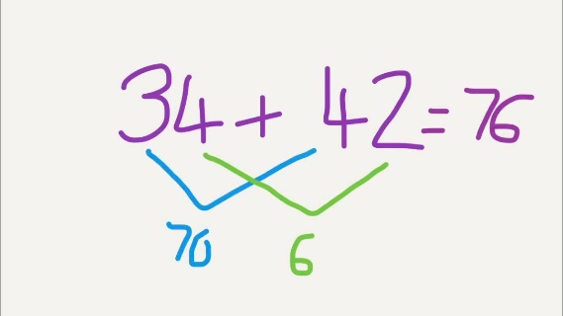We can add two numbers using criss cross. Don’t forget to add the tens and then add the units
* 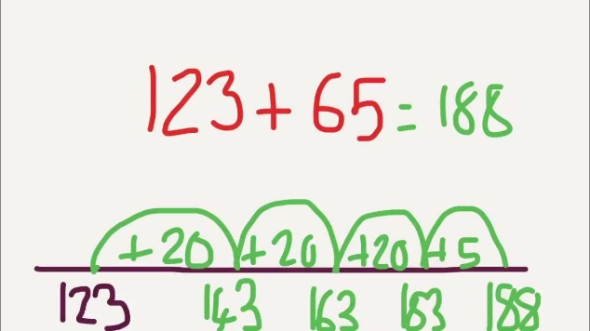We can do it on a number line. Add the smaller number to the bigger number and add the hundred, tens and then the units.
* We can do it a tall sum way. Remember if the units go over 9 you will have to carry a ten over to the other side.

 **Subtraction**- Careful with your take away sums. We can only do our take away/ subtraction sums two ways! A tall sum or a number line.

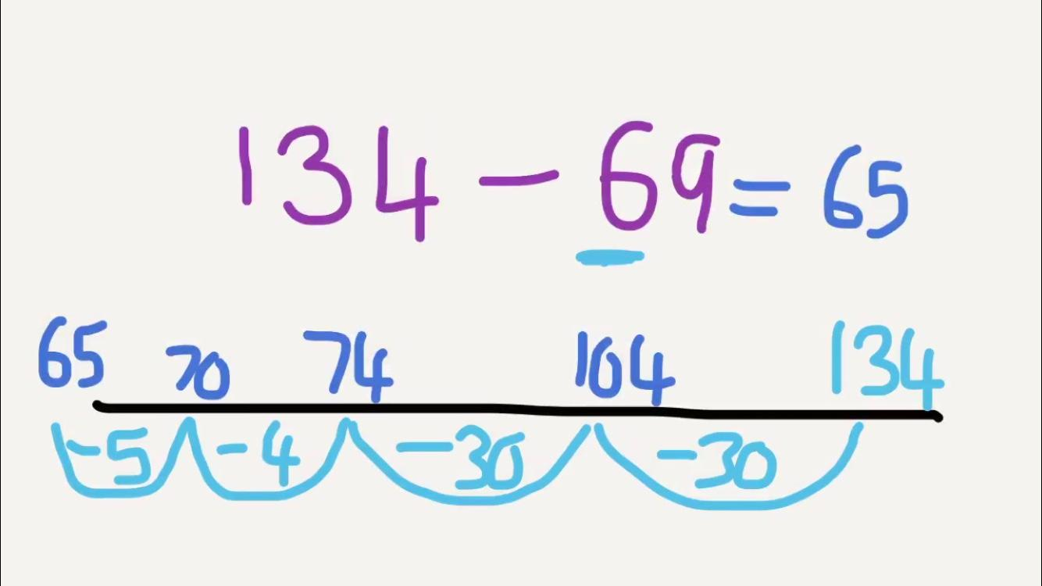**-**If the number on top is bigger than the number on the bottom we can do it the tall sum way but if not we are going to have to do it a number line way. Remember we draw the line, put the bigger number (we are taking from) to the right of the line and then take away the tens first and then the units.

**Word problems**

* You can write your own word problems and do the sums later. Or how about you write some for your brother or sister and they can write some for you? Here are some examples that might help.
* *Ms. O’Hare had 220 pairs of runners. Ms. Watson has 133 pairs. How many do they have altogether?*
* *Mrs. May has 78 colouring pencils and when Ms. O’Hora used them she lost 23 of them. How many does Mrs. May have now?*
* *Ms. O’Halloran has 54 books read since Januray. Mr. Conneely has twice that much read. How many did Mr. Conneely read? How many did they both read?*

Rememeber when you are writing these sums and doing them to see if the number is getting bigger or smaller. Here are some maths words you can use in your word problems.

|  |  |
| --- | --- |
| **Addition words** | **Subtraction words** |
| Altogether  More  Also  Together  Plus  Total  Increase | Less  What is the difference  Fewer  Take away  Lost  Deduct  Decrease |

*Other maths activities you can do:*

* You can practice your skip counting in 2’s, 3’s, 5’s, 10’s and 10’s off the decade. E.g. 3, 13, 23, 33,etc. It’s easy to count up but I wonder can you skip count backwards? From 100 or even 200!
* If you can borrow some coins from someone you can set up your own ‘Shop’ at home. Practice buying things from your shop with the coins you’ve borrowed. E.g. If the teddy bear costs 75c and you give €1, what change will you get back?
* Practice telling the time. We all know the o’clock pretty well in second class but can you remember how to tell if its quarter to and quarter past a time?
* Remember this is what quarter past looks like.... What time does it show on this red clock?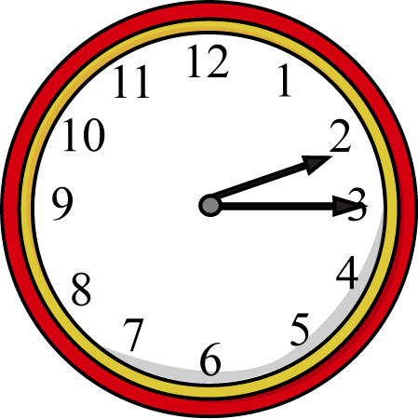
* And this is what quarter to looks like…. What time does it show on this yellow clock?

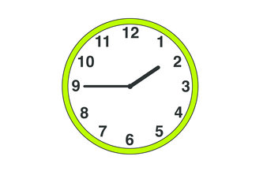

**Irish**

* Continue to practice songs/poems learnt in school
* Dialogue ‘Cad is ainm duit?’ ‘Conas atá tú?’ ‘Cad atá ort?’ ‘Conas atá an aimsir inniu?’ etc.
* Days of the week: An Luan, An Mháirt, An Chéadaoin, An Déardaoin, An Aoine, An Satharn, An Domhnach

Cén lá é inniu? Inniu ______.

* Look at programmes on TG4 and in particular, Cúla 4 online
* Stories on Seidean Si <https://www.seideansi.ie/>

**S.E.S.E**

* Go on a nature walk in your local area. What signs of spring do you notice? Can you find any spring flowers? What trees do you recognise? What birds can you see?

<https://birdwatchireland.ie/>

<http://www.photobirdireland.com/>

<https://www.treecouncil.ie/>

* Mini Project: My Local Area

Walk around your local area. What buildings are there? Are there any green spaces? What are the names of the roads? Who works in your local area?

Draw a map of your local area, including main roads, estates, buildings and parks.

Write a short piece on the different people who work in your local area. What is their job and how do they help the community?

Try this quiz about people who help us

<https://www.twinkl.ie/resource/t-t-2547934-ks1-the-big-end-of-the-year-people-who-help-us-quiz-powerpoint-game>

Write about the job you would like to have when you grow up and don’t forget to draw a picture too!

* Read ‘The Story of Icarus’ online

<https://www.twinkl.ie/resource/t2-h-4826-icarus-story-powerpoint>

<https://www.twinkl.ie/resource/us2-e-223-daedalus-and-icarus-powerpoint>

Write about your favourite part of the story

Make your own comic strip of the story

**ART ACTIVITIES TO TRY AT HOME: HAVE FUN!**

1. Stand Up Easter Eggs: <https://www.pinterest.ie/pin/290693350947015006/>

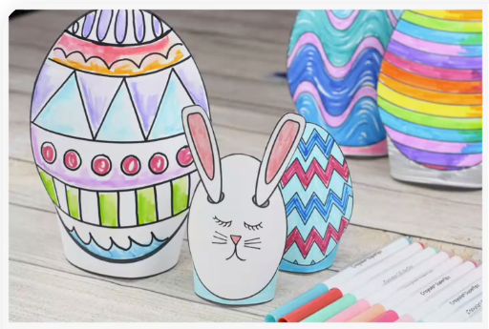

2) Tinfoil and Marker Easter Eggs:

Instructions:

- Cut out Easter Egg shapes from a cereal box

- Cover in Tin Foil

- Decorate with markers (“Sharpies” are best if you have them)

1. Easter Egg Collage

* Cut out an Easter Egg shape
* Use scrap paper to decorate your egg (magazines, newspapers etc)

1. Paper Plate Easter Bunny <https://www.pinterest.ie/pin/573505333802077246/>

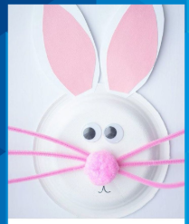

Foam Cup Easter Bunny: <https://www.pinterest.ie/pin/293437731972499750/>



1. Doilie Easter Bunny: <https://www.pinterest.ie/pin/523050944226193263/>

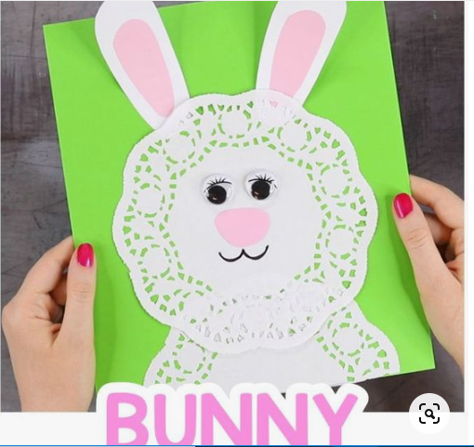

1. Garden Creatures

Draw some creatures that you find in your garden or local park such as Ladybird, Bumble Bee, Butterfly etc

1. Chalk Art:

* Outside: Draw a summer picture on the footpath or
* Inside: Use black paper and coloured chalk to make a Summer picture

1. Rock Art:

* Collect a flat stone and decorate it to make a garden creature or paint your own design on it

1. Lollipop Stick Art Puzzle:

* Put lollipop sticks in a row, one underneath the other
* Outline a drawing in marker (a flower, an emoji, a face etc)
* Colour in your drawing
* Mix up all the lollipop sticks
* Get a friend or family member to put your drawing back together

1. Eye Pictures: <https://www.pinterest.ie/pin/290482244685708921/>

* Draw the shape of an eye with some eyelashes
* Draw a summer scene in the pupil of the eye
* Colour in your drawing



1. Pasta Picture

* Draw a picture of a beach scene with sky, birds, water, beach etc
* Use different types of Pasta or other food ingredients (e.g. rice, spaghetti, seeds etc) to fill in your picture

**Recommended Websites for Kids Art:**

* Kidsites.com
* You Tube: Art for Kids Hub

**P.E./ Exercise**

* 'Go Noodle' online channel for guided dancing
* 'The Body Coach' online channel (There is a live PE class each school day at 9 a.m.)
* 'Cosmic Kids Yoga' online channel
* [10@10-10](mailto:10@10-10) minutes of guided exercise
* Stretches/Jumping Jacks/Lunges

**Music**

* Peace Proms music: Do you remember all the wonderful songs and dance moves we learned for the Peace Proms concert? If you have access to a computer, tablet or smartphone you can find all the songs if you search ‘Peace Proms 2020’ on youtube.
* Dance to your favourite pieces of music!