This set of work is based on the Theme of Water. As always these are suggested activities, please do as much or as little that suits your home situation. The teachers are always available at [**www.kids@stphilipsjns.ie**](http://www.kids@stphilipsjns.ie) should you have any questions or if you would like to send photos or videos of the children and their work.

Stay well and take care,

Ms. Crimin, Ms. Carroll and Ms. Scully ☺

**English**

* Keep reading books and sharing stories as much as possible, if the weather is nice maybe you can read outside. Or if you still have your reading den you can read in there. You can read with mam, dad, old brothers or sisters, even teddies. Or you could send your teacher a video of you reading to www.kids@stphilipsjns.ie
* Remember the website Oxford Reading Owl has lots of free eBooks and readers. <https://home.oxfordowl.co.uk/reading/>
* Starfall also has a stories section that will build on the children’s phonics and sight words skills in the ‘Learn to Read’ section. <https://www.starfall.com/h/ltr-classic/>
* Listen to a story the story of ‘The Ugly Duckling’ by Hans Christian Anderson. <https://www.youtube.com/watch?v=xQ6YYzmkBMs&t=245s>
* I’ve spotted lots of ducks and ducklings on my daily walk by the canal. Here are some photos I took:

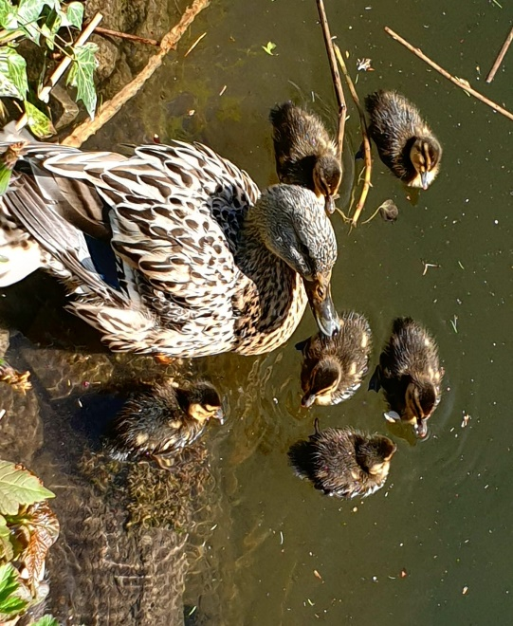 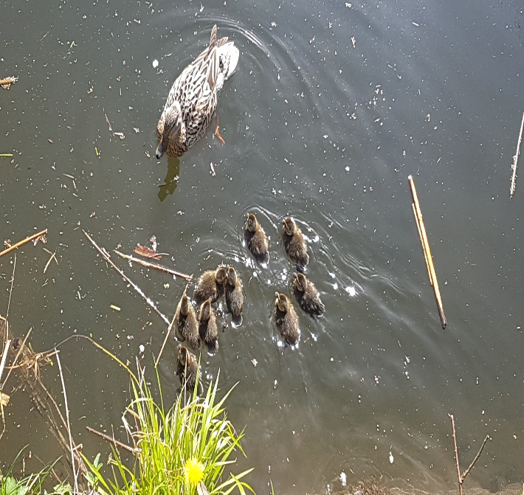

It reminded me of the great story ‘Make Way for Ducklings’ by Robert McCloskey. You can listen to the story here <https://www.youtube.com/watch?v=83Circtj7Tg>

* **Poem: I Have a Little Frog**

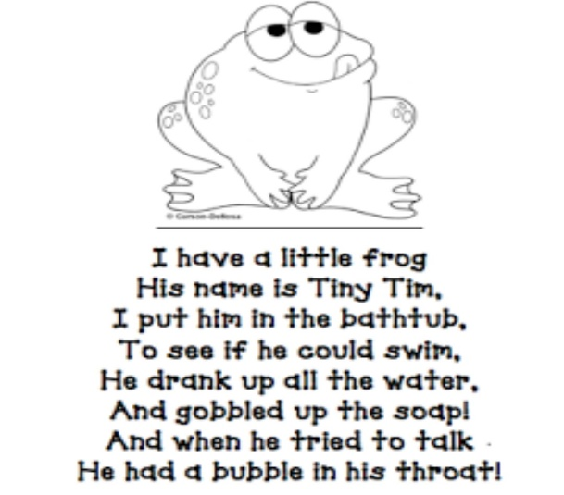

* **Tongue Twister:**

Swan swam over the sea, Swim Swan Swim!

Swan swam back again Well swum, Swan!

* **Writing:**
* Think of the stories ‘The Ugly Duckling’ and/or ‘Make Way for Ducklings’. Pick something that happened at the start, the middle and the end of the story. Draw a picture and write a sentence about each picture to help re-tell the story. (Children might need some help with tricky words) For example, 1. The duck’s eggs cracked. 2. The ducklings were mean to the ugly duckling. 3. The Ugly duckling was a swan. Include labels on your picture.
* Or pick your favourite part of the story and write a couple of lines about the story.
* Keep writing in your diary – draw pictures and write a sentence about what you did or your favourite part of that day/week e.g. On Monday I went to the park. My sister’s birthday was yesterday. She is ten. I played in the garden. Etc.
* **Phonics:** We will revise the **‘sh’** sound (e.g. **sh**op, fi**sh**, **sh**ell, **sh**ip, cru**sh**, ma**sh,** spla**sh, shrink etc.).** Write a list of ‘sh’ words, they could be at the start, middle or end of the word.
* Play ‘The Points Game’ – give your child 1-2 minutes to think and write down a list of ‘sh’ words. Child gets 1 point if they think of a word with the ‘sh’ sound and if the spelling is correct, they get an extra point. Play again later in the week and see if you can beat their score.
* Geraldine the Giraffe: Watch Geraldine the Giraffe learns the sh sound YouTube <https://www.youtube.com/watch?v=RCRqtFBQ_2k>. Go for a sound hunt and see can you find any things in your house that have the sound sh, draw pictures of what you find and label the pictures.
* Alphablocks: Pause the video at different stages and see can your child sound out the word. This episode uses the ch (e.g. chip) sounds as well as the sh sound <https://www.youtube.com/watch?v=Us3ZC-VDQ9w>
* **Phonic Spelling Challenges -** Choose the words your child can do. If your child can’t do it, you write it and let them copy. Do it every day that you have time.
* Parent calls out single letters and child writes it down.
* Parent calls out words from the ‘og’ word family (dog, log, bog, nog, tog, frog) and the ‘op’ word family (hop, top, cop, shop, wop). These words can be both real and made-up words. Child writes it down.
* Parent calls out sentence (I see a dog. I like the frog. I will go to the shop.) and child writes it down.
* Say the sound sh and write sh. Draw some pictures with the sh sounds e.g. dish, push, trash etc.
* **Tricky Words: if, now, want, your, for, were** are the words to concentrate on for the next two weeks. Here are some activities to try with these and previous tricky words explored.
* **Tricky words slap**: Write some tricky words on pieces of paper and lay them out on the table. Each player has a wooden spoon. Adult calls out the word and players have to slap the word as fast as they can. Fastest player keeps the card. Child with the most cards at the end of the game wins.
* **Snap**: Divide the words equally between you and your parent/brother/sister/teddy. Turn over one each on top of each other. Say snap and hit the deck if there are two in a row the same.
* **Spelling: Look-Say-Cover-Write-Check Challenge**: Pick a tricky word, Look at and Say the word, Cover the tricky word and have a go writing it again, Check to see if it’s right or wrong.
* **Tricky word match**: Write the tricky words on a sheet of paper or card (e.g. an empty cereal box) and have a second set of tricky words cut up. Match the words to those on the sheet of paper.

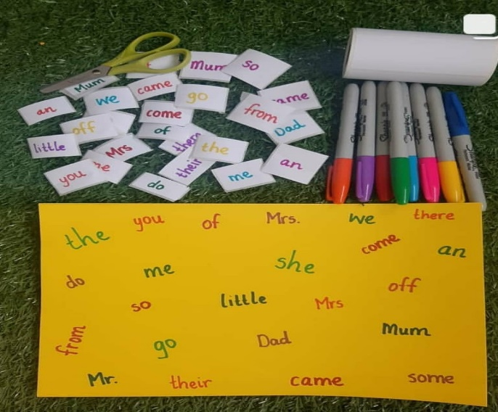 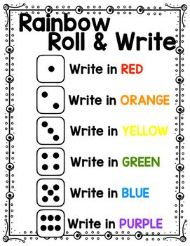

* **Rainbow Roll & Write:** Pick a tricky word, roll a dice and write the word using the right colour. (See above right).
* Here are some of the previous tricky words to keep revising at home:

|  |  |  |  |
| --- | --- | --- | --- |
| it | down | The | my |
| likes | this | can | at |
| am | here | me | some |
| he | she | In | but |
| Today | yes | no | so |
| It | Down | Get | do |
| That | Yes | No | from |
| was | be | He | then |
| You | has | had | not |
| him | her | said | have |
| with | his | our | they |
| little | an | come | there |
| got | of | by |  |
| them | says | are |  |

**Maths**

* **Counting** – children should practice counting every day for a few minutes. This should be forwards and backwards. Stick to numbers between 0 – 29 but if you feel that this is too easy for your child you can extend this range. Remember to start at different starting points and not always 1. E.g. start at 7 and count to 15, start at 11 and stop at 24, start at 12 and stop at 3, start at 18 stop at 9. Below are some fun activities to incorporate counting:
* **Active Counting:** Children can take a trip to the number gym. Pick an activity e.g. jogging on the spot, star jumps, “weight-lifting”, squats etc. Children count while engaging in the physical activity.
* **Number Tennis:** This needs two players, or you can play it with your child. To make it more exciting you could use tennis rackets if you have them or even spoons! Take turns saying numbers back and forth to one another e.g. **Parent:** I’ll start, and we’ll keep going until we get to 16. 7!

**Child:** 8

**Parent:** 9 etc.

* **Grandma’s in the Kitchen:** Two player game which again involves taking turns saying numbers. Pick a number range e.g. start at 14, whoever says 5 is the winner. Start by saying the rhyme ‘Grandma’s in the kitchen doing a bit of knitting, how many stitches did she do?’ and then take turns saying the numbers until someone says the winning number.
* **Numeral Work:** For these activities you will need a set of numbers on small pieces of paper. Again, a cereal box is perfect for this. A range of numbers between 0-20 is a good starting point but can be expanded if your child is finding it too easy.

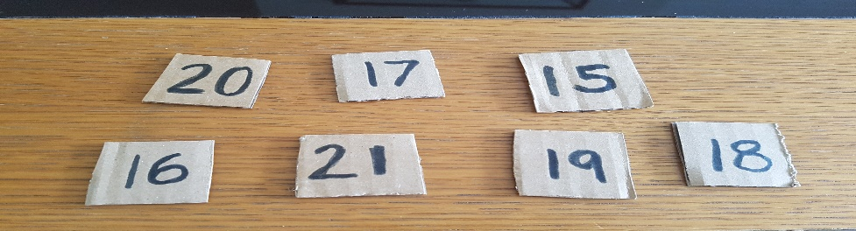

* **Number recognition:** Put out a mix of numbers and ask child to show you a particular number e.g. show me 15, show me 21 etc. (Photo above)
* **Number Ordering:** Put the numbers in the correct order, this could be done forwards or backwards. (Photo below)

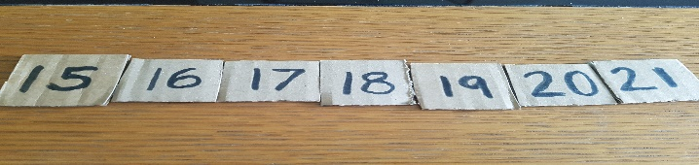

* **What’s the missing number?** When the children have ordered the numbers. Cover one of the numbers and children figure out the missing number or numbers and explain how they know. (Photo below)

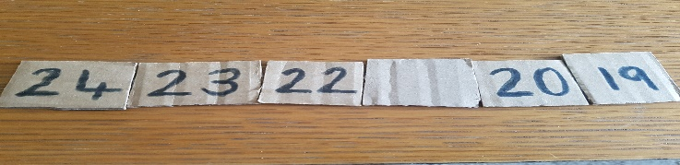

* **Number Sorting:** Put out a random mix of numbers for the child to order. They could try from smallest to biggest or from biggest to smallest.

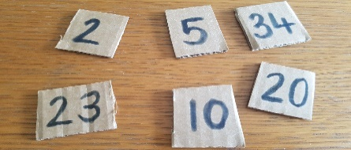 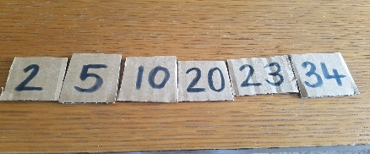

* **The Calendar:** Recite days of the week and predict day and date. If you have a calendar at home the children could mark off every day or if not the Starfall website has a calendar that you will find here <https://www.starfall.com/h/holiday/calendar/?t=294144234>
* Questions you could ask
  + What month are we in?
  + How many days does the month have?
  + What was last month / next month/ what month is your birthday?
  + What day is on the 10th / 15th / first / last?

**Gaeilge**

* Look at programmes on TG4 and in particular, Cúla 4 online
* **LOG INTO BUA NA CAINTE – SEE WEBPAGE FOR GUIDE TO LOGGING ON.**
* Learn the dán (song) Froganna Beaga Glasa (Little Green frogs) <https://www.youtube.com/watch?v=hrUvfVUegcg>

**Science:**

* Fill up a basin/ baby bath/ bucket. Use this for water play either in the bath or outside in the garden if you have access to it. Find items around your house to see what will float or sink. Here is a sample video to show you.

<https://www.youtube.com/watch?v=cSjNd2kZW-k>

* Make a boat to float in your bath/basin/bucket. You could try using different materials e.g. tinfoil, playdough, paper, Lego. Why did your boat float/ sink? Send a photo of your creation to your teacher. Add coins to your boat, what happens?

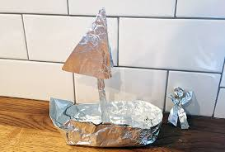

**Music:**

* Learn the song ‘Ugly Duckling’ <https://www.youtube.com/watch?v=neX_E8Ozf88&t=24s>

**Art & Crafts:**

* Design their own umbrella (or a sun parasol if the weather stays sunny). You can do this with a variety of materials like crayons, pencils, paint, fabric, string, plastic bags etc.

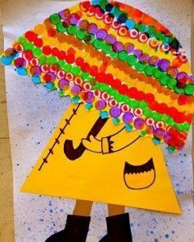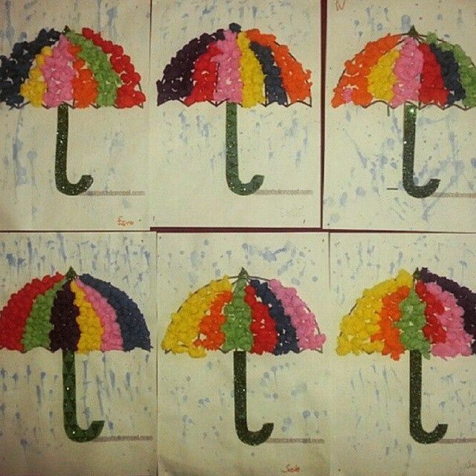

* Have a go making some Puffy Paint:

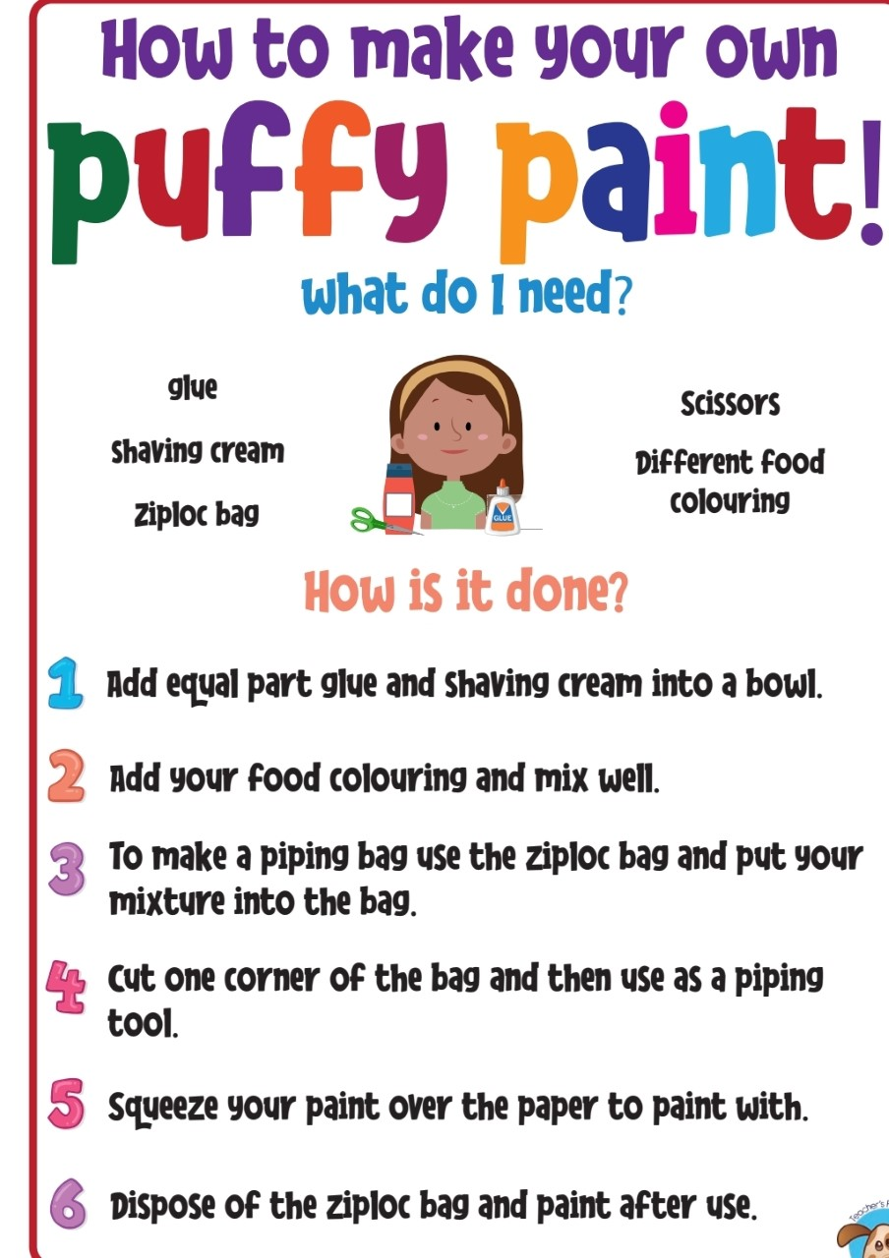

**Well-being:**

* This is a difficult time for all of us, especially little children. Also, in the home learning section you will find a sheet to give you the opportunity to talk about things that may be worrying your child. The children can fill in what might be causing them anxiety and you can have a chat about ways to overcome these worries and help them to “float” away.

**Physical Activity:**

* PE with Joe Wicks- Watch live every day at 9am (lots of saved videos available too!) <https://www.youtube.com/watch?v=QvWzWqLk8iQ>
* 10@10 - daily 10minute exercise videos. <https://rtejr.rte.ie/10at10/>
* Have you tried the challenges that Amanda from St. Peregrine’s has set us? You can find her videos on our school website.
* We learnt the ‘Cha-Cha Slide’ in Junior Infants, can you still remember all the moves? Have a go <https://www.youtube.com/watch?v=qSHxl9dhM8s>

**The following are activities that are excellent for developing the children’s logic skills, creativity as well as aiding with academic development.**

* Drawing, colouring and painting
* Jigsaws
* Water and Sand-play
* Building with Lego and blocks
* Nature walk/Scavenger walk
* Make a list of things to look out for on a walk. (Children could help to write the list)
* Take a photo of what you find or draw pictures when you come home.

**Some Practical Skills for your Child to Learn**

**Choose one skill to work on at a time and encourage your child to try it every day for a few minutes and then move onto a new skill. Praise, praise, praise, their efforts.**

**Some of these skills might even make your life easier in the long run!!**

* **Personal Information**
* say when it’s their birthday
* learn their home address
* learn their parents’/ guardians’ phone numbers off by heart
* how to contact emergency services- dial 999/112
* **Life Skills** – some of these will seem like play to the children and will occupy them for longer than other activities, these are marked with an **\***
* Wrap a present (use newspaper or kitchen paper if you don’t have wrapping paper) **\***
* Inserting batteries (into torch/ remote control)
* Sorting coins **\***
* Dressing themselves
* Putting dirty clothes in the laundry
* Blow their own nose
* **TIE THEIR SHOELACES**
* Clean their plates off after a meal
* Use a knife and fork
* Open and close lids of jars, lunchboxes**\***
* Pour water from a jug into cups/ pots**\***
* Use a dustpan and brush
* Clean windows**\***
* Help put the shopping away (reward them with an empty box from Lidl or Aldi!)
* Polish surfaces