Dear Parents/Guardians,

Welcome to week 5 of the summer term!

Thank you to all the children from Second Class who emailed [kids@stphilipsjns.ie](mailto:kids@stphilipsjns.ie) last week. We really enjoyed reading about the things you have been up to and the photographs of activities you have been doing. Please keep in touch as we love to write back to all the boys and girls. We have a list of some more activities this week. We hope you will enjoy them!

As we mentioned in last week’s letter, please contact [kids@stphilipsjns.ie](mailto:kids@stphilipsjns.ie) if you would like to ask us any questions, send a photo of a child’s work, etc. As always, the priority is wellbeing, looking out for each other and staying well.

The teachers have been making phone calls to the children in their classes over the last 2 weeks. If you missed the phone call and would like to arrange a time for your child’s teacher to call again please e-mail [kids@stphilipsjns.ie](mailto:kids@stphilipsjns.ie).

We would again like to really emphasise that you are welcome to see this suggested weekly outline of activities as a menu - you can explore as many or as little of the tasks as you can, depending on your own family routine. There may be days where you explore a small number of suggested school tasks with your child and other days where you may have more time for school-based activities and explore a little more.

There is no pressure on any family to complete all of the weekly suggested tasks. You are welcome to prioritise the activities that you feel will benefit your child most and enrich their daily routine.

We hope you and your families have a nice week and we will be in touch again soon.

Best wishes,

*Mr. Conneely, Ms. O’Hora, Mrs. Maye, Ms. O’Hare, Mrs Watson.*

*School Website:*

*Continue to keep an eye on the school website for new news, pictures or videos.

*There is a daily challenge each day that the children can try out too.

**Monday 18th May**

**Literacy**:

As it’s the start of the week write **‘Our News’** – What did you get up to at the weekend? What day is it today? What’s the weather like? Remember to keep it interesting! You can draw a picture of your weekend and colour the picture too.

Word Family of the week: Let’s look back on the **‘ow’ word family.**  ‘ow’ can make 2 different sounds. It can make the ‘ow’ sound like in bl**ow** and it can make the ‘ow’ sound like n**ow**. Today we’re going to concentrate on the ‘ow’ sound like in bl**ow**.

Example: blow, glow, pillow, elbow. Can you name any ‘ow’ words? Try to list out as many as you can.

Can you figure out the clues to these ‘ow’ words?

1. The sun is______________.
2. My mam likes to ___________ the lawn.
3. The stickers on the ceiling ________ in the dark.
4. I will ___________ you my new bike.
5. You have to _____________ the boat.
6. ____________ out the candles on your cake.
7. You can hop over the gate. It is not high. It is ________.
8. I went to see a _____________ in Draoicht.
9. I want to play with my bow and ______________.
10. I want to be a teacher when I ____________ up.

Can you make up clues for the “ow” words you listed above? Do 5 examples.

Send your answers to [kids@stphilipsjns.ie](mailto:kids@stphilipsjns.ie) ! ☺

Check out this video for lots of examples of ‘ow’ words

https://www.youtube.com/watch?v=NZdgP2wAQic

***Reading***- Read the story “Peter and the Dragon ‘’ (from The Green Genie, Page 88) and answer these questions on a page.

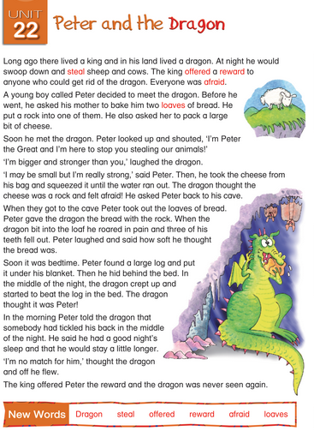

1. What did the king offer to anyone who could get rid of the dragon?
2. What did Peter’s mother bake?
3. What happened to the dragon when he bit into the loaf of bread?
4. What did Peter put under his blanket?
5. Who got rid of the dragon?
6. Can you put the words in red at the end of the story into sentences?

Send your answers to [kids@stphilipsjns.ie](mailto:kids@stphilipsjns.ie) ! ☺

**Numeracy:**

Today we are going to revise the topic of Time

Where is the big hand when it is **o’clock**?

Where is the big hand when it is **half past**?

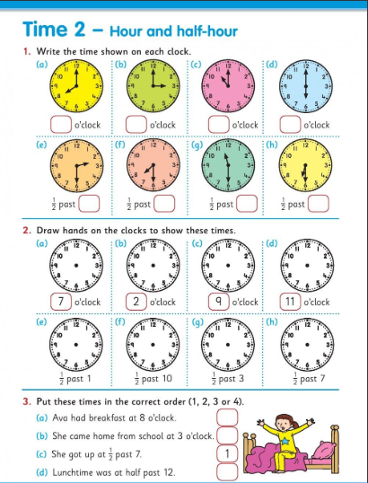

Count in **2s** starting at the number 2 all the way up to 32. Practice makes perfect so try counting in 2s a few times.

Here is a fun song to help you count in 2s!

<https://www.youtube.com/watch?v=GvTcpfSnOMQ>

**Gaeilge:**

Eadaí

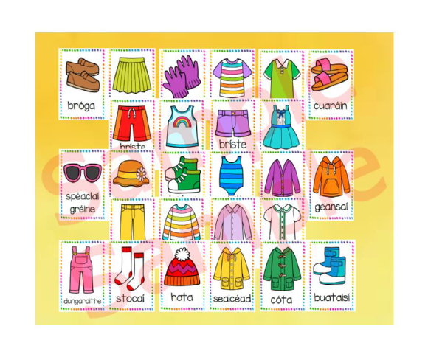

Cad atá ort?

An bhfuil hata ort? Tá hata orm / Níl hata orm.

An bhfuil geansaí ort? Tá geansaí orm / Níl geansaí orm.

An bhfuil sciorta ort? Tá sciorta orm / Níl sciorta orm.

Practice using these questions and answers with somebody at home.

**Active Work:**

1. High knees for 30 seconds
2. Frog jumps for 30 seconds
3. Jumping Jacks for 30 seconds
4. Lunges for 30 seconds
5. Squats for 30 seconds

**Daily Challenge:**

Check out today’s daily challenge on the school website and try to complete it.

**Tuesday 19th May**

**Literacy**

Yesterday we were looking at “ow” words. Here is another fun video for you to watch.

<https://www.youtube.com/watch?v=PHJmFE5E2T0>

Can you put these ‘ow’ words into sentences. Try to think of some funny sentences!

1. crow 6. yellow
2. snow 7. arrow
3. blow 8. glow
4. meadow 9. show
5. window 10.low

Send a picture of your sentences to [kids@stphilipsjns.ie](mailto:kids@stphilipsjns.ie) ! ☺

Drop Everything And Read! Choose a book to read with an adult, can you find any **‘ow’** words in your book?

**Numeracy:**

Let’s try some sums. Watch out for the sign. Is it + or –

Will you use **criss cross** or a **number line** or work it out as a **tall sum**?

|  |  |  |  |
| --- | --- | --- | --- |
| 41+21= | 60+33= | 82-44= | 73+31= |
| 64-42= | 54-33= | 55+22= | 42-17= |
| 26+19 | 29-10= | 99-77= | 45+29= |

Let’s look at **Time** again.

Where is the big hand when it is a **quarter past**?

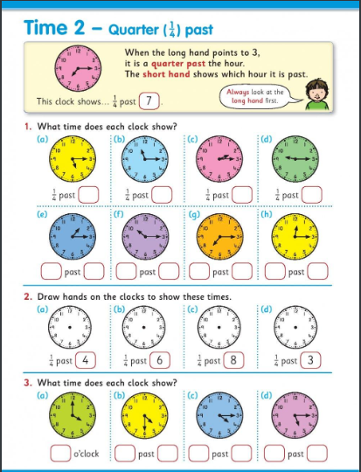

Get a pencil and paper. Find something round to trace around like a cup or a glass.

Draw 12 clocks and show the following times.

2 o’clock half past 8

half past 3 10 o’clock

5 o’clock quarter past 11

quarter past 7 12 o’clock

half past 9 half past 6

quarter past 1 quarter past 12

Send a picture of your clocks to [kids@stphilipsjns.ie](mailto:kids@stphilipsjns.ie) ! ☺

**Gaeilge:**

Have a look on the school website at Mr. Conneely and Ms. Watson practising Comhrá Beirte. Ask somebody at home to practise these questions with you.

[www.stphilipsjns.ie/](http://www.stphilipsjns.ie/)

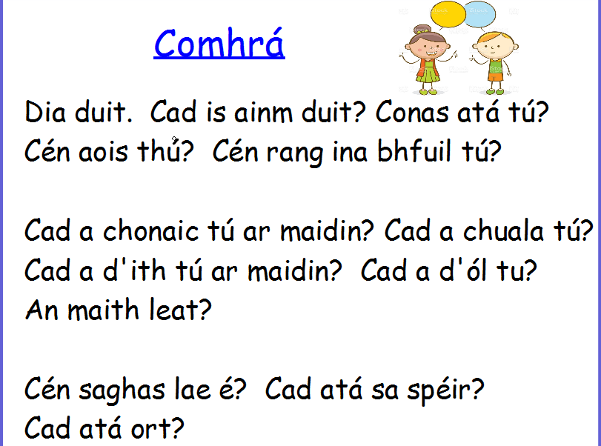

**Active Work:**

Go onto the GONOODLE website and pick out 3 fun dances. Get moving! ☺

[www.gonoodle.com/](http://www.gonoodle.com/)

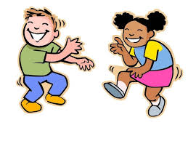

**Daily Challenge-**

Check out today’s daily challenge on the school website and try to complete it.

**Wednesday 20th May**

**Literacy:**

Story writing

Today’s story title: The Island Adventure

A story plan is a good idea to write before you start your story.

What does a good story always need?

* A beginning, a middle and an end
* Characters: Who will be in my story? What will their names be?
* Setting: Where will my story be set? (For example: a castle, a haunted forest, outer space, a school, a playground, a chocolate factory, an island)
* What problem will happen? How will the problem be fixed?

**Numeracy:**

Today, we are going to count in **4s**. Can you make up some actions to do as you count? You could pretend you are lifting weights at the gym!

Let’s start! 4, 8, 12, 16, 20, 24, 28, 32….. How far can you count in 4s?

Here are some fun videos to watch:

<https://www.youtube.com/watch?v=pkcIJn5HrMI>

<https://www.youtube.com/watch?v=VSn2O4mTYD4>

Let’s try some word problems today. You will need a pencil and paper for these.

*Maya had 22 twistables. Ruby gave her 41 more. How many did she have altogether?*

*Mr. Conneely has 33 match attack cards. Ms. O’Hare has 26. Ms. Watson has 42. How many cards do the teachers have between them?*

*Mrs. Maye has 57 smarties. She gave Ms. O’Hora 33. How many did she have left?*

*Marek had 22 balloons. He gave half of them to Anthony. How many does he have left?*

*Ms. Igoe has 62 glue sticks. She needs 100. How many more will she have to buy?*

**Art:**

We have been learning about time this week. Can you find some materials in your house to make a clock? Here are some ideas.

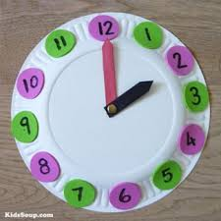 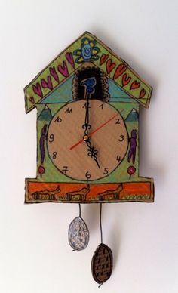 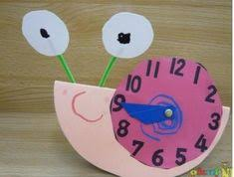 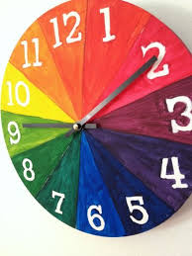

Send in photos of your clocks to [kids@stphilipsjns.ie](mailto:kids@stphilipsjns.ie) ! ☺

**Active Work:**

Try some yoga today ☺

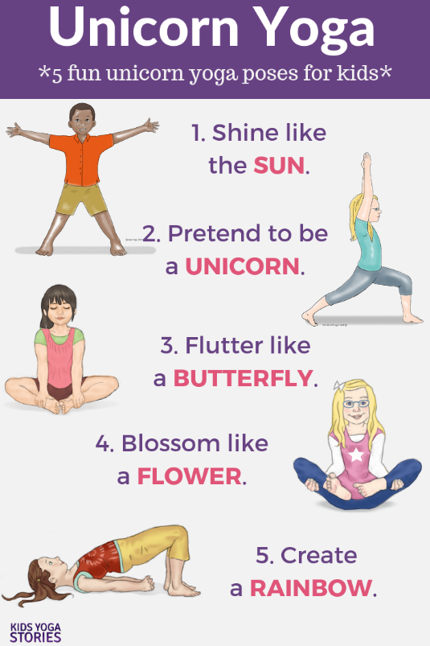

**Daily Challenge-**

Check out today’s daily challenge on the school website and try to complete it.

**Thursday 21st May**

**Literacy**:

Let’s look at the **‘ow’ word family** again**.**  ‘ow’ can make 2 different sounds. It can make the ‘ow’ sound like in bl**ow** and it can make the ‘ow’ sound like n**ow**. Today we’re going to concentrate on when it makes the the ‘ow’ sound like in n**ow**.

Example: how, now, wow. Can you name any ‘ow’ words? Try to list out as many as you can.

Can you figure out the clues to these ‘ow’ words?

1. _________ did you get here?
2. The farmer has to milk the ______________ every day.
3. Your eye____________ is above your eye.
4. __________! That was a great goal you scored.
5. You have to come inside _________. Your dinner is ready.
6. The actors took a ____________ at the end of the show.
7. The _____________ is a very wise bird.
8. The ______________ in the circus are very funny.

Have a look at this fun video!

<https://www.youtube.com/watch?v=9Ph6nnHrVwY&t=10s>

**Gaeilge:**

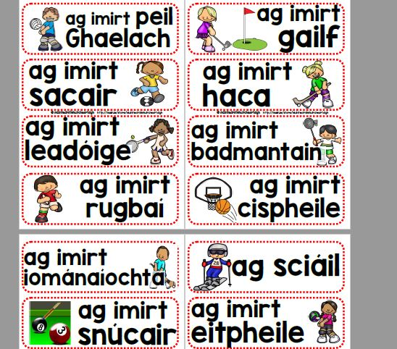

Is maith liom bheith ag imirt sacair Is maith liom bheith ag imirt peil ghaelach

Is maith liom bheith ag imirt cispheile Is maith liom bheith ag imirt leadóige

Draw a picture of your favourite hobby and write the sentence: Is maith liom bheith ag………

**Maths:**

Let’s look at greater than, less than and equal to. Remember the hungry alligator’s mouth is always open towards the bigger number.

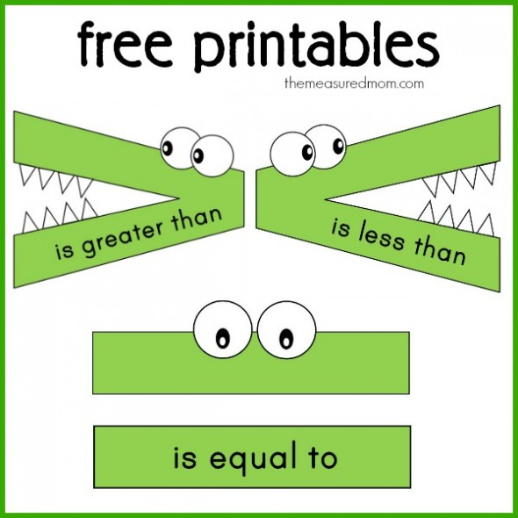

Try these and then see if you can make up some of your own on a page.

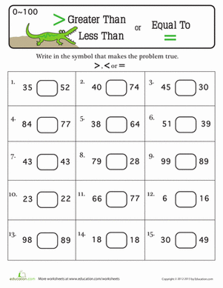 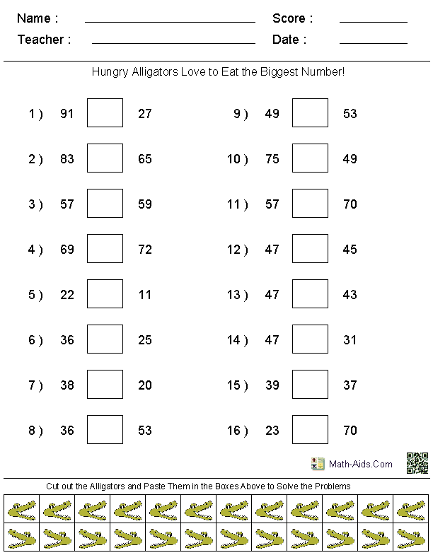

**History:**

Today we will be learning about the legend: Oisín in Tír na nÓg.

Look at this short video to learn all about it:

<https://www.youtube.com/watch?v=1nFcXcPldzY>

After watching the video answer the following questions:

1. Who came to visit Oisín one day?
2. Where did they go together?
3. What does Tír na nÓg mean in English?
4. Why did Oisín decide to go home?
5. What happened to him when he went back to Ireland?
6. Draw a picture of your favourite part of the story.

Send your pictures to [kids@stphilipsjns.ie](mailto:kids@stphilipsjns.ie) ! ☺

**Active Work:**

10 jumping jacks

10 burpees

10 squats

10 lunges

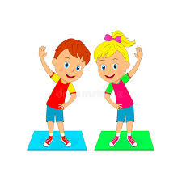

**Daily Challenge-**

Check out today’s daily challenge on the school website and try to complete it.

**Friday 15th May**

**High Five for a super week of trying your best!**

**Literacy:**

We know that ‘ow’ can make two different sounds. Blow and now.

Can you grab a pencil and paper and make 2 lists of ‘ow’ words.

|  |  |
| --- | --- |
| **OW** | **OW** |
| blow | now |

**Poetry:**

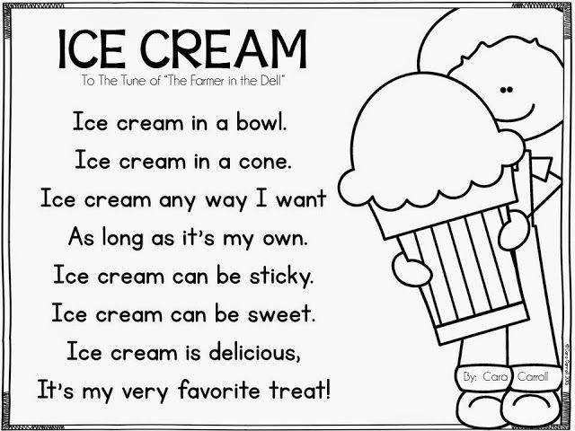

Read this poem and answer these questions:

1. Can you find any rhyming words in the poem? Make a list.
2. What adjectives can you find in the poem? Remember an adjective is a describing word.
3. Write a list of as many adjectives as you can.
4. Read the poem a few times. Can you say it without looking?
5. Draw a picture to go with the poem.

Send your answers to [kids@stphilipsjns.ie](mailto:kids@stphilipsjns.ie) ☺

**Numeracy:**

Try these 2 step word problems today:

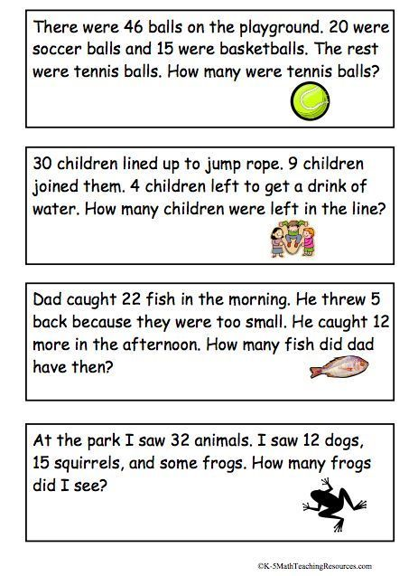

**Art:**

We looked at the poem Ice Cream. Have a go at designing your own ice cream dessert. What flavours would you use?

 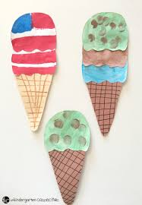

Send pictures of your delicious desserts to [kids@stphilipsjns.ie](mailto:kids@stphilipsjns.ie) ☺

**Active Work:**

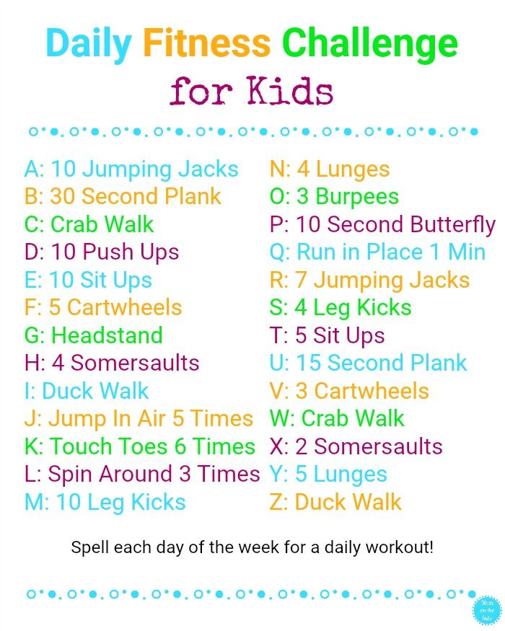

**Daily Challenge-**

Check out today’s daily challenge on the school website and try to complete it.