Hello boys and girls.

We hope you are all well.

Here are a few more suggested activities for you to try over the next week.  
You do not need to do all of them, just keep up some English and Maths everyday and pick one other activity that day.

We really love seeing your photos and videos of any of your work so if you do try out any of the activities please send a photo/video with your teachers name in the subject box to [kids@stphilipsjns.ie](mailto:kids@stphilipsjns.ie). We will put your work on the school website to show all your friends!   
We can't wait to see what you have been up to!

**English**:

**Reading:**

It is so important to keep up a little bit of reading each day.    
Read with your parent, an older brother/sister or on your own.

* **Reader:**Read a few pages of any book each day.  
  Chat to your Mam/Dad about the story. Mam & Dad can ask you questions, or you can try asking Mam & Dad questions about the story too!

Why not record yourself doing some reading and send to your teacher by email!

* For more books you could log onto <https://home.oxfordowl.co.uk/>. Parents can set up an account and then you can browse ebooks for your age and complete activities.
* This week, we will be learning about Minibeasts!  
  Read this online story all about The Cautious Caterpillar.  
  <https://www.twinkl.ie/resource/t-l-526203-the-cautious-caterpillar-ebook>  
    
  You could then try out these questions afterwards.  
  <https://www.twinkl.ie/resource/t-l-526270-the-cautious-caterpillar-differentiated-reading-comprehension-activity>
* **Two little frogs Workbook:**Continue with the next unit from your book this week.
* **Sounds Scavenger hunt**:

Find something in your house that

* begins with ‘a’
* begins with ‘wh’
* ends with ‘p’
* ends with ‘s’
* has ‘oa’ in the middle, eg. boat
* has ‘ee’ in the middle eg. sweet
* **Tricky words**

These are the words that we have covered so far this year.

|  |  |  |  |
| --- | --- | --- | --- |
| the  to  and  he  a | I  you  it  of  in | was  said  his  that  she | for  on  they  but  had |
| at  him  with  up  all | look  is  her  there  some | out  as  be  have  go | we  am  then  little  down |
| do  can  could  when  did | what  so  see  not  were | get  them  like  one  this | my  would  me  will  yes |
| big  went  are  come  if | now  long  no  came  ask | very  an  over  your  its | ride  into  just  blue  red |
| from  good  any  about  around | want  don't  how  know  right | put  too  got  take  where | every  pretty  jump  green  four |

Games to help practice tricky words:

* **Tricky Word Bingo**  
  Draw out a 3x3 grid and pick out 9 words to write in the spaces.

Call out a selection of words from the box and the child crosses out the word once they hear their word called.

* **Tricky Word Hunt**– pick a tricky word and see where you can find it e.g. in books, newspapers, etc.
* Practice **Spelling** the words, using the following method:Look-Say-Cover-Write-Check

Pick a tricky word

Look at and say the word

Cover the tricky word and have a go writing it again

Check to see if it’s right or wrong.

**Writing**:

* **My News:** Tell us about your day and how you are getting on. Record yourself reading a story you read this week.
* **Diary**: Continue to write a Diary of what you are doing during these weeks. Just write a few sentences about what you are doing each day. It will be very interesting to read it someday!
* **Write about Minibeasts**: Write a few sentences about what you have learned about the minibeasts (see below in the SESE section) or the caterpillar from the story The Cautious Caterpillar.
* **Free writing**

Give the child complete control over what they would like to write about. During this activity, there is no need to focus on the children’s spellings. The important thing is that they write freely about something they are interested in. At the end, get the child to read what they have written back to you.

Remember some of the ideas that we tried out in school

-label a picture  
-write a postcard  
-a note/message for Mam/Dad  
-words from your favourite story/song  
-make a list  
-a story

**Maths**:

**Check out the videos uploaded by Ms. Williams for 1st Class maths ideas and activities**

**Counting:**

* Counting forwards in 1’s up too 100.  
  Consider starting at different numbers.  
  Start at 45 and count forward to 53.  
  Start at 68 and count to 79.
* Counting backwards in 1’s from 100.  
  Again start at different numbers,  
  Start at 28 and count backwards to 19.  
  Start at 81 and count backwards to 72.
* Counting in 10’s up to 100.  
  Start with different numbers,~  
  Start at 7, ….. 7, 17, 27, 37,  
  Start at 12,……… 12, 22, 32, 42, 52

**Counting Games:**

* Buzz off, Sit down!  
  Your child might have played this in school with their class and could play it with an adult or an older sibling or even in a group.

Pick a target number to count to.

Now pick another number to start counting from and take turns counting until you reach the chosen number. When you reach the target number, the person who has said that number, gets to turn to the next person and say “Buzz off sit down!” and they’re out of the game.    
Eg. The target number is 43. Everyone in the game/circle takes a turn saying a number until you get to 43.

* **Bingo:** Split the page into nine boxes. Put a number in each one. Bingo master can call out numbers until one player has got all the numbers and says: Bingo!
* **Snap:** Good for number recognition and quick thinking.
* **Snakes and ladders:** Very good for counting and fun for all the family!

**Addition:**

* Practice your doubles eg. 4 + 4 = 8, 6 + 6 = 12.
* Practice your Numbers in Love (numbers facts that make 10)  
  3 + 7 = 10. 9 + 1 = 10.
* Addition with **pack of cards**

-Add 2 or 3 cards together and write a sum.

-Go fish (to make 10). If you have 4, you ask for 6 so you can make 10. If you have a 2, you ask for an 8, etc.

**Subtraction :**

* Practice subtraction sums within 20.  
  Remember - Keep the big number in your head, count backwards and use your fingers to help keep track of the number you are taking away.  
    
  17 – 6 =   
  11 – 8 =   
  12 – 5=  
  13 – 4 =   
  9 – 7 =

**Word problems**

* Simon had 10 sweets and his Mam gave him 8 more. How many does he have now?
* Jamie got 16 football cards for his birthday.   
  But he gave 5 cards to his friend. How many football cards does he have now?
* I have 9 crayons.   
  My friend Fatima has double that amount. How many crayons does Fatima have?
* Ethan has 16 toy cars. Andreas has 11 cars.  
  Who has more?   
  How many more cars does he have?
* Aizah has 7 sweets, Daire has 3 sweets and Hollie has 7 sweets.   
  How many sweets do the children have altogether?  
  (How did you work it out? – Did you use any of the things you already know?)
* Jake scored 20 points on his computer game.  
   Ms. Slattery scored 5 less than that.  
  How many points did Ms. Slattery score?
* Jackson is making a cake. He needs 12 eggs. He has 7 eggs. How many more eggs does he need to make the cake?

**Other Maths Activities:**

* Practice Telling the time – Can you remember how to tell if it is ‘o’ clock’, or ‘half past’?
* Money:  
  Set up a shop at home, using some coins up to 20c.  
  -Work out how much it costs to buy what you would like.  
  -What coins would you use to make up that amount?  
  -Have you enough to buy 2 of the oranges/apples etc?  
  -What change will you get?

**ICT games Website:**

* Save the whale <https://www.ictgames.com/saveTheWhale/index.html>
* Whack a mole <https://www.ictgames.com/mobilePage/whackAMole/index.html>
* Shark Numbers ( up to 99) <https://www.ictgames.com/sharkNumbers/mobile/index.html>
* Hit the Button <https://www.topmarks.co.uk/maths-games/hit-the-button>
* Mental Maths Train <https://www.topmarks.co.uk/maths-games/mental-maths-train>

**Twinkl Website Worksheet suggestions:**

<https://www.twinkl.ie/resource/t-n-1346-tens-and-units-worksheet>

<https://www.twinkl.ie/resource/t-n-2544731-counting-in-tens-activity-sheets>

<https://www.twinkl.ie/resource/t-n-1347-place-value-tens-and-units-cut-and-stick-worksheet>

<https://www.twinkl.ie/resource/roi-n-092-patchwork-elephant-addition-to-20-colour-by-number>

<https://www.twinkl.ie/resource/roi-n-5550-missing-number-addition-within-20-activity-sheet>

<https://www.twinkl.ie/resource/t-or-131-jakes-first-day-subtraction-to-20-colour-by-number>

<https://www.twinkl.ie/resource/t-n-2544952-oclock-and-half-past-activity-sheets#tabbed_content>

<https://www.twinkl.ie/resource/roi-n-5276-up-up-and-away-money-addition-problems-activity-sheet>

**Irish**:

***\*\*\*See News page for an Irish conversation video with Ms. Watson and Mr. Conneelly\*\*\****

* Continue to practice songs/poems learnt in school  
  Access our school Irish programme ‘Bua na Cainte’ online   
  ***(See News page for details of Bua na Cainte)***
* Dialogue ‘Cad is ainm duit?’ ‘Cén aois thú?’ ‘Conas atá tú?’ ‘An maith leat úll?’ etc.
* Look at programmes on TG4 and in particular, Cúla 4 online
* Stories on Seidean Si <https://www.seideansi.ie/>

**SESE:**

This week we will be looking at **Minibeasts**.

Have a look in your garden or while you are out for a walk in your local park and see can you spot any of these little minibeasts?

Check under rocks, in the flowerbeds, under trees, maybe even under flower pots.

Here are some ideas for what to look out for.

<https://www.twinkl.ie/resource/t2-s-1165-insects-photo-powerpoint>

Print off this little checklist to help you keep track of how many you find.

<https://www.twinkl.ie/resource/T-T-019-Minibeast-hunt-sheet>

If you would like to learn more about any of these little creatures, you can read more information on each here.

<https://www.twinkl.ie/resource/t-t-10435-minibeasts-and-their-micro-habitats-powerpoint>

Here is a fun wordsearch all about minibeasts.

<https://www.twinkl.ie/resource/roi-t-350-minibeast-word-search>

Here are the results of what one little girl found in her garden.  
Can you graph the results on the bar graph?

<https://www.twinkl.ie/resource/t-n-2830-minibeasts-bar-graph-activity-sheet>

**Art:**

**Minibeast rocks:**

Collect some flat rocks while you are out on your Minibeast hunt.  
You could then design and paint one of the rocks to show your favourite minibeast.  
Does you favourite minibeast have spots or stripes?  
Does your minibeast need a shell?  
Remember the eyes and antennae!

Here are some ideas.

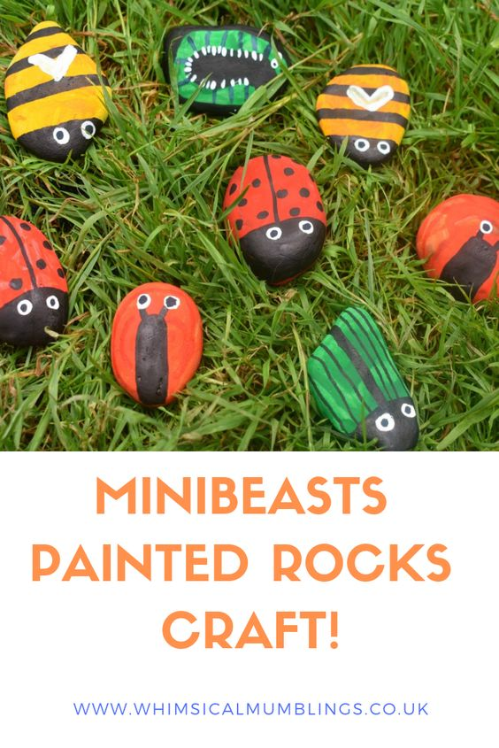

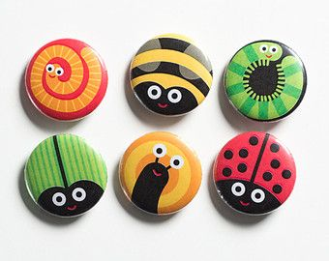

**Nature Picture:**

You could collect some grass, twigs, leaves, petals from flowers.   
Think about a picture you could make with them.   
Design and layout your picture first.  
Then glue them to a page to make a nature scene.  
  
Here are some ideas:

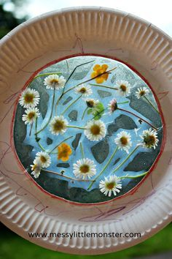

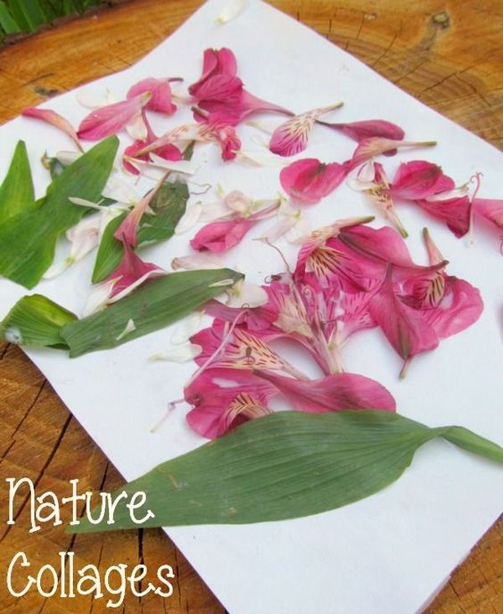

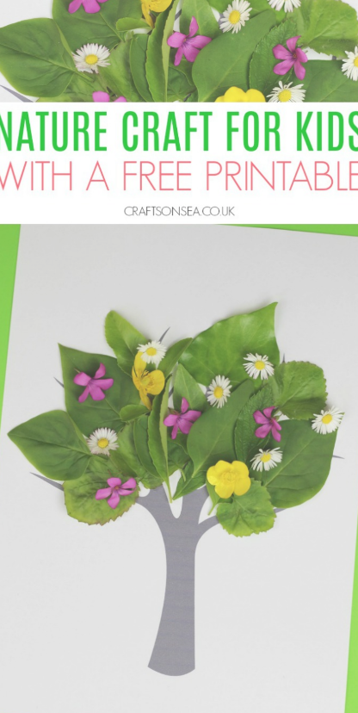

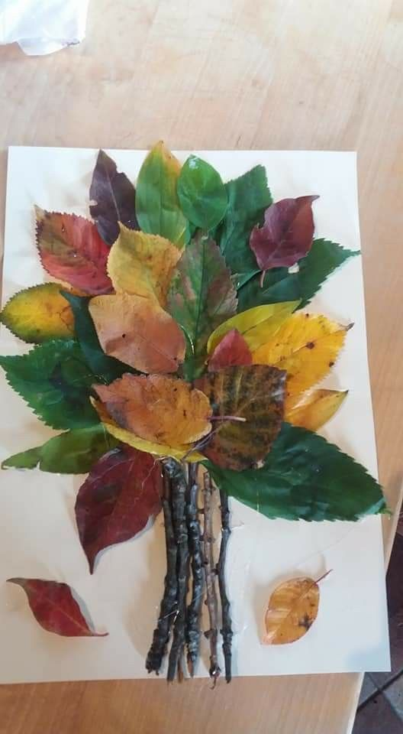

**Music:**Song Singing:

Herman the Worm song  
This is such a catchy tune, you will want to sing it again and again!

<https://www.youtube.com/watch?v=0-rg7EIt1x4&list=PLyitPFkxk2OV6mY_vDsa9KTq5Is92isEl&index=5>

Guess the sounds game:

<https://www.youtube.com/watch?v=n1m4h79JZso>

Now close your eyes! Listen for 1 minute to all the sounds that you can hear around you, in your room, in the house, outside?  
  
Can you make a list of the sounds you heard?

**PE:**

* ‘PE with Joe’ streamed live each morning at 9am on 'The Body Coach TV' Youtube channel.  
  And every Friday is ‘Fancy Dress Friday’ so you can dress up in your costume while exercising!
* 'Go Noodle' online channel for guided dancing
* 'Cosmic Kids Yoga' online channel
* 10@10 on Rte player, 10 minutes of guided exercise
* Walk, jog, run, cycle around your local area.
* Practice your football/basketball skills in your garden.